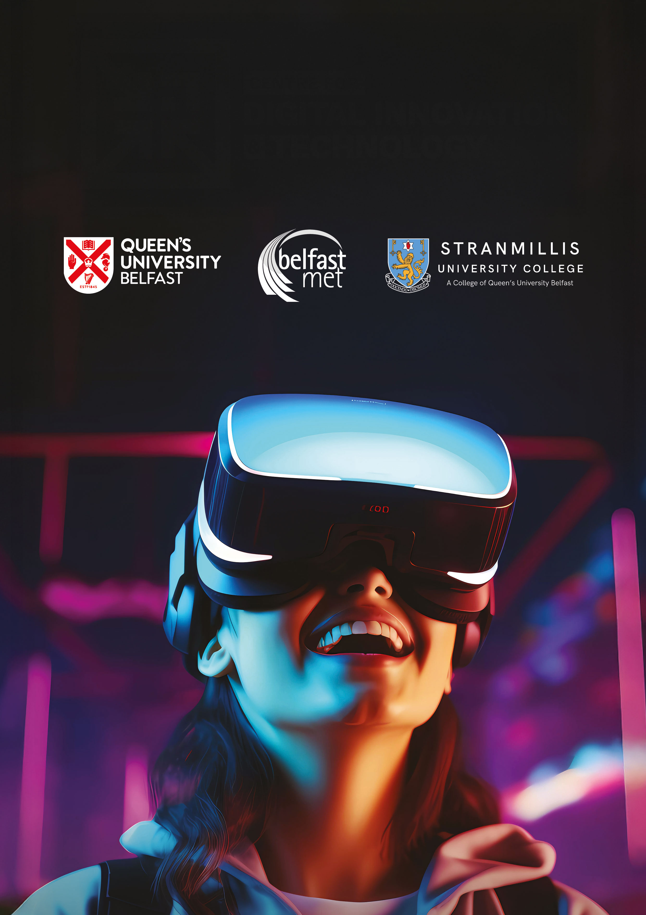

CDIT Industry Projects

2025

# What is CDIT

### The Centre for Digital Innovation and Technology (CDIT) is a collaborative framework between Further and Higher Education and industry partners to create a shared centre to advance digital innovation and technology through a skills-based approach. The centre aims to develop industry relevant skills through a shared multi-disciplinary environment that enables Industry and academia to co-create an educational experience for students based upon project based learning.

### Belfast Metropolitan College, Stranmillis University College, and

### Queen's University Belfast are collaborating to offer their students the

### opportunity to complete Industry specific projects.

* Why do we need projects?

We want students to learn through doing. We employ a project-based learning approach so that students learn through addressing challenges from the outside world. It is important that we provide students with the opportunity to interact with industry professionals on a regular basis throughout their degree and that, as far as possible, we mimic the workplace environment with the work delivered in iterations and increments by teams of students.

* The CDIT Industry Project Portal

The CDIT Industry Project Portal is a central portal to allow local industry to submit project ideas that can be incorporated into the curriculum delivery in Belfast Metropolitan College, Stranmillis University College, and Queen's University Belfast. Note, that in some instances students might attempt part of the scenario due to time constraints and other factors.

* What are the requirements of a suitable project?

**Projects need to:**

* Fit within the curriculum and be delivered at the appropriate time.
* Allow students to meet the academic aims of a particular module by being consistent with the expected module level.
* Be typically 4-10 weeks depending on the module to which a project is aligned to.
* Be realistic about what the students can produce in the time available to them. It should be noted that the learning opportunity for the students is the key output, and the shorter projects could perhaps be seen as small industry challenges. Students may produce a prototype or proof of concept but will not deliver fully finished software.



**What sort of projects are we looking for?**

In brief, these are the general projects we seek for each semester. See the following pages for more information:

**Research**

* AI / Innovative ideas

**Development**

* Website
* Database
* Application Development (Prototyping)

This is not a full list, if you have a good idea that students could use as a project and it is not listed here you can still complete the form or contact the team on the emails listed below.

* Project Timeframe

We have three submission windows throughout the Academic year, August 􀀠 to January, January to April, and April to August.

Ideas can be returned using this [CDIT Industry Project Portal online form](https://forms.office.com/pages/responsepage.aspx?id=MnyPmMZA6E2bWJcs8sP4NQnCAInhcpxLi7DJgt08JVRUREFVUFhUTlkyTjNWV1AyQ0QzODFITkNaUS4u&route=shorturl) or􀀠 the contacts below.

* Intellectual Property & Confidentiality

We understand that intellectual property (IP) and confidentiality are important considerations when proposing projects. We have established template agreements to address these matters, ensuring clarity and protection for all parties. These agreements cover ownership of IP, confidentiality obligations, and any necessary rights for project outcomes. If a project requires a specific agreement beyond our standard templates, we are happy to discuss this further. For more information, please use the contact details below

Contacts

Belfast Metropolitan College: [cdit@belfastmet.ac.uk](mailto:cdit@belfastmet.ac.uk)

Queen**'**s University Belfast: cdit@qub.ac.uk

Stranmillis: cdit@stran.ac.uk