


Operational Processes and Procedures for students with Learning Difficulties and Disabilities (SLDD) at Belfast Metropolitan College

Contents

1.Overview 2
2. Scope 3
3a. Centre for Supported Learning- Curriculum Provision 3
3b. Inclusive Learning 4
Referral and Evidence 5
Referral Process 5
Student Assessment and Support 6
Reasonable Adjustments/Curriculum Support Recommendations 6
4. Work Placements/Field Trips 7
5. Health and Safety Considerations 7
6. Examination Access Arrangements 8
7. Disabled Students Allowance 8
8. Review 8
9. Accountability Reporting 9
10. Further reading 9
11.Complaints 9
Appendix A: Supported Learning 10
Appendix B: Inclusive Learning 11

Document History

Version Number | Author | Reason for Change and Changes | Date | Review Date
1.0 | David McDowell |  | 02/12/2021 | 31/07/2023
2.0 | David McDowell | 05 July- Accessibility check – alt text added to image | 05/07/2023 | 31/07/2024
3.0 | David McDowell | 12 March- amendments made following EC feedback | 12/03/2024 | 31/07/2024
4.0 | David McDowell | 07 Aug- further reading page 9 updated/link removed | 07/08/2024 | 31/07/2025
5.0 | David McDowell | 25 June- Additional information in relation to: Supported Learning, Inclusive Learning communication. | 25/06/2025 | 31/07/2026
6.0 | David McDowell | 26 August- Amendments to work placement/field trips section | 26/08/2026 | 31/07/2027
Version control details

1.Overview
Belfast Metropolitan College (Belfast Met) wants students to experience an inclusive, enjoyable, and safe environment, where they feel supported and empowered. The purpose of this procedures document is to make all staff and students aware of how students with a learning difficulty or disability can access support.
These procedures have been developed to support the Interim Policy for Student with Learning Difficulties and Disabilities (available on the Policies section of the Belfast Met website). The Policy and Procedures have been developed to clarify how the College manages its legal obligations as stated below.
Article 13(2) of the Further Education (Northern Ireland) Order 1997 requires that “the Governing Body of an Institution of Further Education shall have regard to the requirements of persons over compulsory school age, who have learning difficulties”. Further Education (FE) Colleges are required under The Special Educational Needs and Disability (Northern Ireland) Order 2005 to make reasonable adjustments for Students with Learning Difficulties and/or Disabilities (SLDD), so that they can access provision.
In addition, Section 75 of the Northern Ireland Act 1998 imposes statuary duties on Public Bodies to promote the equality of opportunity between the nine equality categories of person, including between persons with a disability and persons without.
To comply with these requirements Belfast Met has a duty to meet the person’s individual requirements by making reasonable adjustments. The duty to make reasonable adjustments is a continuing duty. We will keep adjustments under review in the light of our experiences with disabled people applying to courses and using our services.
This document outlines the procedure for ensuring that appropriate arrangements are provided for students who meet the eligibility criteria as detailed Interim Policy for Students with Learning Difficulties and Disabilities (SLDD) in Further Education (FE) NI. In doing so it is essential to note that the College can only support students where:
- The disclosure is followed by the completion of LS1 referral form to Inclusive Learning and attendance at a needs assessment; OR
- Student has followed the admissions process for Supported Learning programmes
- and
- Appropriate evidence has been provided to support the student’s disclosed condition.
Failure to disclose could reduce the College’s capacity to provide appropriate support for the student.

2. Scope

This document is targeted at Belfast Met students who meet the definition outlined on page 10 of the Interim Policy for Students with Learning Difficulties and Disabilities (SLDD) in Further Education (FE) NI and attend courses wholly or mainly on the Colleges’ campuses, or outreach centers.

3a. Centre for Supported Learning- Curriculum Provision

Overview
The Centre for Supported Learning at Belfast Met ensures that every student is assessed fairly and receives the appropriate support to access and benefit from their course. The admissions process is designed to match students to the most suitable programme and to identify any additional learning needs at the outset.

Assessment Process
Applicants who submit an Expression of Interest are invited to attend an assessment session where they participate in structured activities designed to assess:
• Literacy and numeracy skills
• Social interaction and communication
• Suitability for specific course pathways
Academic staff apply consistent, standardised criteria when assessing applicants.

Identifying Support Needs
Following the assessment, applicants receive feedback and are signposted to the most appropriate programme to apply to. At this stage, the academic team determines:
• Whether the student meets course entry criteria
• Any reasonable adjustments required
• The level of support needed to ensure successful participation in learning

Declaration of Disability Form
All applicants must complete a Declaration of Disability form. This is a vital part of the admissions process and:
• Enables students to formally disclose any learning difficulty or disability
• Must be supported by evidence from a qualified professional (e.g., teacher, social worker, or medical practitioner)
• Supplementary Learning Agreement (SLA)
Once a student accepts an offer, the academic team completes a Supplementary Learning Agreement (SLA). This document:
• Outlines the student’s identified support needs
• Records agreed adjustments and strategies to support learning
• Is reviewed regularly in collaboration with the student to ensure support remains relevant and effective

Appendix A sets out a disclosure flow chart for students.

3b. Inclusive Learning
The College maintains a dedicated unit, Inclusive Learning, whose role is to:
- Promote the referral process and support available to students
- Meet with the student, their parent/ carers as appropriate and assess their needs, explore potential, reasonable adjustments
- Devise Curriculum Support Recommendations Plan outlining student’s needs and support on course
- Advise teaching staff of a student’s needs and possible support strategies for use in the classroom
- Implement and review the effectiveness of support arrangements
- Liaise with the examination unit and/or curriculum to ensure that appropriate access arrangements are in place for those students doing examinations and other assessments
- Provide general information to assist staff to support learners

Referral and Evidence
It is in a student’s best interest to disclose a learning difficulty or disability so that the College can make adequate, reasonable adjustments as soon as possible. The College therefore strongly encourages students and those applying for courses at the College to disclose as early as possible by completing an LS1 Referral Form.
References are also made to the need to disclose at induction and in the Student Support Handbook, Canvas and College website. Students also receive regular email communication.

Referral Process
All students and prospective students who require support must complete a LS1 Referral Form available on the College website.
Inclusive Learning contact all students who indicate at application and enrolment that they may require support and advise them to complete the LS1 Referral Form.
Student will receive an appointment for an initial needs assessment within approximately three weeks of the Centre receiving a completed LS1 Referral Form. The form can be completed at any stage of the academic year. However, we strongly encourage students to refer to the Centre before the start of the academic year. Students who do not complete the LS1 Referral Form will not be able to avail of support from Learner Success.
Initial needs assessment for mainstream provision students are conducted by Inclusive Learning.
In accordance with paragraph 3(B)(vi) of the Interim Policy for Student with Learning Difficulties and Disabilities, students should provide evidence of their disclosed learning difficulty, disability and/or long-term medical condition (preferably in advance of the initial appointment) to avail of funded support.
The College can only confirm the implementation of a reasonable adjustment upon the receipt of appropriate evidence of the student’s condition. This evidence will normally be provided by a medical practitioner or other professional e.g. Educational Psychologist report, Specific Learning Difficulties (SpLD) Tutor report, Medical Professional report. Confirmation of support in the classroom and in examinations from previous educational institutions should also be provided by the student.
The responsibility for providing appropriate evidence lies with the student and/or their parents or carers.
A Statement of Special Educational Needs as provided by Education Authority ceases validity when a young person leaves school. However, Inclusive Learning can use a former statement as a guide in identifying appropriate reasonable adjustments.
Some students may prefer not to disclose a disability, learning difficulty or long-term medical condition for their own reasons. In such circumstances the student should be aware of the impact of not disclosing. Not disclosing will result in no support on course including in examinations as well as tutors being unaware of the student’s needs.
Inclusive Learning maintain email contact with students via College Information System (student email and personal email, where appropriate and if provided).
Should consent be provided by student, we will reply to emails from appropriate parties e.g. parents/guardians, however these parties will not be copied into standard email communication with student.
Parents/Guardians may wish to encourage their child to access their College emails regularly so they do not miss out on key messages. Issues with accessing student email accounts should be directed to ITServiceDesk@belfastmet.ac.uk

Appendix B sets out a disclosure flow chart for students.

Student Assessment and Support
Inclusive Learning will undertake an initial assessment which entails
- a careful and sensitive screening of the needs of the individual;
- discussion on adjustments that have previously been helpful (e.g. at school); and
- if necessary, referral for further assessment to other specialists.
- signposting to other Student support services
The scope of this initial assessment is to identify educational need. It does not include assessments that would constitute a diagnosis of any disability, learning difficulty or long-term medical condition.
In doing this assessment the following areas will be addressed with appropriate information being recorded, both for College purposes and to comply with Department of the Economy requirements:
- The extent / history of the disability presented
- The impact the disability will have on the student’s College experience/learning
- The identification of progression routes for the student
- The type and likely duration of any additional support to be implemented
- Advice and guidance for the teaching team
- Additional information required by DfE for monitoring purposes (policy available here: InterimPolicyforSLDDinFE.pdf (belfastmet.ac.uk))

Reasonable Adjustments/Curriculum Support Recommendations
Students on mainstream provision will receive a set of Curriculum Support Recommendations Plan which are devised in conjunction with the student, to be shared with the teaching team and other relevant parties with the consent of the student. This document contains detailed advice to the student’s teaching team that will identify how best that student can be supported during class activities, assessments and examinations. Additional support may be recommended e.g. laptop loan, 1-1 Specific Learning Difficulties teaching.
In identifying appropriate reasonable adjustments, the College is committed to making reasonable adjustments for students using guidance from the Disability Discrimination Code of Practice for Further and Higher Education, while at the same time accepting that some limitations may apply. This means that as far as is reasonably possible, a student has the same access to the curriculum and College services as other students. The following factors will be taken into account when considering adjustments:
- The need to maintain academic standards.
- Health and Safety.
- The impact on other stakeholders including students
- Practicality.
- The effect of the impairment on the individual student.
Should a member of Inclusive Learning staff identify that it is not possible to facilitate an appropriate “reasonable adjustment” then the case will be escalated to the Head of Learner Success and the Head of Curriculum Department for their consideration and review.

4. Work Placements/Field Trips
Curriculum Teams, Business and Skills, and/or the team responsible for sourcing the work placement/field trip should ensure that risk assessments consider students with a disclosed disability, learning difficulty or long-term medical condition.
The relevant team noted above should meet with the student to discuss any support needs relating to their work placement. Before sharing any documentation or discussing a student's disclosed disability, learning difficulty or long-term medical condition with a work placement provider, the student’s written consent must be obtained.

5. Health and Safety Considerations
Some courses may have particular health and safety issues that make it essential for a student to disclose certain impairments or conditions before enrolment.
There may be times when the nature of a student’s ill-health requires support beyond the expertise or capacity that the College can reasonably offer.

In instances where a student’s ill health/medical condition presents an unmanageable health and safety risk to either themselves or to others in the College educational setting a risk assessment may be carried out. In such circumstances it is reasonable for the College to ask the student to produce a letter from their G.P. advising the College of the student’s fitness to study.

Following risk assessment process, a panel should be convened to determine if the college can reasonably be expected to manage the risk presented. This panel should consist of three members of staff to include HOD/CAM/Support or Health and Safety representative.

Should the outcome of the risk assessment be that the College cannot manage the risk posed by the health and safety impact of a student’s ill health the Curriculum Area Manager should advise the student in question of the panel’s decision making in writing and subsequently withdraw the student.

The student should be advised of the College’s Careers and Employability service and other education and learning provision whose environment may be better place to manage the associated risk.

6. Examination Access Arrangements

Examination Access Arrangements may be approved for students who have a learning difficulty, long term medical condition or disability. It is the students’ responsibility to make sure they have contacted Inclusive Learning as soon as possible indicating that they require Access Arrangements and can supply evidence that meets the Awarding Bodies’ requirements. Parents/Guardians should encourage students to meet the relevant deadlines to access support. The nature of examination arrangements will be determined according to the needs of an individual student. The College’s decision will take account of the awarding body criteria.

Students should be familiar with the Student Guide to Access Arrangements with associated deadlines This is available on Canvas: Inclusive Learning: Student Support Services (instructure.com).

7. Disabled Students Allowance
Disabled Students Allowance (DSA) is additional funding to help students on Higher Educational courses with extra essential costs as a direct result of a disability.
You can get help with the costs of:
- specialist equipment, for example a computer if you need one because of your disability
- non-medical helpers
- extra travel because of your disability
- other disability-related costs of studying
Disabled Students' Allowance does not cover:
- any disability related costs you'd have if you weren't studying
- any non-disability related costs

Application forms and further information can be found at www.studentfinanceni.co.uk.
You should also complete the College’s LS1 Referral Form.

8. Review
Any student on a mainstream course who attends an initial needs assessment and is being supported by Inclusive Learning, should attend a review appointment twice a year to discuss and review reasonable adjustments/curriculum support recommendations. Additional review appointments can be made at any time to identify and discuss any concerns that the student may have in relation to their support and its effectiveness. Students should note that failure to engage with any learning support service that has been provided (without due reason) may result in that support service being removed.
Reviews of support required for students on Supported Learning courses (Discrete provision) are conducted by a Discrete Provision Specialist.

9. Accountability Reporting
FE (Additional Support Fund)
The College must submit an annual evidence-based report to Department for the Economy (DfE) that details the value and effectiveness of the student support that has been provided.

10. Further reading
- Interim Policy for Student with Learning Difficulties and Disabilities (available on the Policies section of the Belfast Met website).
- Belfast Met Student Support: Students Support - Life at the Met - Belfast Met
- Disability Discrimination Code of Practice for Further and Higher Education: SENDOCoPforFHE2006.pdf (equalityni.org)
- Disabled Students Allowance: What is Disabled Students' Allowance for NI students - Student Finance NI

11.Complaints
It is hoped that we will be able to resolve any complaint through the complaints procedure. If the student remains dissatisfied with the outcome, they have the right to raise the matter with the Northern Ireland Ombudsman’s Office (in his/her role as Commissioner for Complaints).
The customer can complain to the Ombudsman however, the Ombudsman will normally only consider a complaint after it has been managed in accordance with the College’s Customer Complaints and Compliments Policy.
Contact details for the Ombudsman are:
Northern Ireland Public Services Ombudsman,
Progressive House,
33 Wellington Place,
Belfast BT1 6HN

Appendix A: Supported Learning

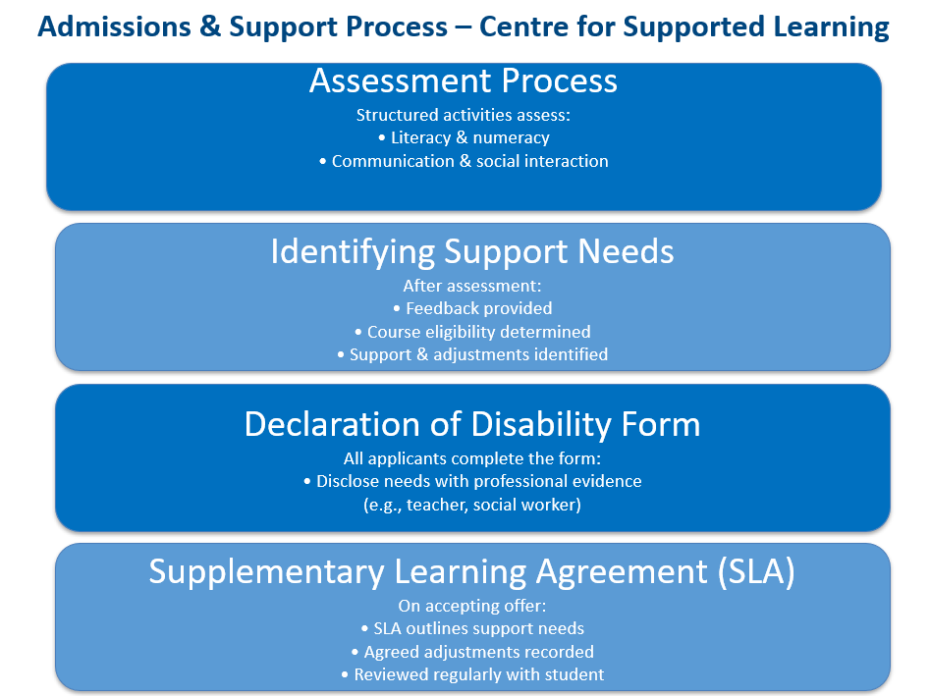

Appendix B: Inclusive Learning

