Programme specification

(Notes on how to complete this template are provide in Annexe 3)

1. Overview/ factual information
Programme/award title(s) | FD Digital Art and Animation for VFX and Virtual Production
Teaching Institution | Belfast Metropolitan College
Awarding Institution | The Open University (OU)
Date of first OU validation | 23.03.2023
Date of latest OU (re)validation | N/A
Next revalidation | 23.03.2028
Credit points for the award | 240 points
UCAS Code
HECoS Code
LDCS Code (FE Colleges)
Programme start date and cycle of starts if appropriate. | September 2023
Underpinning QAA subject benchmark(s) | QAA Undergraduate Subject Benchmark Statements for Events, Leisure, Sport and Tourism (2019)
Other external and internal reference points used to inform programme outcomes.
For apprenticeships, the standard or framework against which it will be delivered.
Professional/statutory recognition | We are working closely with NI Screen, Aura Digital, Epic Games and Yellowmoon.
For apprenticeships fully or partially integrated Assessment.
Mode(s) of Study (PT, FT, DL,  Mix of DL & Face-to-Face)  Apprenticeship | Full time - Face to Face  Part time - Face to Face
Duration of the programme for each mode of study | Full time- 2 years  Part-time 2.5 years
Dual accreditation (if applicable)
Date of production/revision of this specification | 16/01/23

Please note: This specification provides a concise summary of the main features of the programme and the learning outcomes that a typical student might reasonably be expected to achieve and demonstrate if s/he takes full advantage of the learning opportunities that are provided.
More detailed information on the learning outcomes, content, and teaching, learning and assessment methods of each module can be found in student module guide(s) and the students handbook.
The accuracy of the information contained in this document is reviewed by the University and may be verified by the Quality Assurance Agency for Higher Education.

2.1 Educational aims and objectives
The proposed rationale of the programme is to:

- Equip learners with the skills and knowledge relevant to employment in the Digital Production for the Screen Industries Sector. With a focus on Visual Effects and Virtual production it will develop transferable skills in digital asset creation, animation and compositing for a rapidly evolving sector covering current conventional and real time on set virtual production workflows.
- To support the participation of learners from a range of disciplines to equip them with the knowledge and skills to enter employment where data is used to shape organisational growth and sustainability.
- To provide a sustainable pipeline of new talent for employers currently experiencing skills deficit in the ever growing area of Visual Effects, Animation and Virtual Production.
- To provide an opportunity for learners to progress to a range of bachelor’s degree (Hons) programmes.
- To provide an opportunity for learners to experience and apply the knowledge and transferable skills in the workplace.

Target Audience:

The target audience is learners who have recently completed BTEC Level 3 Extended Diplomas, A-Levels or equivalent in the subjects.

These learners may wish to undertake a programme of study that combines Visual Effects, animation, digital art, film making, game development and motion graphics. The learners will learn all these skills in a subject area that they enjoy.

Structure:

- The FD in Digital Arts and Animation for VFX and Virtual Production will be structured in a way that supports transfer of academic knowledge and understanding and that this integrates with and supports the development of, vocational skills and competencies, whilst ensuring academic rigour.

- The structure of the Programme will take account of external reference points such as Frameworks for Higher Educational Qualifications, Professional Body accreditation schemes.

- The programme will ensure that the Work Based Learning (WBL) is relevant and contextualised within the scope of the employer's need in this area in order to promote and ensure the availability of a pipeline of talent. WBL will also be structured to support the enhancement of relevant transferable skills needed for employment in this sector. Cognisance will also be given to ensuring the Programme is representing opportunities for employment across small and medium sized enterprises and self employment.

- WBL will be supported to enable learners to take on appropriate role(s) within the workplace, giving them the opportunity to learn and apply the skills and knowledge they have acquired as an integrated element of the course. Whilst WBL will be supported and encouraged through a range of media including part time work, integrated work placements and real work environments, it will be defined clearly within the context where the WBL should lead to the identification and achievement of defined and related learning outcomes for the learner.

- The structure of the FD in Digital Arts and Animation for VFX and Virtual Production will have at its core, an integrated approach to demonstration of characteristics that include employer involvement; accessibility; articulation and progression, flexibility and partnerships with industry.

- The learners will take part in extracurricular competitions/initiatives outside of the classroom including those offered by Epic Games and The Rookies, as well as those through Northern Ireland Screen/Department for the Economy

Progression Pathways

Belfast Metropolitan College aspires to offer the FD in Digital Arts and Animation for VFX and Virtual Production as a route to a bachelor’s degree with honours course and would explore the options with OU in VFX/Virtual Production. Alternatively, it is felt the FD in Digital Arts and Animation for VFX and Virtual Production provides learners with options for progression to a range of other providers/courses.

Context

Visual effects, animation and virtual production are industries that are experiencing significant growth globally. Due to this, it is important to provide training in these areas to learners. The FD in Digital Arts and Animation for VFX and Virtual Production aims to address the skills gap within these sectors and prepare learners with the work ready skills that meet the current and future needs of employers in these growing industries.

The global virtual production market was valued at 1,464 million U.S. dollars in 2020 and is projected to reach 4,733 million U.S. dollars by 2028; it is expected to grow at a CAGR of 15.9 percent during the forecast period from 2021 to 2028.

According to the Department of Trade, the UK has been at the forefront of LED Volumes and VP based production.

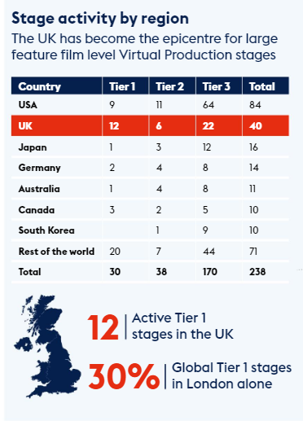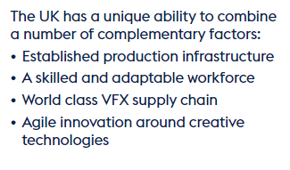
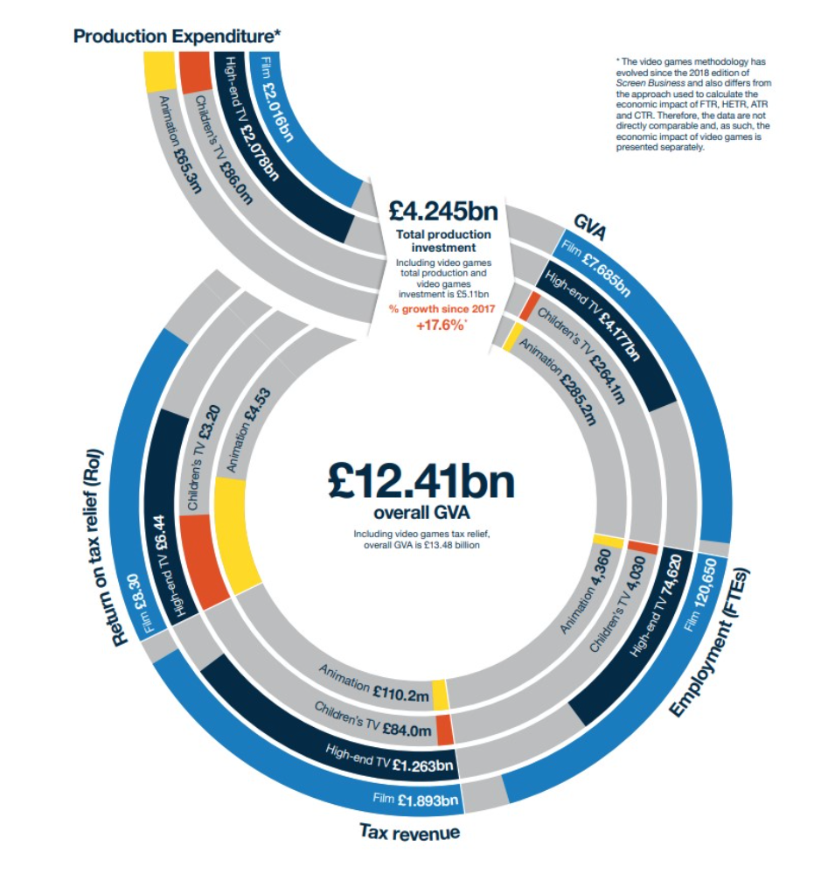
Virtual Production is also a core area for development in the Northern Ireland Department for Economy “10x Economy” strategy:
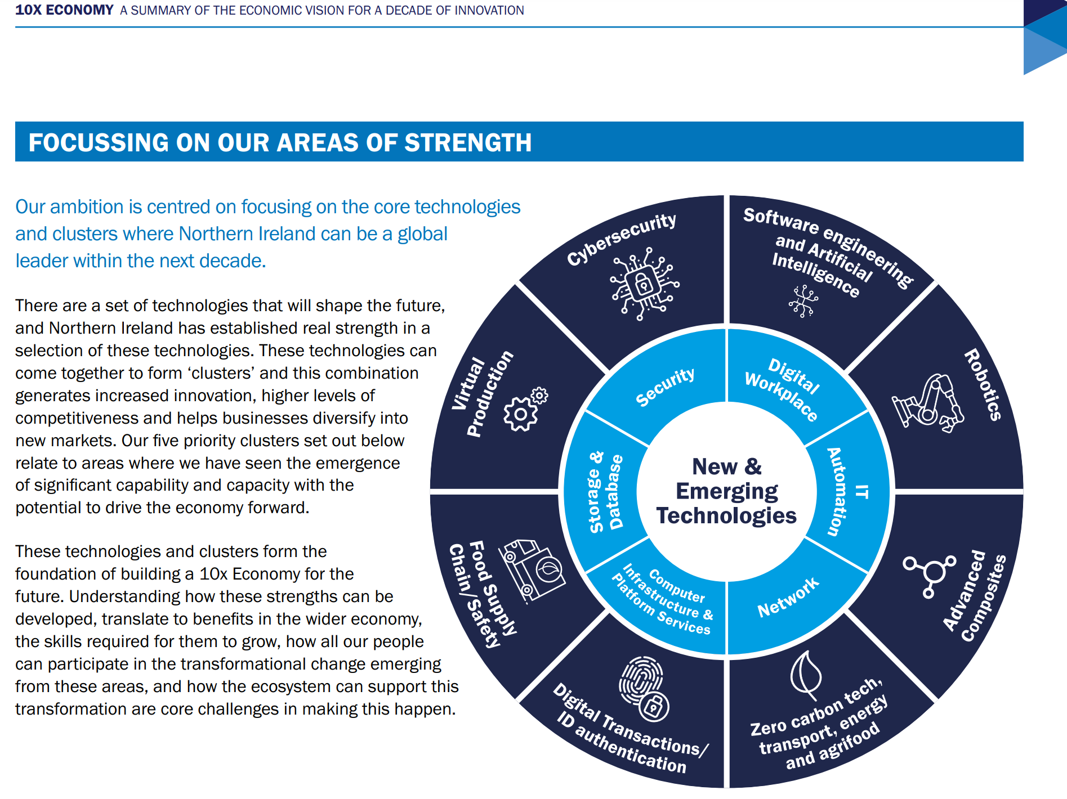
Support for the creative industries, specifically in the areas of Visual Effects and Virtual Production has also been clearly identified for 2022-2026 through the NI Screen Strategy “Stories, Skills and Sustainability”. The core focus of this strategy is to attract large production companies such as Warner Bros and Netflix to the Belfast Harbour area; development of an £70M VP stage in the harbour will also be completed by 2024, this has been funded through the Belfast City Deal.

According to the Department for Communities for NI the creative industries namely those focused around TV/Games/Animation/VFX contributed 1.3 Billion to Northern Ireland's total GVA and is expected to increase through to 2026.

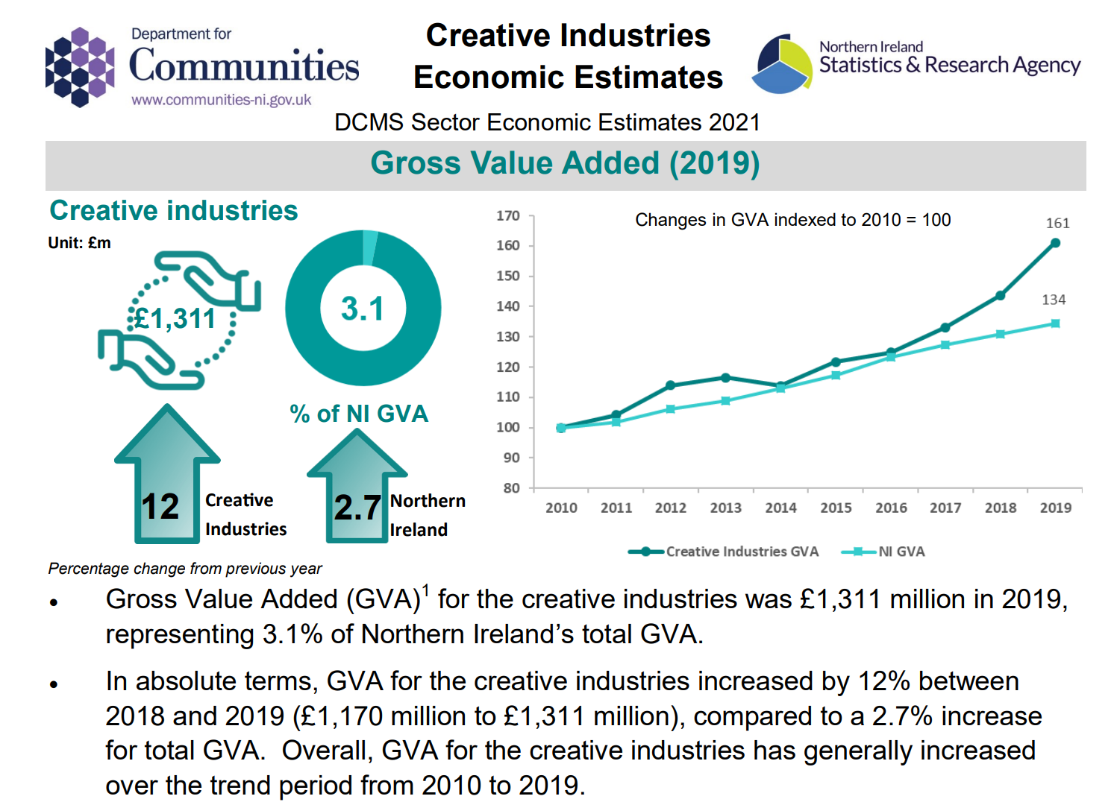

https://www.communities-ni.gov.uk/system/files/publications/communities/creative-industries-economic-estimates-2021.pdf

The Department for Communities (DfC) estimates the number of people in creative employment in 2019 in Northern Ireland at 29,000 or 3.4 per cent of the local workforce. This is expected to increase through 2026-28. 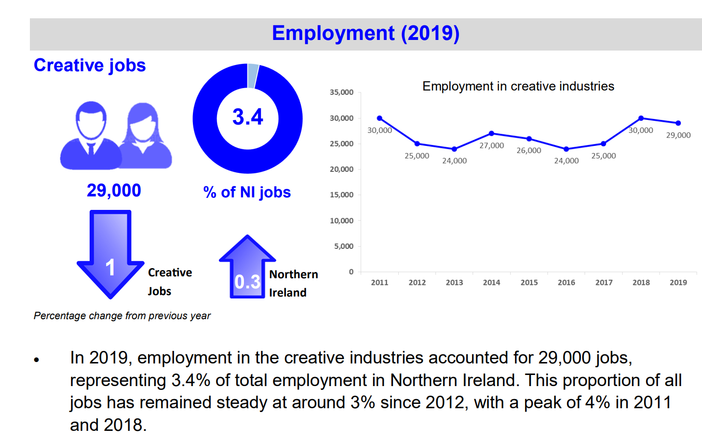

For VFX sector alone, the ScreenAlliance UK has found that from a combined UK VFX spend during 2019 of £710m for tax relief related activity and non tax relief related work, such as advertising, the report estimates that the sector contributed £1.68bn in GVA to the UK economy and supported 27,430 jobs.
Out of these, 10,680 are FTE, generating high productivity, delivering £89,743 of GVA per FTE, which is £23,643 more per person than the average for the whole UK economy.

Globally, the animation sector is also projected to grow significantly and is set to reach $587 Billion by 2030. Within the UK it was worth an estimated £1.6Billion in 2020 and is forecast to reach almost £5 Billion by 2030.
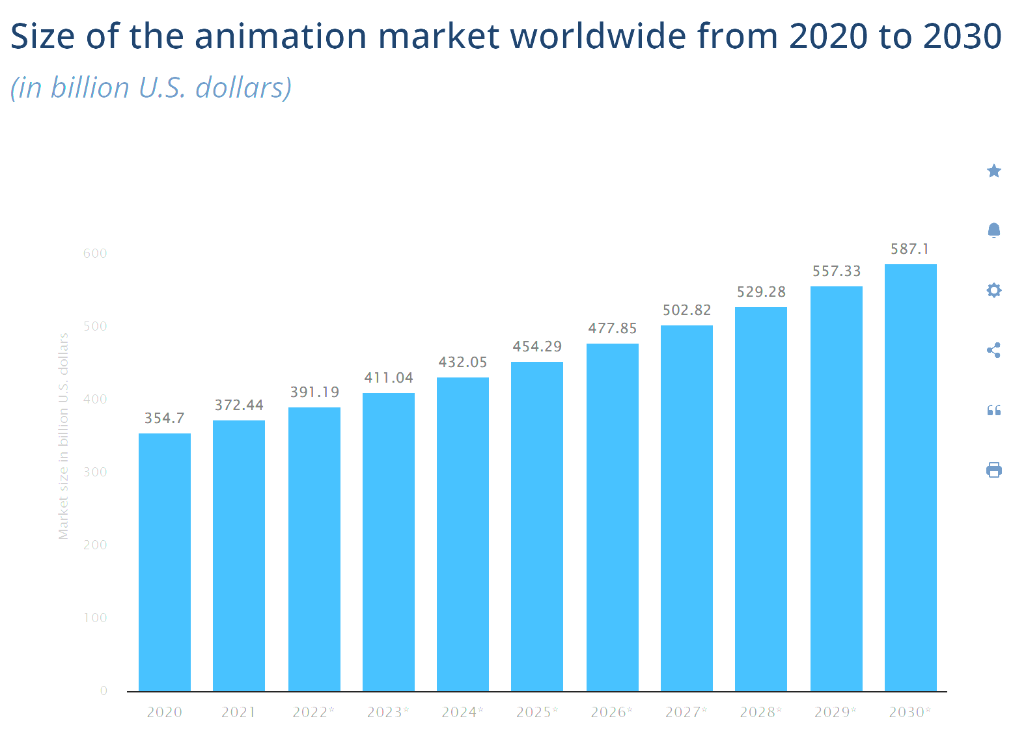
The predominant aim of the Foundation Degree in Digital Arts and Animation for VFX and Virtual Production course is to furnish a coherent yet flexible undergraduate programme of study which will immerse and engage learners in an academically challenging and stimulating educational experience and produce dynamic graduates who are intellectually competent and vocationally prepared to build and develop professional careers in the VFX/VP/Animation industries.
The emphasis is on equipping learners with the ability, skills and knowledge to successfully expand their creativity and develop careers within these sectors. The FD programme is regarded as a natural progression route for students completing the BTEC Level 3 Digital Art for Animation and the Level 3 VFX / Film / Games courses.
The Foundation Degree course will focus on developing knowledge of the field (content) while giving the learners the opportunities to apply their learning in practical contexts (experience) while enhancing their learning through problem solving approaches (challenging and authentic tasks). The learning approaches will consider the diverse backgrounds of learners, nurturing them through Level 4 and 5 while developing them into independent learners and critical divergent thinkers ready for employment or post graduate study (through an inclusive learning environment and activities linked to the overall student experience).
The Foundation Degree programme looks to support the vision of Belfast Met learners by challenging current processes and practices and exploring new concepts. Our learners must be encouraged to adopt a critical approach and challenge conventional thinking about the VFX/VP/Animation sectors.
One such evolving and expanding concept is emerging technology and this is embedded within the overall context of the programme to reflect the ongoing developments. Learners will be encouraged to apply creative thinking, solve problems, address solutions and apply strategies to identify issues.
The teaching and learning strategies have been formulated based on research and professional experience and practice. Teaching and learning are conducted through tutor led lectures and workshops, learner led workshops, seminars, practical sessions (in modern PC Workstation classrooms, our Virtual Production Stage and using our TV Studio, independent research and study, set individual and teamwork tasks, discussions and debates, individual and team presentations and showcases, invited industry and external speakers/stakeholders. Assessment is through a variety of assignment strategies (in various forms such as written, oral, video, observation) and research projects with end products and results. Transferable skills gained include presentation, research and communication and a deeper academic understanding of the requirements of VFX/VP/Animation. Learning will be facilitated in a range of ways such as:
- Interaction with experienced and accomplished lecturers who will contextualise learning relevant to the VFX/VP/Animation industries.
- Experiential industry visits.
- Hands on practical experience with industry standard equipment
- Interaction with a range of external speakers.
- Working alone as a self-motivated and independent learner to accomplish learning tasks and assignments.
- Working as a team member to achieve a range of learning tasks and assignments.
- Taking part in local, national and international competitions.
Learners will have to demonstrate and apply their knowledge and understanding to a range of learning outcomes specific to each learning module providing transferable skills needed for lifelong learning. The learning modules aggregate to fulfil the programme learning outcomes. Learners will be able to graduate from the programme upon the achievement of these outcomes.
Aims
The Foundation Degree in Digital Arts and Animation for VFX and Virtual Production programme aims have been developed with the learner in mind in order to be to:
- Demonstrate knowledge and understanding of a range of topics related to the VFX/VP/Animation industries specialising in content and production.
- Appreciate the importance of both theory and practice for effective results.
- Develop critical thinking in practical and technical skills to encourage creativity and innovation.
- Develop academic writing and thinking skills.
- Stimulate the development of students’ technical and industry skills and apply this to broader business activities and the role of the entrepreneur.
- Apply research methods, analysis and critical interpretation of data collected and use of proper technologies and techniques specific to VFX/VP/animation practices and present in a more constructive and influential manner.
- Partake in Loca, national and international competitions to develop teamwork and industry knowledge.
- Demonstrate a range of transferable employability and lifelong learning skills, including the use of self reflection, self appraisal and independent approaches to learning as reflective practice for continuous professional development and career progression.
- Develop management and business skills relevant to the industry.
- Effectively use a range of communication skills for different purposes, including the effective use of ICT.
- Build confidence in learners presenting and professionally discussing work.
- Utilise enhanced employability skills in developing a career in the VFX/VP/Animation industries.

2.2 Relationship to other programmes and awards

(Where the award is part of a hierarchy of awards/programmes, this section describes the articulation between them, opportunities for progression upon completion of the programme, and arrangements for bridging modules or induction)

Belfast Met is the largest and longest established further and higher education college in Northern Ireland. We offer a broad range of innovative high quality, economically relevant provision. Our modern, award winning estate spans the length and breadth of the city of Belfast. Our Vision is to be a world class college that nurtures the talent and ambition of the City of Belfast and beyond.
Our mission is to make a fundamental impact on the economic and social success of the City of Belfast and beyond by equipping its people, employers and communities with the education and skills for work. Belfast Met has a diverse range of Higher Education (HE) programmes and is committed to excellence in this area in its curriculum strategy. The HE provisions at Belfast Met is at credit Level 4 i.e. Higher National Certificate (HNC), Level 5 Higher National Diploma (HND) and Foundation Degree level. Belfast Met also offers BSc (Hons) and full Honours Degree programmes. These partner programmes are with our prestigious partner Universities like the Open University. Higher Education at Belfast Met is aligned to the Framework for Higher Education Qualifications (FHEQ) of the Quality Assurance Agency (QAA). This Framework is an integral part of quality assurance in HE. Belfast Met uses this framework in its planning, delivery and monitoring of all its HE programmes.

The Foundation Degree seeks to develop a range of intellectual, cognitive, practical and transferable skills. These are introduced across the programme and are developed both between and across each level. The programme has been designed in a way to provide learners with the opportunity to enhance their knowledge and skills at each level and within modules taught at each level. The programme and module design are based on research against similar programmes, benchmarking, the input of industry representatives and the views of students and alumni.
At Level 4 learners will undertake four compulsory modules:
- Production Assets 1
- Production Pipeline 1
- Production Assets 2
- Production Pipeline 2
At level 5 learners will undertake four compulsory modules:
- Production Assets 3
- Production Pipeline 3
- Advanced Production Techniques
- Work Based Learning
Upon successful completion of Level 4 and Level 5 modules, students will have attained the award of Foundation Degree (FD).
The programme will prepare learners to work in many creative industries covering a wide range of jobs within the VFX/VP/Animation sectors.

2.3 For Foundation Degrees, please list where the 60 credit work-related learning takes place. For apprenticeships an articulation of how the work based learning and academic content are organised with the award.
The work-based learning element.
The programme will ensure that the Work based learning (WBL) is relevant and contextualised within the scope of the employer need in this area in order to promote and ensure the availability of a pipeline of talent. WBL will also be structured to support the enhancement of relevant transferable skills needed for employment in this sector. Cognisance will also be given to ensuring the Programme is representing opportunities for employment across small and medium sized enterprises, and self employment.

WBL will be supported to enable learners to take on appropriate role(s) within the workplace, giving them the opportunity to learn and apply the skills and knowledge they have acquired as an integrated element of the course. Whilst WBL will be supported and encouraged through a range of media including part time work, integrated work placements and real work environments, it will be defined clearly within the context where the WBL should lead to the identification and achievement of defined and related learning outcomes for the learner.

The structure of the Foundation Degree in Digital Arts and Animation for VFX and Virtual Production will have at its core, an integrated approach to demonstration of characteristics that include employer involvement; accessibility; articulation and progression, flexibility and partnerships with industry.

The College has a Work Based Learning pack to support students on placements (where applicable). The Work based Project will be college and employer driven and provide the student with the opportunity to apply the knowledge and skills acquired during year one of the programme to undertake a project. Guidance to employers, students and assessors regarding appropriate roles and responsibilities is provided along with documentation templates for the monitoring/assessment process. In cases where a student is an employee of the company, the module may be completed in the student’s workplace or part of it may be designed to include components of their current working activities. The College will follow the Quality Code guidance:
https://www.qaa.ac.uk/en/quality-code/advice-and-guidance/work-based-learning

This is course/module specific.

The College will ensure employer involvement in the monitoring of progress by following the Quality Code, Advice and Guidance Theme ‘Monitoring and Evaluation’
https://www.qaa.ac.uk/en/quality-code/advice-and-guidance/monitoring-and-evaluation

2.4 List of all exit awards

Certificate of Higher Education (Cert HE) upon successful completion of 120 credits at Level 4.
Foundation Degree (FD) upon successful completion of 240 credits at Level 5.

3. Programme structure and learning outcomes
(The structure for any part-time delivery should be presented separately in this section.)

Programme Structure - LEVEL 4
Compulsory modules | Credit points | Optional modules | Credit points | Is module compensatable? | Year/Semester runs in
Production Assets 1 | 40 |  |  | No | 1/1
Production Pipeline 1 | 20 |  |  | Yes | 1/1
Production Assets 2 | 40 |  |  | No | 1/2
Production Pipeline 2 | 20 |  |  | Yes | 1/2

Intended learning outcomes at Level 4 are listed below:

Learning Outcomes – LEVEL 4
3A. Knowledge and understanding
Learning outcomes: | Learning and teaching strategy/ assessment methods
A1 Identify and demonstrate knowledge of some of the theories, concepts and principles of digital content creation for the Screen Production Industries.  A2 Understand and explain the impact of new developments and  their impact on the Screen Production Industries.  A3 Demonstrate some knowledge and understanding of the social, cultural, ethical, environmental and legal issues which underpin best practice in the industry.  A4 Demonstrate knowledge of planning and implementation processes within industry projects. | - Teaching and Learning Methods: Lectures, tutor directed tutorials, supervised practical sessions, student led seminars and use of the College’s Virtual Learning Environment.  - Assessment Methods: Coursework related to assignments, case studies and projects, open book assessments, presentations, practical observation and project reports.

3B. Cognitive skills
Learning outcomes: | Learning and teaching strategy/ assessment methods
B1 Apply some theories, principles, and concepts to situations within the Screen Production Industries.  B2 Apply some management principles and practices.  B3 Apply a range of study skills and research techniques demonstrating the ability to interpret data and undertake independent research.  B4 Recognise issues within the Screen Production Industries. | Learning and Teaching Methods:  Learners are challenged to develop their cognitive skills by developing arguments, strategies and hypotheses based upon their research. They will explore diverse topics and develop a critical analysis of their findings.  Intellectual qualities are developed mainly through lectures, seminars, tutorials, coursework, assignments, experimental work and projects.  Students will be presented with briefs (both live and simulated) that utilises Project Based Learning, a student centred pedagogy.  At Level 4 students, will be introduced to fundamental practices across the industry that they will further build on and analyse at Level 5.  Assessment Methods:  Learners will be assessed on their ability to critique and evaluate research. They will develop their knowledge using independent thinking skills and produce recommendations based upon and justified through supporting literature.  The assessment focuses on the coursework submissions, class tests, end of semester presentations/examinations, essays and project reports. Some of these skills are assessed in formal presentations.  Assessment strategies offer students clear guidance concerning future development. Self reflection and peer evaluation constitute an important part of formative assessment.

3C. Practical and professional skills
Learning outcomes: | Learning and teaching strategy/ assessment methods
C1 Undertake practical activities using technical skills and  procedures whilst working as an individual for specific  production requirements.  C2 Demonstrate practical/professional skills with due regard for safe working practices, procedures, concepts and legislation.  C3 Undertake independent research and effectively communicate findings.  C4 Design, plan and produce content in a variety of industry contexts. | - Teaching and Learning Methods: Lectures, tutor directed tutorials, student led seminars, supervised practical sessions and self directed learning employing and use of the College’s Virtual Learning Environment.  - Assessment Methods: Coursework related to assignments, case studies and projects, written unseen examinations, open book assessments, presentations, practical examination/observation and project reports.  - Application of hardware and software in an industry context.  - Guest speakers/workshops to reflect on industry standards, procedures, best practice and current trends.  - Use of project based module and case studies to build on knowledge and apply theoretical concepts and practical skills to real life situations.

3D. Key/transferable skills
Learning outcomes: | Learning and teaching strategy/ assessment methods
D1 Develop effective written and oral communication and numerical skills including the application of IT.  D2: Use organisation skills (including task, time management and problem solving) both individually and in groups.  D3: Develop the ability to self appraise and reflect on practice in order to improve future performance.  D4: Demonstrate personal and interpersonal skills such as effective planning, organising, time management and teamwork. | Learning and Teaching Methods:  Transferable and fundamental skills are delivered throughout the course, i.e., lectures, coursework assignments. The teaching and learning of ICT skills will be within the course structure. Workshops include demonstrations such as ICT skills, PowerPoint and other I.T. applications, presentations and library research skills. Other learning and teaching methodologies include team teaching, demonstration and peer learning.  Workshops with lecturing staff and visiting professionals will support learners with research, academic writing and referencing throughout the year. Teaching and learning will be contextualised with social, ethical, and legal relevance to the industry. Collaboration and communication techniques will be utilised through all learning and teaching activities, group discussions and simulations, project based learning activities, report writing and blended and virtual learning platforms.  Over the course of the programme, learners are provided with essential information which they must then research, analyse and interpret. Learners will undertake further independent reading to broaden the understanding of specific problems and design principles. This is designed to stretch and challenge learners and develop their ability at Level 4 as preparation for Level 5. Creative thinking and critical analysis are engendered in every aspect of the programme and will be further fostered and encouraged through lecturer mentoring weekly. Discussion and critiques support the development of problem resolution at a higher intellectual level.  Assessment Methods:  Learners will develop subject knowledge from data examination and enhance their understanding of assessments. Throughout the programme learners will develop digital literacy by completing assessments and presentations using suitable methods.  The testing of learner knowledge is principally through coursework assignments, reports, online assessment, experimental reports and class tests. Assessment of teamwork is through submission of teamwork tasks, student/peer and self assessment and oral presentations.  Assessment strategies offer students clear guidance regarding future development. Self reflection and peer evaluation constitute an essential part of formative assessment.

Exit Award: Certificate in Higher Education in Digital Arts and Animation for VFX and Virtual production (Cert HE)

Programme Structure - LEVEL 5
Compulsory modules | Credit points | Optional modules | Credit points | Is module compensatable? | Semester runs in
Production Assets 3 | 30 |  |  | No | 2/1
Production Pipeline 3 | 20 |  |  | Yes | 2/1
Advanced Production Techniques | 30 |  |  | No | 2/2
Work Based Learning | 40 |  |  | No | 2/1, 2/2

Intended learning outcomes at Level 5 are listed below:

Learning Outcomes – LEVEL 5
3A. Knowledge and understanding
Learning outcomes: | Learning and teaching strategy/ assessment methods
A1 Evaluate theories, concepts and principles of digital content creation for the Screen Production Industries.  A2: Be able to apply the processes and procedures for effective planning and skill acquisition within a digital production context.  A3: Demonstrate detailed knowledge of content creation within digital production pipelines and processes.  A4: Develop digital working practises using a range of practical and managerial skills, integrating knowledge and techniques required for a specific production pipeline. | - Teaching and Learning Methods: Lectures, tutor directed tutorials, supervised practical sessions, student led seminars and use of the College’s Virtual Learning Environment.  - Assessment Methods: Coursework related to assignments, case studies and projects, written unseen examinations, open book assessments, presentations, practical examination/observation and project reports.

3B. Cognitive skills
Learning outcomes: | Learning and teaching strategy/ assessment methods
B1: Exercise critical thinking in the analysis of a range of appropriate theories, principles and concepts to situations within the digital production pipeline.  B2: Develop the ability to provide reasoned analysis of current practices in the sector in order to initiate improvement.  B3: Locate, extract and analyse data from multiple sources, including the appropriate acknowledgement and referencing of sources.  B4: Develop the ability to critically assess and reflect on own performance and peer feedback, providing constructive feedback where needed. | Learning and Teaching Methods:  These intellectual cognitive skills are developed through lectures, seminars, tutorials or practical based activities, independent project work and work based learning activities.  As with Level 4, students will be presented with briefs; however, at Level 5, project based Learning will move to more complex industry defined problems, forcing the students to develop their critical thinking, creativity and communication skills.  At Level 5, WBL will guide the students to develop more critical awareness, enabling students to formulate ideas and confidently research and experiment to strengthen their outcomes.  Assessment Methods:  The formative and summative assessment focuses on coursework submissions, essays and project reports. Other assessment evidence may be generated using Log Books / Diary / Digital Diary, Reflective Journals, A/V evidence and completed products.  Assessment strategies offer students clear guidance regarding future development. Self reflection and peer evaluation constitute an important part of formative assessment.  Where students solve real life problems, cognitive skills are assessed via pitching and presenting ideas and peer feedback.

3C. Practical and professional skills
Learning outcomes: | Learning and teaching strategy/ assessment methods
C1: Plan, design and execute practical activities using techniques  and procedures appropriate to the digital screen production  industry pipeline.  C2: Demonstrate practical/professional skills within a team setting - adapting and developing new skills and workflows for a digital production pipeline.  C3: Plan, design and create assets using appropriate media and digital formats.  C4: Employ creative solutions to complete and industry relevant production. Using industry techniques and production workflows. | - Teaching and Learning Methods: Lectures, tutor directed tutorials, student led seminars, supervised practical sessions and self directed learning employing study packs and use of the College’s Virtual Learning Environment.  - Assessment Methods: Coursework related to assignments, case studies and projects, written unseen examinations, open book assessments, presentations, practical examination/observation and project reports.  - Application and use of online virtual labs that enable students to construct real life scenarios to experiment and test out practical approaches to simulate remote working practises.  - Site visits to organisations and companies to reflect on industry standards, procedures, best practice and current trends.  - Use of project based modules and case studies to build on knowledge and apply theoretical concepts and practical skills to real life situations.

3D. Key/transferable skills
Learning outcomes: | Learning and teaching strategy/ assessment methods
D1: Identify key problem areas and choose appropriate tools and methods, applying numeracy and literacy skills, information and data analysis for appropriate solutions.  D2: Interact effectively within a team, giving and receiving information and ideas and modifying response where appropriate, to develop professional working relationships and effective production workflows.  D3: Demonstrate personal and interpersonal skills such as the effective planning, organising, management of and responsibility for contributing to the bringing of projects to completion on time either independently or as a team member.  D4: Evaluate own strengths and weaknesses, challenge received opinion and develop own criteria and judgement. | Learning and Teaching Methods:  Key/transferable skills will be developed through lectures, seminars, and tutorials. This also includes ICT skills, information management, library research skills and preparation for placement activities. All transferable skills apply to theoretical disciplines, practical and work based activities. Other learning and teaching methodologies include team teaching, demonstration and peer learning.  Learners will be provided with key information which they will research, analyse and interpret, then seek out further reading where they must independently broaden their understanding of specific problems and creative design principles. The fundamental design of the programme is to stretch learners, develop their skills at Level 5 as preparation for Level 6.  Work Based Learning at Level 5 enables students to work in industry (or simulated) contexts, driving them to become effective in their time management, taking responsibility for their work and managing working with others in a professional environment.  Creative thinking and critical analysis are applied to all aspects of the programme and will be further fostered and encouraged through lecturer mentoring weekly. Discussion and critiques support the development of problem resolution at a higher intellectual level. At Level 5, students are encouraged to develop their self reflection and set targets with the tutor, reflecting on feedback and responding to this.  Assessment Methods:  Formative and summative assessments will be shown through coursework submissions, essays and project reports. Other assessment evidence may be generated using Log Books / Diary / Digital Diary, Reflective Journals, A/V evidence and completed products, peer and supervisory review/evaluation.

4. Distinctive features of the programme structure
- Where applicable, this section provides details on distinctive features such as:
- where in the structure above a professional/placement year fits in and how it may affect progression
- any restrictions regarding the availability of elective modules
- where in the programme structure students must make a choice of pathway/route
- Additional considerations for apprenticeships:
- how the delivery of the academic award fits in with the wider apprenticeship
- the integration of the ‘on the job’ and ‘off the job’ training
- how the academic award fits within the assessment of the apprenticeship

This programme will facilitate the opportunity for successful progression from Level 3 Visual Effects, Games Development, IT, Film, Art or animation. The FD Programme is subject to prominent levels of employer engagement in areas such as curriculum and module design. Employer engagement will be encouraged throughout the programme in curriculum development, evaluation and self sourced placements on an ongoing basis. The course programme is designed to provide a high quality academic experience for students and enables student achievement and reliable assessment.
This programme of study will offer clear routes that facilitate opportunities for successful progression from relevant BTEC and A Level qualifications.
Learners will engage and develop skills for personal and professional development. This is embedded throughout the programme modules and the Work Based Learning module (WBL) in semester 1 of year 2.
Personal development planning is embedded into tutorial sessions, whereby learners will engage in activities to allow them to complete their course and progress into employment or level 6 education. This includes career planning, job searching, applications and interview techniques.
Access to a strong teaching team with a range of industry experience, academic and professional qualifications supporting high quality teaching and learning. Continuing professional development of staff responsible for learning and teaching is paramount to the ongoing progression of students. The College is committed to continuous staff training through staff contracts, the lecturers into industry initiative, training needs and staff development seminars. The College’s online learning platform is used extensively to deliver and support learning.

Learners will have the opportunity to engage in research in areas of their choice. The added value of such an approach is to ensure the relevance of the programme requirements to the VFX/VP/Animation industries. Side by side with the academic development of learners, the programme looks to develop the learner’s key skills profile. The importance of such personal, transferable skills in graduates is widely recognised.

5. Support for students and their learning.
(For apprenticeships this should include details of how student learning is supported in the work place)

The department for Learner Success sits alongside the five curriculum schools and the department for Curriculum Operations and Planning Services (COPS) as part of the remit of the Director of Curriculum.

The Department’s primary role is to enable learners to succeed at Belfast Metropolitan College. This is done by providing effective operational and support services via our Student Services teams and our Student Support teams.

The Student Services function is made up of the Admissions, Examinations Services and Library and Information Services teams.

The Student Support function is made up of the Careers and Employability, Inclusive Learning, Student Funding, Students’ Union and Student Wellbeing teams.
As well as supporting our students, the Department also provides related support to staff throughout the College.

The College offers a wide range of student support services. These include:

· The Careers and Employability service.
· The Inclusive Learning service.
· The Student Finance Service.
· Students’ Union.
· The Faith Room.
· Centre for Student Wellbeing.
· Safeguarding Services; and
· Administration Services.

Further details can be accessed through the College website and the College Student Activities and Advice section on Canvas (VLE).

College Student Activities and Advice notifications are also displayed at Campus reception and in the Student Union in every campus.

As part of a NI College Approach, BMC has invested and rolled out EBS as a data and performance dashboard; this is a software tool which consolidates relevant data from multiple sources into a single application and presents data through graphics and dashboards. The system is now firmly embedded to ensure the availability of data right down to team level to aid quality improvement, to improve data and its reporting across the College and underpin the performance review process. Live student attendance reports are available to be able to identify students at risk and trigger support interventions as well as course retention, achievement and success rates.

These approaches to evaluate performance, support and monitor learners have substantially contributed to the sustained year on year sustainability in college’s student success rates.

The College has a Work Based Learning pack to support students on placements (where applicable). The Work based Project will be college and employer driven and provide the student with the opportunity to apply the knowledge and skills acquired during year one of the programme to undertake a project. Guidance to employers, students and assessors regarding appropriate roles and responsibilities is provided along with documentation templates for the monitoring/assessment process. In cases where a student is an employee of the company, the module may be completed in the student’s workplace or part of it may be designed to include components of their current working activities. The College will follow the Quality Code guidance:
https://www.qaa.ac.uk/en/quality-code/advice-and-guidance/work-based-learning

This is course/module specific.

The College will ensure employer involvement in the monitoring of progress by following the Quality Code, Advice and Guidance Theme ‘Monitoring and Evaluation’
https://www.qaa.ac.uk/en/quality-code/advice-and-guidance/monitoring-and-evaluation

In addition, Higher Level Apprentices will have a college mentor who will liaise with their workplace mentor to monitor progress and to offer support.

6. Criteria for admission
(For apprenticeships this should include details of how the criteria will be used with employers who will be recruiting apprentices.)

Students who wish to gain admission to first year of the Foundation Degree.
Applicants must have reached the age of 18 years on admission.

GCSE English & Maths Grade C or equivalent

64 UCAS points has been set for this programme of study and is reflective of the number of UCAS points required for similar Level 5 programmes across the 6 colleges within the FE Sector in Northern Ireland. This will also allow the programme to competitively position itself alongside other programmes offered by both Queens University and Ulster University also located in the city of Belfast.

Applicants who do not hold any formal Level 3/4 qualifications but hold significant and relevant Industrial experience may gain admission through experiential learning and should request the College APEL procedure.

Students may gain admission through Recognised Prior Learning.
RPL is the process by which the College can identify, assess and certify an applicant’s past educational and vocational achievements. Applicants wishing to be considered for APL for a particular program for the purpose of admission or credit must bring this to the attention of the course director at the application and interview stage.
APEL is where applicants can gain admission to a program based on their experiential learning. At the application stage applicants should inform the admissions staff and the relevant course director of their intention to apply for APEL. APEL can only be used for admission purposes and not to gain credit or exemptions.

International Students
An international student is defined as a student who requires a Tier 4 (student) visa to study in the UK. Such applicants may or may not be living overseas at the time of making their course application. International applicants should apply via the usual route for full time undergraduates, All International students must meet the College general entry requirements and academic qualifications requirements of the course. In addition, International students must have the required level of English Language IELTS academic 6.0.
All international qualifications will be checked for academic comparability using the online UKNaric qualifications database. The Admissions team has access to UKNaric training materials and guidance on the evaluation and verification of international qualifications.

7. Language of study

English only.

8. Information about non-OU standard assessment regulations (including PSRB requirements)

Modules will be assessed by a mix of continuous assessment, coursework and group work. Within the Work based learning module there will be a final year project that will be assessed through a portfolio of evidence based on their work placement experience. This module will be 40 credits.

In each module students will be required to complete a number of coursework assignments. Assignments will assess knowledge and understanding; cognitive skills; practical and professional skills and key/transferable skills.

The Foundation Degree in Digital Arts and Animation for VFX and Virtual Production is a mixture of coursework, practical exercises and group work. The aims and learning outcomes of the programmes are achieved through the application of a variety of learning and teaching methods across the modules. The range of modules allows a varied and interesting mix of methods to be used to enhance knowledge and understanding as well as allowing students to practice and develop their professional and transferable skills. A variety of teaching methods and learning environments are utilised within the programme to provide an optimal framework for study, the development of skills and expertise, the production of coursework, work ready skills and preparations for examinations. Assessment is provided in both formative and summative formats.

Students’ experiences on their course should be such as to meet the aims of the course in developing their facility for critical thinking, problem solving, professional attitudes and the capacity for sustained independent work.

In each taught module the relative weighting assigned to all assessment constructs is specified. Assignments will take the form of case studies, practical activities and/or research, video records and observations.

Staff members provide prompt and detailed feedback to all students within 15 working days. The Course Director and Team currently monitor the assessment burden on students in each year and take action where necessary. The staggering of submissions is considered essential in determining student workload is as balanced as possible throughout the semester. It is also hoped that the indirect impact of which is that marking and feedback workload for the teaching is also addressed in increments.

Assessment strategies will be closely related to the aims and learning outcomes of individual modules, but similar types of strategies are assessed and given feedback by standard methods to promote consistency across modules. Central to any assessment strategy is the need to assess whether learning outcomes have been met by candidates in relation to not only the course aims and objectives but also as a form of feedback to students in terms of their learning progression. It is in furthering this clarity that feedback sheets (included in the assessment details and brief), contain a marking scheme with detailed reference to the learning outcomes also stated on the Cover Sheets.

Students will be provided with comprehensive information at the start of each module detailing assessment schedules throughout. Individual Assessment Specifications clearly articulate requirements (including submission and return deadlines) and a marking scheme will be provided.

A comprehensive range of assessment strategies will be employed by the course team, involving both individual and group work. These are essential to assess students’ skills of report writing and incorporates the understanding and development of academic skills in helping students to appreciate a range of presentation media and appreciate where and how best to apply these media. Coursework is also a vehicle with which to allow students to illustrate academic rigour in research and referencing. Students are made aware of the concepts of intellectual property and plagiarism. Coursework can be presented in a variety of assessment methods such as:
- Group Based work
- Time Constrained Practical Exercises
- Project Reports
- Observations
- Portfolios of evidence
- Recordings
All coursework material is both internally and externally moderated prior to it being made accessible to students. Also following its marking, cross marking is generally accepted as essential before summative feedback is delivered to the students to ensure adequate validity, reliability and fairness.

Innovative approaches are used in the assessment process, including observations, practical exercises, case studies, podcasts, broadcasting and Live Streaming, etc. In some units the assessment involves group activity.

The following outlines those regulations specific to the programme:
- Pass mark for the module shall be 40%. Where a module is assessed by a combination of coursework and examination a minimum mark of 35% shall be achieved in each element.
- Modules have the ability to use compensation

Summary of assessment requirements
The Programme adopts in full the Awarding Body Academic Principles and Regulations. Students will be provided with a copy of the Student Assessment Regulations at the point of registration for their programme.

Internal Verification/External Verification

- Internal Verification of Assessment
In Belfast Metropolitan College, Internal Verification is one of the key Quality Assurance processes used to ensure consistency, transparency, validity and reliability of assessment design, grading and marking. All assessed work submitted will be sampled by an internally allocated verifier in accordance with College’s standard Operating Procedures, with no confirmation of criteria achieved reported to students until this has been completed.

Internal Verification Process

In line with Open University Handbook for validated awards and Open University regulations:
OU Handbook for Validated Awards | Validation Partnerships (open.ac.uk)

OU Validation Regulations Single Awards (belfastmet.ac.uk)

Each module has an identified Internal Verifier.

The process at level 4-7 is monitored and overseen by External Examiners

The College employs a three tier system of internal assessment quality control which includes:
- Assessment validation carried out by module Internal Verifier.
- Internal verification of assessment decisions by module Internal Verifier; and
- Assessment sampling by External Examiners.

Every student will have their assessed work, including the assessment decision sampled at some stage during the programme; Belfast Met considers assessment validation and internal verification of assessment decisions to be the cornerstones of the assessment Quality Assurance process. All assessment briefs are validated by an Internal Verifier prior to use and a sample of ALL assessments submitted will have the assessment decisions internally verified, prior to feedback to the students.

- External Examination / Verification
The programme is externally verified by an External Examiner (EE) appointed by the Open University. This will be a subject specialist who will ensure that the student work meets the Academic Standard. This external appointee will visit annually to carry out this verification.

Assessment Principles
The Programme adopts in full the Awarding Body Academic Principles and Regulations. Students will be directed to the location of the Student Assessment Regulations at the point of registration for their programme.

9. For apprenticeships in England End Point Assessment (EPA).
(Summary of the approved assessment plan and how the academic award fits within this and the EPA)
Not Applicable.

10. Methods for evaluating and improving the quality and standards of teaching and learning.
The Programme is managed and operated in accordance with College and Open University regulations and procedures. This will include representation and input from employers who will contribute to curriculum development and review. Reports will be made to the College’s Quality Department (and the Awarding Body) which will take appropriate action including reviews and audits to continually enhance the programme.

College standard mechanisms for review and evaluation of teaching, learning and assessment of the curriculum and outcome standards include: -
- Formal cycle of student engagement and feedback to include Module Evaluations, Course Evaluations and Staff Student Consultative Committees.
- Annual Programme Review.
- External Examiners visits.
- College internal quality assurance arrangements including internal auditing of programme management.
- External quality assurance arrangements.
- Staff Appraisal; and
- Staff development including scholarly activity.

The committees with responsibility for monitoring, evaluating, and improving quality include
- Internally
  - The Centre for Curriculum Quality Assurance and Performance Development.
  - HE Coordinators Forum.
  - HE Quality Forum.
  - Monthly Performance review Process; and
  - Management through the Appraisal Process.
- Externally
  - External Examiners; and
  - The Quality Assurance Agency.

Mechanisms for gaining student feedback on the quality of their learning experience include: -
- Formal cycle of student engagement and feedback to include Module Evaluations, Course Evaluations and Staff Student Consultative Committees.
- Weekly personal tutor review of student progress/e-ILP (Individual Learning Plan); and
Supervised Work based learning visits and reports – where applicable

10. Changes made to the programme since last (re)validation
Not applicable

Annexe 1: Curriculum map
Annexe 2: Curriculum mapping against the apprenticeship standard or framework (delete if not required.)
Annexe 3: Notes on completing the OU programme specification template
Annexe 1 - Curriculum map A5, A6, B5 B6, B7, B8, C5, C6, C7, C8, D5, D6, D7 NOT APPLICABLE
This table indicates which study units assume responsibility for delivering (shaded) and assessing (✔) particular programme learning outcomes.
 |  | Programme outcomes
Level | Study module/unit | A1 | A2 | A3 | A4 | A5 | A6 | A7 | A8 | B1 | B2 | B3 | B4 | B5 | B6 | B7 | B8 | C1 | C2 | C3 | C4 | C5 | C6 | C7 | C8 | D1 | D2 | D3 | D4 | D5 | D6 | D7
4 | Production Assets 1 |  | x | x |  |  |  |  |  | x | x |  |  |  |  |  |  | x |  |  | x |  |  |  |  | x |  |  | x
 | Production Pipeline 1 | x |  |  | x |  |  |  |  |  | x | x | x |  |  |  |  |  | x | x |  |  |  |  |  |  | x | x
 | Production Assets 2 |  | x | x |  |  |  |  |  | x | x |  |  |  |  |  |  | X |  |  | X |  |  |  |  | X |  |  | X
 | Production Pipeline 2 | x |  |  | x |  |  |  |  |  | X | X | X |  |  |  |  |  | X | X |  |  |  |  |  |  | X | X

 |  | Programme outcomes
Level | Study module/unit | A1 | A2 | A3 | A4 | A5 | A6 | A7 | A8 | B1 | B2 | B3 | B4 | B5 | B6 | B7 | B8 | C1 | C2 | C3 | C4 | C5 | C6 | C7 | C8 | D1 | D2 | D3 | D4 | D5 | D6 | D7
5 | Production Assets 3 |  | X | X |  |  |  |  |  | X | X | X |  |  |  |  |  | X | X | X |  |  |  |  |  | X |  |  | X
 | Production Pipeline 3 | X |  |  | X |  |  |  |  | X |  | X | X |  |  |  |  |  | X |  | X |  |  |  |  |  | X | X
 | Advanced Production Techniques |  | X | X |  |  |  |  |  | X | X | X |  |  |  |  |  | X | X | X |  |  |  |  |  | X |  |  | X
 | Work Based Learning | X |  | X | X |  |  |  |  | X |  | X | X |  |  |  |  | X | X | X | X |  |  |  |  |  | X | X | X

Annexe 3 - Curriculum mapping against the apprenticeship standard
This table indicates which study units assume responsibility for delivering (shaded) and assessing (✔) particular knowledge, skills and behaviours.
Please amend this mapping to suit Frameworks used within the different Nations if appropriate.
 |  | Apprenticeship standard
Level | Study module/unit | K1 | K2 | K3 | K4 | K5 | K6 | K7 | K8 | S1 | S2 | S3 | S4 | S5 | S6 | S7 | S8 | B1 | B2 | B3 | B4 | B5 | B6 | B7 | B8
4

 |  | Apprenticeship standard
Level | Study module/unit | K1 | K2 | K3 | K4 | K5 | K6 | K7 | K8 | S1 | S2 | S3 | S4 | S5 | S6 | S7 | S8 | B1 | B2 | B3 | B4 | B5 | B6 | B7 | B8
5

Annexe 2: Notes on completing programme specification templates

1 - This programme specification should be mapped against the learning outcomes detailed in module specifications.

2 – The expectations regarding student achievement and attributes described by the learning outcome in section 3 must be appropriate to the level of the award within the QAA frameworks for HE qualifications: http://www.qaa.ac.uk/AssuringStandardsAndQuality/Pages/default.aspx

3 – Learning outcomes must also reflect the detailed statements of graduate attributes set out in QAA subject benchmark statements that are relevant to the programme/award: http://www.qaa.ac.uk/AssuringStandardsAndQuality/subject-guidance/Pages/Subject-benchmark-statements.aspx

4 – In section 3, the learning and teaching methods deployed should enable the achievement of the full range of intended learning outcomes. Similarly, the choice of assessment methods in section 3 should enable students to demonstrate the achievement of related learning outcomes. Overall, assessment should cover the full range of learning outcomes.

5 - Where the programme contains validated exit awards (e.g. CertHE, DipHE, PGDip), learning outcomes must be clearly specified for each award.

6 - For programmes with distinctive study routes or pathways the specific rationale and learning outcomes for each route must be provided.

7 – Validated programmes delivered in languages other then English must have programme specifications both in English and the language of delivery.

