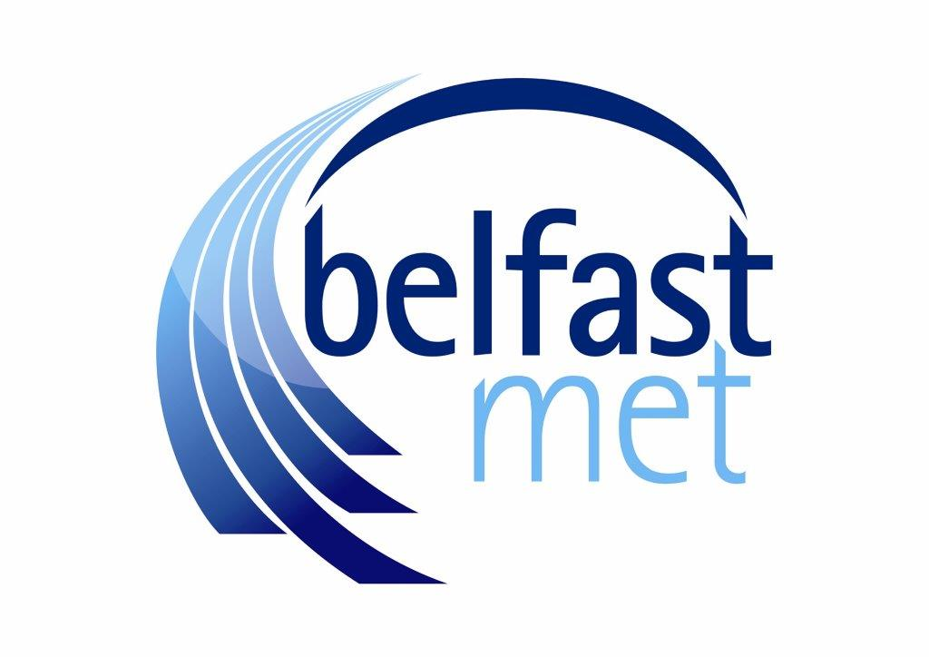
Belfast Metropolitan College

SCREENING FORM

Background

Under Section 75 of the Northern Ireland Act 1998, the FE Sector is required to have due regard to the need to promote equality of opportunity:
- between persons of different religious belief, political opinion, racial group, age, marital status or sexual orientation;
- between men and women generally;
- between persons with a disability and persons without; and,
- between persons with dependants and persons without.

Without prejudice to the obligations set out above, the FE Sector is also required to have regard to the desirability of promoting good relations between persons of different religious belief, political opinion or racial group.

Belfast Metropolitan College’s (Belfast Met) 2nd Generation Equality Scheme was approved by the Equality Commission in January 2012. The College is committed to equality screening all policy decisions.

Screening

The College uses the tools of screening and equality impact assessment to assess the likely impact of a policy on the promotion of equality of opportunity and good relations.

The screening procedure should lead to one of two conclusions:

- The policy being screened does not have a significant impact on equality of opportunity and therefore does not require an Equality Impact Assessment (EQIA)
- The policy being screened has (or is likely to have) a significant impact on equality of opportunity and will require an EQIA.

Mitigation – Where an assessment (screening in this case) reveals that a particular policy has an adverse impact (or is likely to have an adverse impact) on equality of opportunity and good relations, a public authority must consider ways of delivering the policy outcomes which have a less adverse effect on the relevant Section 75 categories.

Policy Title | Policy on Smoking in Belfast Met subsequently  Non-Smoking/Vaping Policy (May 2021)
Screening Date | April 2018 and reviewed May 2021 following a change to the policy scope
Screening outcome (to be inserted after the completion of this form) | Screened Out
Date submitted to the Equality and Good Relations officer

Rescreened following review of policy: April 2018

1.0 Information about the policy
The Colleges of Further and Higher Education in Northern Ireland are committed to providing the highest quality of service to all our customers. If a customer is not satisfied with the quality of service provided they have the right to complain.

Aim and Description of the policy
As part of the continuous review of health and safety the College has considered the current evidence of the health risks associated with passive smoking, as well as the discomfort suffered by non-smokers exposed to tobacco smoke and smoke from electronic cigarettes, also known as e-cigarettes, e-cigs, vaporisers and vapes. Since Monday 30th April 2007 it has been an offence to smoke tobacco in any of the College buildings, smoke free zones and vehicles.

The aim of the Non Smoking Policy is to guarantee the right of non-smokers to breathe smoke-free air, whilst also taking into account the needs of those who smoke. The policy is not concerned with whether people smoke, but where they smoke whilst at work and in public places.

Who owns and who implements the policy?

Estate and FM

1.1 Implementation factors

a) What are the factors that would detract from the achievement of the aims of the Policy?

Are they:-
 | Financial
 | Legislation
x | Communication
 | Staff Development
X | Consistent approach
 | Other – please specify:- failure to ensure the policy is adhered to.
b) | What action is necessary to ensure that the aims/outcomes of the policy are met?  The policy is supported consistently by management across the College to ensure it is implemented in all designated workplaces.

1.2 Main stakeholders affected

Who are the internal and external stakeholders (actual or potential) that the policy will impact upon and who need to be consulted with as part of the equality consultation.

X | Governing Body
X | Managers/staff
X | Voluntary/Community/Trade Unions
X | Students/service users
X | Members of the public
x | Third Party Stakeholders
 | other, please specify:-

Detail any consultation that has taken place with stakeholders.

None

1.3 Other college policies that relate to this policy

Policies and other College documents:- | College/Sector
Student and Staff Disciplinary policies  Health and Safety Policy | College level

1.4 Available evidence

Evidence to help inform the screening process may take many forms. Colleges should ensure that their screening decision is informed by relevant data. This can be obtained from MIS (quantitative data) or evidential/qualitative data (surveys, reports, conversations etc).

What evidence/information (both qualitative and quantitative) have you gathered to inform this policy? Specify details below.

The Colleges have developed this policy to ensure:

That the College complies with its legal and regulatory obligations in the management of its Health and Safety. And complies with relevant legislation.

At the point of screening there is no data available that can add to the screening of this policy.

1.5 Needs, experiences and priorities

Taking into account the information referred to above, what considerations are essential to ensure those in the following categories can achieve fair participation in relation to this policy, and how does the College promote equality on the basis of each category?

(considerations may include access to courses (e.g. those with caring responsibility – action could be timetabling courses at different times, provision of crèche facilities, distance learning, use of Blackboard and technology); Some faith groups need prayer time which may fall during a lesson – Action to promote equality is to ensue Attendance policy incorporates permission for approved absences for students).

Section 75 category | Details of needs/experiences/priorities
 | Consideration* | Actions to promote equality**
Religious belief  Political opinion  Racial group  Age  Marital status  Sexual orientation  Men and women generally  Disability  Dependants | As the policy applies to, and impacts on, all section 75 categories in a fair and consistent manner no qualitative and quantitative evidence has been gathered to inform this policy. | n/a

Part 2

Introduction

Having collated relevant information in relation to Part 1, it is now necessary to use this information when making a decision as to whether or not there is a need to carry out an equality impact assessment.

In assessing the questions in Section 2 it will be necessary to determine the impact of the policy in respect of Section 75.

If the college’s conclusion is that there is a major in respect of one or more of the Section 75 equality of opportunity and/or good relations categories, then consideration should be given to subjecting the policy to the equality impact assessment procedure.

If the college’s conclusion is that there is a minor in respect of one or more of the Section 75 equality categories and/or good relations categories, then consideration should still be given to proceeding with an equality impact assessment, or to:

- measures to mitigate the adverse impact; or
- the introduction of an alternative policy to better promote equality of opportunity and/or good relations.

If the college’s conclusion is that there is no impact, i.e. none in respect of all of the Section 75 equality of opportunity and/or good relations categories, then the College may decide to screen the policy out. If a policy is “screened out” as having no relevance to equality of opportunity or good relations, the College should give details of the reasons for the decision taken.

In favour of a ‘major’ impact

- The policy is significant in terms of its strategic importance;
- Potential equality impacts are unknown, because, for example, there is insufficient data upon which to make an assessment or because they are complex, and it would be appropriate to conduct an equality impact assessment in order to better assess them;
- Potential equality and/or good relations impacts are likely to be adverse or are likely to be experienced disproportionately by groups of people including those who are marginalised or disadvantaged;
- Further assessment offers a valuable way to examine the evidence and develop recommendations in respect of a policy about which there are concerns amongst affected individuals and representative groups, for example in respect of multiple identities (i.e. more than one equality category is impacted);
- The policy is likely to be challenged by way of judicial review;
- The policy is significant in terms of expenditure.

In favour of ‘minor’ impact

- The policy is not unlawfully discriminatory and any residual potential impacts on people are judged to be negligible;
- The policy, or certain proposals within it, are potentially unlawfully discriminatory, but this possibility can readily and easily be eliminated by making appropriate changes to the policy or by adopting appropriate mitigating measures;
- Any asymmetrical equality impacts caused by the policy are intentional because they are specifically designed to promote equality of opportunity for particular groups of disadvantaged people;
- By amending the policy there are better opportunities to better promote equality of opportunity and/or good relations.

In favour of none

- The policy has no relevance to equality of opportunity or good relations.
- The policy is purely technical in nature and will have no bearing in terms of its likely impact on equality of opportunity or good relations for people within the equality and good relations categories.

Taking into account the evidence presented above, consider and comment on the likely impact on equality of opportunity and good relations for those affected by this policy, in any way, for each of the equality and good relations categories, by applying the screening questions given overleaf and indicate the level of impact on the group i.e. minor, major or none.

2.0 Screening questions

1 What is the likely impact on equality of opportunity for those affected by this policy, for each of the Section 75 equality categories? (major/ minor/ none)
Section 75 category | Details of policy impact | Level of impact? major/minor/none
Religious belief  Political opinion  Racial group  Age  Marital status  Sexual orientation  Men and women generally  Disability  Dependants | The purpose of this policy is to protect the health and safety of those who work, study or visit college premises. Consequently, the policy aimed at having a positive impact on all groups. There is no evidence to suggest that any particular group will be more disadvantaged by this policy. | No adverse impact

2 Are there opportunities to better promote equality of opportunity for people within the Section 75 equalities categories?
Section 75 category | If Yes, provide details | If No, provide reasons
Religious belief  Political opinion  Racial group  Age  Marital status  Sexual orientation  Men and women generally  Disability  Dependants | None  None  None  None  None  None  None  None  None | No

3 To what extent is the policy likely to impact on good relations between people of different religious belief, political opinion or racial group? minor/major/none
Good relations category | Details of policy impact | Level of impact major/minor/none
Religious belief  Political opinion  Racial group | There is no likely impact on good relations between people of different religious belief, political opinion or racial group. | None

4 Are there opportunities to better promote good relations between people of different religious belief, political opinion or racial group?
Good relations category | If Yes, provide details | If No, provide reasons
Religious belief  Political opinion  Racial group |  | No, the scope of the policy does not offer the opportunity to promote good relations between groups

Part 3

3.0 Screening decision

Option 1  (no impact) | If the decision is not to conduct an equality impact assessment, please provide details of the reasons. | There are no adverse impacts on any of the s75 categories. This policy is designed to protect the health and safety of those who work, study and visit Belfast Met campuses.
Option 2  (minor impact) | If the decision is not to conduct an equality impact assessment the public authority should consider if the policy should be mitigated or an alternative policy be introduced.
Option 3  (major impact) | If the decision is to subject the policy to an equality impact assessment, please provide details of the reasons.

If Option 1 is identified proceed to Part 4 of the form.

If Option 2 is identified proceed to 3.1 Mitigation (minor impact).

If Option 3 is identified proceed to 3.2 EQIA - Timetabling and prioritising

3.1 Mitigation (minor impact)

When the college concludes that the likely impact is ‘minor’ and an equality impact assessment is not to be conducted, the college may consider mitigation to lessen the severity of any negative equality impact, or the introduction of an alternative policy to better promote equality of opportunity or good relations.

Can the policy/decision be amended or changed or an alternative policy introduced to better promote equality of opportunity and/or good relations?

No

If yes, give the reasons to support your decision, together with the proposed changes/amendments or alternative policy.
The actions to be taken forward to mitigate the impact of this policy decision are as follows:-

3.2 EQIA - Timetabling and prioritising

An EQIA is a mechanism, where existing and proposed policies are assessed in order to determine whether they have an adverse impact on equality of opportunity for the relevant Section 75 categories EQIA’s require the analysis of both quantitative and qualitative data.

Factors to be considered in timetabling and prioritising policies for equality impact assessment.

If the policy has been ‘screened in’ for equality impact assessment, then please answer the following questions to determine its priority for timetabling the equality impact assessment.

On a scale of 1-3, with 1 being the lowest priority and 3 being the highest, assess the policy in terms of its priority for equality impact assessment.

Priority criterion | Rating (1-3)
Effect on equality of opportunity and good relations
Social need
Effect on people’s daily lives

Relevance to a public authority’s functions

Note: The Total Rating Score should be used to prioritise the policy in rank order with other policies screened in for equality impact assessment. This list of priorities will assist the public authority in timetabling. Details of the Public Authority’s Equality Impact Assessment Timetable should be included in the quarterly Screening Report.

Is the policy affected by timetables established by other relevant public authorities?

If yes, please provide details

Part 4

4.1 Monitoring

Equality monitoring is a legal obligation under our Equality Scheme. Equality monitoring is more than data collection, it is also about analysing information that is relevant to, and necessary for, promoting equality of opportunity and good relations. Monitoring is an ongoing process, the objective of which is to highlight possible inequalities and why these might be occurring. Monitoring will allow the college demonstrate that its services are accessible to all sections in the community and how it has adapted services to better meet the needs of specific users and community groups thereby widening participation.

More detailed guidance can be provided by the Equality and Good Relations Officer tbc@belfastmet.ac.uk/ 90265455 or through the Equality Commissions’ Monitoring Guidance http://www.equalityni.org/archive/pdf/S75MonitoringGuidance0707.pdf.

The College should consider the guidance contained in the Commission’s Monitoring Guidance for Use by Public Authorities (July 2007).

The Commission recommends that where the policy has been amended or an alternative policy introduced, the public authority should monitor more broadly than for adverse impact (See Benefits, P.9-10, paras 2.13 – 2.20 of the Monitoring Guidance).

Effective monitoring will help the college identify any future adverse impact arising from the policy which may lead the college to conduct an equality impact assessment, as well as help with future planning and policy development.

As part of the monitoring qualitative and quantative data may be used.

Please state monitoring proposals:
What will be monitored? | What is the timescale? | Who will monitor the impact?

Reporting on Monitoring (insert college arrangements)
No Section 75 monitoring data will be collated in relation to this policy. However, breaches of the policy and enquiries will be monitored to ensure it is equitably implemented across the College

Part 5

Signing off of Re-Screened policy.

Signed: Date:

