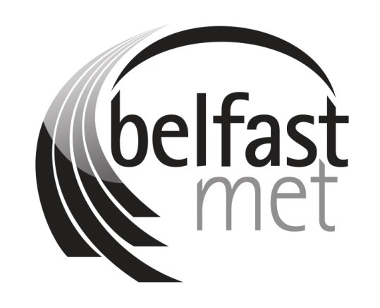

**2023/24 COLLEGE DEVELOPMENT PLAN**

**First draft December 2023**

**Updated January 2024**

**Approved by Governing Body, 7 February 2024**

**Minor updates made 21 February 2024 following feedback from DfE**

**CONTENTS**

1. Executive Summary
2. Strategic Context
3. Financial Performance / Position
4. 2023/24 College Planned Delivery
   1. Setting the Scene
   2. College Profile
   3. Sub-regional Operating Context
   4. 2023/24 Planned Activity
5. Key challenges / constraints

**Annex 1 – College Data Analysis**

1. **Executive Summary**

Legislation requires all Further Education Colleges in Northern Ireland to produce and publish an annual College Development Plan[1] that sets out College objectives, outcomes and performance measures which are aligned to wider government policy and spending priorities.

Our Vision, Purpose and Values are articulated in the [2021-22 – 2023-24 Strategic Plan](https://indd.adobe.com/view/2bb96cba-985a-4073-b356-d1763dc1863e), ‘*Choose Success*’. Our Strategic Objectives were developed to deliver on our dual mandate of economic development and social inclusion as well as key government policies such as 10X Economy – Skills strategy for NI. Our strategic objectives are as follows:

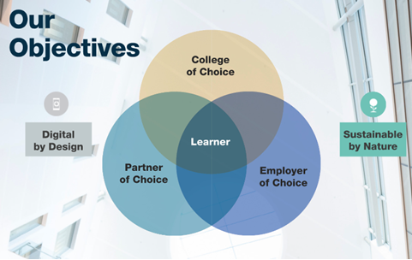

Belfast Metropolitan College exists to provide high-quality education, skills and employability programmes to a diverse range of learners, delivering the skills needed to support inclusive growth and promoting innovation. We need to continually ensure that the programmes we deliver meet the needs of learners, society and employers, now and into the future. COVID-19 changed how we deliver, moving significant elements into the digital sphere. Our research shows that face-to-face learning is required by many of our learners – however, the use of digital to complement and support learning provides clear benefits in terms of flexibility and accessibility for our learners.

We also need to be agile and flexible in the types of provision offered and in how we deliver programmes in partnership with other key stakeholders across the City, so that we are able to respond to the evolving challenges associated with economic recovery and growth. Previous comparative analysis from OECD on the skills landscape in Northern Ireland also highlighted the need to support inclusive approaches to Lifelong Learning and this a key theme for the College which we are working in partnership on to ensure wider reach across the most disadvantaged areas of the Belfast City Region.

We need to future proof ourselves by being a truly technology-driven, sustainable College and being clear about how we will collaborate and partner with others to contribute to Northern Ireland’s economic, social and environmental success. We need to be digitally connected to enhance learning and productivity.

This plan sets out the operational targets for 2023/24 to ensure progression of the College’s longer term Strategic Plan and contribution towards the delivery of government policies.

Despite the current FE Sector enrolment backdrop, and a challenging operating environment characterised by declining funding, increasing costs, staff recruitment and industrial relations difficulties, as well as, political and budgetary uncertainty, we have increased provision in the following areas:

* Social inclusion programmes
* Business engagement programmes
* Inclusive learning and well-being support.

This Plan reflects the support of the Chair of the Governing Body and, in accordance with the [FE Code of Governance](https://www.economy-ni.gov.uk/sites/default/files/publications/del/Code-Governance-FE-04-12.pdf) was approved by the Governing Body in December 2023.

1. **Strategic Context**

|  |
| --- |
| **Executive’s draft PfG Outcomes Framework**  Of the nine strategic outcomes included in the PfG’s draft Outcomes Framework, the College supports the following draft outcomes:   * We live and work sustainably – protecting the environment. * Our children and young people have the best start in life. * Everyone can reach their potential. * Our economy is globally competitive, regionally balanced and carbon neutral. |
|  |
| **Strategies / Priorities / Policies**  The College is a key delivery partner in taking forward:  DfE’s - [10X Economy](https://www.economy-ni.gov.uk/publications/10x-economy-economic-vision-decade-innovation), [Skills Strategy for Northern Ireland - Skills for a 10X Economy](https://www.economy-ni.gov.uk/publications/skills-10x-economy-skills-strategy-northern-ireland), [10x Delivery Plan 2023/24](https://www.economy-ni.gov.uk/sites/default/files/publications/economy/10x-Delivery-Plan-2023-24.pdf) [Trade and Investment for a 10X Economy](https://www.economy-ni.gov.uk/publications/trade-and-investment-10x-economy-priorities-northern-irelands-inward-investment-trade-and-exports), and [Energy Strategy for Northern Ireland – The Path to Net Zero Energy](https://www.economy-ni.gov.uk/publications/energy-strategy-path-net-zero-energy) |
|  |
| **Review of the Further Education Delivery Model**  **The Department for the Economy agreed the following priorities for the FE Sector:**   1. Improve the value for money provided by the sector through increasing enrolments and reducing costs; 2. Ensure the FE Sector is more clearly focused on delivering against the Department’s objectives; and 3. Ensure the FE Sector has the necessary capacity and agility to respond to the changes in the economic context. |
|  |

1. **Financial Performance / Position**

**2023/24 Forecast Position**

The table below sets out the college DEL resource of £51,042k[2] and capital requirements of £1,690k[3] for 2023/24.

|  |  |  |  |  |  |  |
| --- | --- | --- | --- | --- | --- | --- |
|  | **PROGRAMME / ACTIVITY** | | | | | |
|  | **Further Education** | **Higher Education** | **Apprenticeships / Traineeships** | **Business Development** | **Social Inclusion** | **Other** |
|  | All Levels up to Level 3 not under any of the succeeding categories | Level 4-6 | Programmes up to Level 3 including AppsNI; Traineeships; Skills for Life and Work; TfS | InnovateUs; Skills Focus; Assured Skills Academies; Flexible Skills; International Programmes; Innovation Voucher Scheme | Access NI; Essential Skills; ESOL; College Connect; Skill Up; NI Prisons Service; VEP; Princes Trust; UK Shared Prosperity Fund | Self-funded recreational courses; Fast track tutorials; ILM certificates; adhoc full cost recovery courses. |
| Direct Teaching Costs - Pay | 9,521 | 4,437 | 3,157 | 239 | 1,530 | 687 |
| Direct Teaching Costs - Non Pay | 440 | 205 | 146 | 11 | 71 | 32 |
| Non-Direct Costs* | 22,297 | 10,390 | 7,393 | 559 | 3,584 | 1,609 |
| **Total Delivery Cost** | **32,258** | **15,032** | **10,696** | **809** | **5,185** | **2,328** |
| Non-Grant in Aid Income | 973 | 4,468 | 2,097 | 2,707 | 4,068 | 953 |
| **Net Requirement** | **31,285** | **10,564** | **8,599** | **(1,898)** | **1,117** | **1,375** |
| *\* Includes total support service/non-front-line activity overheads apportioned based on delivery hours.* | | | | | | |

|  |  |
| --- | --- |
| **TOTAL RESOURCE REQUIREMENT (£000’s)** | **51,042** |

|  |  |
| --- | --- |
| Capital Expenditure | 1,690 |
| Capital Receipts | 0 |
| **Net Capital Requirement (£000’s)** | **1,690** |

1. **2023/24 College Planned Delivery**
2. Setting the Scene

In support of the Strategic Context, the College takes into account the College profile and Sub-regional Operating Context to prioritise resource utilisation to areas of greatest need.

To align with 10x Economy, the College Planned Delivery has been set out to show the College’s contribution to 10x as follows:

**10x Objectives:** 11 objectives grouped intoInnovation, Inclusive Growth and Sustainability Pillars.

**Sector Aims for each 10x Pillar**: reflects the outcomes which the College/Sector is working towards.

.

**10x Metrics**

**Key Performance Indicators (KPIs)/10x Tier 3 Metrics:** sets out the College’s contribution towards Aim/10x Metric(s).

**Background and Supporting Actions to support delivery of KPIs/Tier 3 Metrics:** sets out the College’s key target areas and associated programme/College activity, based on the College’s sub-region.

In-year College Development Plan Progress Reports tracking ***‘how well’*** the College is performing will be provided to the Department for the Economy. The Department for the Economy will publish reports on performance against 10x objectives demonstrating if ***‘anyone is better off’***, along with progress reports on the 10x delivery plan 2023/24.

1. **College Profile for 2023/24**

**Our Learners**[4]

At the heart of our Strategic Plan are our learners, those that are already at the College and the future learners who choose to study at Belfast Met.

As the Further Education College for the capital of Northern Ireland and the Belfast City Region, our college profile is becoming increasingly diverse, and we are actively responding to support learners coming from a range of different backgrounds and communities.

Our campuses and community hubs are located across the Belfast City Region, with the majority of enrolments (76%) based in our campuses in Titanic Quarter or Millfield.



**8%**

Community or Employer based

**3%**

E3

**13%**

Castlereagh

**37%**

Millfield

**39%**

Titanic Quarter

In terms of mode of attendance, our enrolments are:

**43%** full-time

**44%** part-time

**13%** evening classes



**27%** of College enrolments are in Science, Technology, Engineering or Maths courses.

When it comes to our learners, it is unsurprising that our catchment area largely resides within Belfast LGD; **49%** of our current student population live in Belfast.

However, we also attract learners from across other government districts, with 12% of students residing in Lisburn and Castlereagh, 12% in Antrim and Newtownabbey, 8% in Ards and North Down and 7% in Mid & East Antrim.

**Our current learner profile is relatively balanced in terms of gender:

**49.9%** male

**49.5%** female

**0.6%** other gender identity

Over two-thirds **(62%)** of our learners are between 16 and 25 years old:



Our learner profile is also balanced in terms of religious background, with **34%** from Protestant and **34%** from Catholic communities. A substantial portion **(23%)** of our learners state they have no religious background, which could also be influenced by the significant new migrant learner population in the College.

**



**27%** of our learners reside within Quintile 1 areas (the 20% most deprived areas in NI)

**11%** of our learners declare a disability, **43.5%** of whom have a specific learning difficulty

**11%** of learners come from Black, Asian, or Minority Ethnic backgrounds

**Our Learning Environment**

Belfast Metropolitan College has currently four main campuses including Titanic Quarter, Millfield, Castlereagh and Springvale as well as one satellite campus at Girdwood. Our Riddell campus is vacant and earmarked for disposal in 2024.

All main campuses cater for a wide-ranging curriculum with a focus at Titanic Quarter on Catering, Hair and Beauty, Digital IT, Science and Business Management. At Millfield there is an emphasis on Health and Social Care, SLDD and MLDD and Engineering and Construction, whilst our Springvale campus specialises in Digital, TV and Media and is the primary location for our Assured Skills Academies. At the Castlereagh campus we cater for IT and Cyber provision as well as Engineering, Health and Social Care and Travel and Tourism.

The College is currently undertaking a comprehensive stakeholder consultation process regarding the option to close the Castlereagh campus. Should a decision be taken to close Castlereagh, it is intended that curriculum provision will be consolidated onto existing sites in Titanic Quarter and Millfield campuses, with support staff corporate functions being combined into an **Integrated Shared Service Centre** on our Springvale campus.

Once the public consultation has concluded, a briefing paper will be prepared for the Governing Body summarising issues, impacts and mitigation measures surrounding the closure of Castlereagh. When the Governing Body reach a decision, we will engage with the Department on the next steps and the governance processes that must be followed, in line with the requirements set out in the Management Statement/Financial Memorandum. We are aware that any potential decision to close the campus will require the Department’s approval of a business case setting out the justification, rationale and timeframes associated with this course of action.

There are currently no planned capital build projects in the 2023/24 academic year however following the outworking of the 12-week consultation process for the Castlereagh campus, this position may be reviewed.

**Our Staff**[5]

To realise our vision and ambition to become a College of Choice and a Partner of Choice, we need the best workforce.

As at 31 October 2023 the staffing headcount for the College, including all academic and support contracts, was 1,004. 62% of college staff are employed on a full-time basis. A high-level overview of our staffing headcount is provided in **Appendix 1**.

**Our Achievements**

Our 2023 Learner Satisfaction Survey results were excellent across the board and show an overall satisfaction rate of 95% – up 2% from the previous year. This is a testament to talent, hard work and dedication of our staff to our learners.

A highly successful **ETI evaluation of Level 3** and Apps NI took place in March 2023 showing the effectiveness of our level 3 curriculum provision in supporting economic and social development.

In the 2022/23 academic year our staff and students achieved much to be proud of securing a multitude of regional, national and international awards across the full breadth of our activities. In total, we achieved 61 student awards and four corporate awards. Below are just some of these awards:

For the second consecutive year a Belfast Met student was named a recipient of the Peter Roberts Collab Group Bursary for outstanding achievement in the further education sector.

In keeping with our College of Choice objective, we increased academic and pastoral support in response to both the legacy of Covid and the cost-of-living crisis. Initiatives include the Breakfast Clubs and student food banks. for which the Students’ Union was recently awarded the **Best Welfare Campaign at the USI Achievement Awards.**

In the area of ESOL, we secured an additional £350k last year to support Ukrainian students and those Asylum Seekers in temporary accommodation. Through this we were able to support some of our most vulnerable students with transport and technology as well as access new classes.

As a College of Choice, we committed to creating an inclusive and innovative learning environment for every student, and our Centre for Supported Learning team was recently recognised as **Highly Commended at the 2023 Open College Network NI Learning Endeavour Awards.**

Our students once again had the opportunity to showcase their skills at big events, such as WorldSkills, and we hosted four competitions at the UK national finals. As ever, our students did themselves and Belfast Met proud, playing a huge part in Northern Ireland winning 10 gold, 10 silver, eight bronze medals and five highly commended awards in the UK competition.

Our Construction students also scooped first and second place at the **CITB Skill Build Northern Ireland Finals** at the end of May and our student Esports team brought home no fewer than four trophies and 18 medals at the British Esports Student Champions held in June.

We were honoured to be awarded the **Princess Royal Training Award**, a UK-wide awards recognising excellence in training, learning and development.

Our Partner of Choice objective is fundamental to Belfast Met’s role supporting the economic strategy for Northern Ireland and its three key pillars of innovation, sustainability and inclusion. Working in partnership with NICs and the Department for the Economy, we secured the **Best Resourcing and Talent Strategy** for our innovative Civil Service Academy and were shortlisted to the CIPD national finals, following our win at the CIPD NI finals.Our Operational Delivery Apprenticeship Scheme (ODAS) has gone from strength to strength with 25 apprentices form the first cohort appointed in December 2023.

The **new FinTech and Professional Services Programme** was introduced in partnership with companies including Citi and Allstate with the support of the US Consulate in Belfast and launched by the US Economic Envoy, Joe Kennedy. On the back of this relationship, we secured a £2million donation from Bank of America to support the roll out of new Belfast Digital Skills and Employability Programme to address digital exclusion.

**We led on the initial design and launched Step-Up for the FE Sector.** This new programme offers a wide range of flexible courses designed to support those returning to training and education and funded through the UK Government New Deal for Northern Ireland initiative. The College has adopted a unique approach in collaboration with a number of social partners and is targeting socially excluded groups across the city.

We worked collaboratively with departments and teams across the College to deliver a whole series of initiatives in support of our Digital by Design objective including the development of a **new CRM system** to improve the quality and consistency of our approach to stakeholder engagement.

We were successful in renewing our **Cyber Essentials Plus certification** for the second year running, highlighting and demonstrating the professionalism and commitment of the College in ensuring the cyber safety of our students and staff. Belfast Met is the only further education college in Northern Ireland to achieve this high standard of IT certification.

We created four online classrooms – one in every campus – and provided every member of teaching staff with a new high-performing tablet/laptop.

We onboarded new risk and performance management software and provided training to key stakeholders to enhance the efficiency of our governance processes.

In achieving our objective of being ‘Sustainable by Nature’ we achieved **Gold Status in the recent 2023 Business in the Community Northern Ireland Environmental Benchmarking** Survey Results. We also secured the **Energy Globe Award from the UK Austrian Embassy** for our work in leading on green hydrogen project and led on the delivery of the very successful Hydrogen Ireland conference in Belfast in November 2023.

We launched a Sustainability and Climate Action plan setting out key actions that we intend to take over the next five years to use our role as educators to inspire, celebrate and advance the sustainability agenda, maximising our positive impact on the environment, economy and communities we serve. One of our Executive Team members was selected from over 1,000 candidates to complete a **UNESCO Leadership Programme with a focus on Sustainability and Net Zero** and on the back of this work we are leading on the development of a new Sustainability and Net Zero toolkit focused on SMEs in partnership with the FE Colleges across the sector and Queen’s University to explore the opportunity to micro-credentials.

Through a number of energy saving projects by our Estate and IT teams we have reduced our overall energy consumption during 2022/23 in the College by approximately 13% against baseline.

By the end of 2023, following an investment of approximately £550k of capital and ‘Invest to Save’ funding our new solar PV systems at Springvale and Titanic Quarter we will have increased the amount of renewable electricity generated by the College to nearly 10% of the electricity the College consumes.

We have commenced working in partnership with Belfast City Council and Titanic Quarter Ltd on projects to explore opportunities to further decarbonise the college estate at Millfield and Titanic Quarter

The College also has in place a number of **ISO management systems for the maintaining of our estate including ISO9001 Quality, ISO14001 Environmental, ISO 45001 Health and Safety and ISO 50001 Energy Management Systems.**

**Our Impact**

In an effort to help identify the OBA for Belfast Met, each year the College aggregates it’s outcomes and produces an overall Impact Report, reporting progress against 10 strategic indicators, as documented in our Strategic Plan 2021/22 – 2023/24. A summary of our 2022/23 impacts are summarised below:

***What did we do?***

* Our overall enrolments in 2022/23 were 21,374 against a planned target of 20,293. This was an **increase of 11.5%** from 2021/22[6].
* We increased the percentage of people participating in social inclusion programmes by 8% from 2021/22 to 2022/23. This is a **26% increase** from the baseline position in 2020/21[7].
* There was a **44% increase in people enrolling who declared a disability or long-term health problem** as well as a 30% increase in enrolments on ESOL programmes[8].
* There was a **72% increase in the number of people in the care** of the Northern Ireland Prison Service undertaking College led courses[9].

***How well did we do it?***

* In 2022/23 our learners continued to achieve and succeed and we retained more learners than in the preceding year:

**Retention 91.2%** (up by 0.6% on 2021/22)

**Achievement 85.8%** (down by 0.8% on 2021/22)

**Success 78.3%** (down by 0.2% on 2021/22)

*Please note the Retention, Achievement and Success figures are draft as at the time of writing and are yet to be formally published by the DfE.*

There is clear evidence that learners who chose to study with us value their experience highly. We continually work to improve our learner’s experience at Belfast Met, and this is demonstrated through consistently strong survey findings:

* + Our overall student satisfaction increased in 2022/23 for the second consecutive year, by 2% to **95%[10].**
  + We strive to create an inclusive and welcome environment where our learners feel supported.  **99% of our 2022/23 learners** said they felt welcome at Belfast Met, **97% agreeing that their unique background & identity were valued** at College and **96% agreeing that the College provides good support for their personal wellbeing** (Learner Satisfaction Survey, 2023).
  + Focusing specifically on HE students, the findings of the 2023 National Student Survey were also extremely encouraging, with **Belfast Met scoring above the NI and UK HE sector averages in all 7 of the areas surveyed** e.g. Teaching, Learning Opportunities, Assessment & Feedback, Academic Support, Organisation & Management, Learning Resources and Student Voice.
* We engaged with 286 businesses in 2022/23, exceeding our **5% increase target and reaching 15% more businesses** in 2022/23 than in 2021/22.
* **Employer satisfaction in 2023 was 88%[11].** Our survey captured employers’ perceptions of the quality of Belfast Met’s provision and responsiveness to employer’s needs. We almost doubled our response rate from the previous year and more than doubled the total number of responses received.
* Another indication as to the quality of our provision is the positive outcome of the ETI evaluation of the effectiveness of our level 3 curriculum provision in supporting economic and social development. **The evaluation visit – which took place in March 2023 – identified the positive actions that college leaders, managers and staff are taking to deliver a relevant and contemporary curriculum at level 3.**
* Added to this, is our **recent successful Institutional Reapproval by the Open University**. This is valid for the next five years with a small number of conditions to be closed out by mid-January 2024. This successful outcome was the culmination of months of hard work and preparation, and a true collaborative effort by colleagues from across the College.

***Is anyone better off?***

* Studying at Belfast Met prepares our learners for the future: 97% of learners said their course is preparing them well for a future career, and 99% agreed their course was preparing them for future study in their chosen area (Learner Satisfaction Survey, 2023).
* The most recent findings of both the Survey of FE College leavers and HESA Graduate Outcomes Survey, which show that 90.3% of both our FE and HE learners went into further study or employment after leaving the College, an increase of 0.8% from 2021/22.
* In addition, FE and HE leavers going into unemployment decreased to 3.9%, a reduction of 1.5% from 2021/22.

1. **Sub-regional Operating Context**

**Population Profile**

Given that Belfast Met is the only Further Education College in the Belfast City Region, we respond to the opportunities afforded by economic growth and increasing diversity, whilst also dealing with the challenges of areas that have some of the highest levels of poverty, economic inactivity, and deep-rooted social problems in the country. Given that around 50% of our learners reside in Belfast LGD, we are aware of the crucial role we play in providing accessible education and skill development opportunities to a broad spectrum of students from a wide range of backgrounds. **We deliver these outcomes with a core funding model which is not tailored to tackling specific multiple disadvantages which has been shown to have a significant impact on learner potential.**



The population of Belfast is currently **345,418.** This accounts foraround **18%** of the total NI population and makes it the largest of the 11 LGDs by population. The population of Belfast has increased by **3.5%** since 2011[12]. In comparison to Northern Ireland as a whole. Belfast has a larger proportion of its population aged 15 – 39 years[13].

[14]



Belfast is the most ethnically diverse LGD in Northern Ireland – at **7.0%,** it has a significantly larger proportion of individuals from minority ethnic groups in comparison to NI as a whole (3.4%), whilst also having the largest proportion of individuals born outside Northern Ireland of all LGDs **(16.2%).** The College is witnessing an enormous change in the demographic profile of the learner population for refugees and asylum seekers which presents both an opportunity for a more inclusive society, but significant challenges in terms of co-rdination of our ESOL programmes and progression on to FE mainstream.

[15]



**9%** of the current population of Belfast arrived in Northern Ireland after 2011. This is 3% higher than the average for Northern Ireland as a whole.

As to be expected, Belfast city region has the largest post-primary education provision in the country, with: [16]



**17**

Secondary schools

**4**

Universities

**7**

Preparatory schools

**17**

Grammar schools

In terms of outcomes for school leavers in Belfast[17]:

**94.6%** of school leavers in Belfast go into education, employment, or training. This is lower than the NI average (95.8%).

Belfast **(71%)** has the lowest proportion of school leavers who achieve five GCSE’s (incl. English & Maths) of all LGDs.

In comparison to the NI average (4.2%), Belfast sees a higher number of school leavers going into unemployment **(5.4%).**

In Belfast, **41.7%** of school leavers went to HEIs, **20.5%** to FEIs, **18.0%** into employment, and **14.4%** into training.

Despite these significant levels of disadvantage and on average poorer outcomes for the citizens across Belfast, the current resourcing model for the College does not have any particular additional weighting to help target social inclusion.

**

Latest statistics suggest that the employment rate in Belfast is **55.8%**; the third lowest employment rate of the 11 LGDs and below the NI average (59.2%).

*[18]*

**50%** of Northern Ireland’s most deprived areas are located in Belfast. This equates to **29%** of Belfast’s 179 Super Output Areas being considered as “most deprived”: the highest proportion of all Local Government Districts which has a consequence for wider disparity the College has to deal with in terms of entry grades across all our programmes.

**

**53%** of young people in Belfast live in the most deprived Super Output Areas in Northern Ireland. By comparison, the NI average is 25%.

*[19]*

**

**26.7%** of Belfast’s population have a limiting long term health problem or disability. This is above the NI average of 24.3%. In comparison to all other LGDs, Belfast has the lowest proportion of its population with “good or very good” general health (76%), and the highest proportion with ‘Bad or very bad’ general health (10%).



Of all LGDs, Belfast residents reported the **lowest average score** for life satisfaction and overall happiness - an indication of poorer emotional and psychological wellbeing.

**Industry Profile**

The industry profile of Belfast is unique and differs to that of wider Northern Ireland. In essence, Belfast is more skills intensive than the rest of Northern Ireland, has a greater diversity of industrial sectors, and has a high concentration of jobs in sectors forecast to experience rapid growth in years to come. As Belfast’s only FE College, we recognise our role in helping to meet its demand for highly skilled workers over the coming decade and are leading on the sectoral conversations on a region wide basis in respect of anticipated innovations and curriculum developments in a number of key areas.

**30%** of all employee jobs across Northern Ireland are based in the Belfast City Council area.

Belfast has **over 11,000** businesses, accounting for **14%** of all registered businesses operating in NI.

Median annual earnings for full-time working in Belfast is above the NI average (£32,900 ) and the highest of all LGDs at **£35,811.**

Belfast accounts for over half the NI jobs in IT **(64%)** and finance & insurance **(61%),** highlighting its role as a hub for high productive sectors in NI.

[20]

Approximately 47% of Belfast’s workers live in other council areas (the highest proportion of any LGD), whilst just 16% of those living in Belfast commute to other LGDs for work.

Belfast’s skills structure is weighted more heavily towards the higher end of the skills spectrum. In comparison to NI as a whole, Belfast’s workforce has a smaller proportion of people with lower qualifications (NQF Level 1 or below), and a higher proportion of people with a tertiary level education (NQF Level 4+). [21]

However, compared to the 44% of people who work in Belfast, just **28%** of Belfast’s residents have achieved a tertiary level education. In contrast, **23%** of Belfast’s residents have no qualifications, compared to just 9% of its workforce. This highlights a potential mismatch between the resident and workplace skill structure in Belfast, which may be contributing to labour market barriers for those at the bottom of the skills spectrum.

1. **2023/24 Planned Activity**

|  |  |
| --- | --- |
| **Innovation** | |
| **Aim – 1** | **To increase the number of businesses in Northern Ireland engaging in innovation activities.** |
| **10x Tier 2 Metrics** | * **Number of R&D companies** * **R&D companies by (employee) size, ownership, location, sector** * **FTE of R&D workforce (Business)** * **Number of Innovation Driven Enterprises (IDEs) (subject to data availability)** * **Number of innovative active firms** * **Innovation accreditation** |
| **KPI 1.1** | **To deliver 105 innovation-based projects to SMEs in the 2023/24 financial year** |
| **Background:**  Key Innovation Trends by Priority Sector in 2020/21 and 2022/23 are set out in **Appendix 2.**   * The College has delivered InnovateUs, Innovation Vouchers and Connected for over 10 years, providing support to SMEs in areas such as IT, Creative Media, Fashion & Textiles, Advanced Engineering and Food Production. * Over the last three years, within the InnovateUs programme, the College has identified growth in small businesses wanting to develop skills to create new products in areas of engineering and food. The college has increased trainers in these areas to support demand from businesses. * Through Connected, the college supports businesses to explore innovation in emerging technologies and new product development. We run events and workshops to enable businesses to better understand innovation and how it can be adapted for their business. * Belfast Met has been a member of the Connected Project Management Committee since 2019, supporting development of the programme and reviewing activities and budget. * As chair of the Economic Engagement Working Group, Belfast Met is representing the FE sector on the Innovation Recognition Working Group to support uptake of the Innovation Recognition Awards for businesses.   **Planned Activity:**   |  |  | | --- | --- | | **Programme** | **Planned activity** | | InnovateUs | * Deliver 80 InnovateUs Projects | |  | * Full budget spend - £346,000 | | Innovation Vouchers | * Deliver 10 Innovation Voucher Projects | | Connected | * Deliver 15 Innovation Business Projects | | |

|  |  |
| --- | --- |
| **Innovation** | |
| **Aim - 2** | **To meet the skills needs of businesses in Northern Ireland to support increased business productivity and growth.** |
| **10x Tier 2 Metrics** | * **STEM graduates** * **Number of R&D companies** * **R&D companies by (employee) size, ownership, location, sector** * **FTE of R&D workforce (Business)** * **Number of Innovation Driven Enterprises (IDEs) (subject to data availability)** * **Number of innovative active firms** * **Innovation accreditation** * **High growth businesses** |
| **KPI 2.1** | **To deliver tailored training programmes to 135 businesses in 2023/24 financial year.** |
| **KPI 2.2** | **To deliver 50% of tailored training courses at L2+ in Broad STEM related subject areas in 2023/24 financial year.** |
| **KPI 2.3** | **To deliver 8 Academies in 2023/24 financial year.** |
| **KPI 2.4** | **To commence delivery of 4 Digital and Skills Academies with BOA in the 2023/24 academic year.** |
| **Background:**  Key Innovation Trends by Priority Sector in 2020/21 and 2022/23 are set out in **Appendix 2.**   * Skills Focus currently delivers fully funded training courses at L2+ to SMEs in key priority sectors. Across the last 3 years we have seen the proportion of higher-level courses increase, namely level 5 and level 7, and a drop in uptake of courses at level 2,3 & 4. * Courses delivered within Skills Focus are predominantly in the Financial, Business & Professional Services sector, with growth seen in the Engineering and Construction sectors. Further growth opportunities in Life & Health Science and Hospitality and Tourism. * Assured Skills Academies have been delivered by Belfast Met for 10 years. To date the programme has delivered over 140 academies to over 2,500 participants. Of this, Belfast Met has primarily delivered IT academies to companies such as Version 1, Microsoft, KPMG etc. * SME Productivity Booster is a phase 2 pilot programme supporting businesses with tailored non-accredited training to enable them to improve their productivity levels within the business. In the first pilot Belfast Met engaged 3 businesses and delivered 2 complete projects. * Belfast Met has secured funding through Bank of America to deliver 30 Digital Skills and Employability Academies to 600 people over a three-year period. Aimed at those facing social exclusion, it will equip them with the skills and experience to progress into employment or further education.   **Planned Activity:**   |  |  | | --- | --- | | **Programme** | **Planned activity** | | Skills Focus | Within the programme’s 2023/24 financial year:   * 200 individuals upskilled through Skills Focus * 120 businesses supported * Full budget spend - £350,000 | | SME Productivity Booster | Within the programme’s 2023/24 financial year:   * 15 businesses delivered tailored training to improve their productivity. | | Assured Skills Academies | Within the programme’s 2023/24 financial year:   * To deliver 8 Assured Skills Academies (118 enrolments). | | Bank of America (BOA) Digital Skills and Employability Programme | Within the 2023/24 academic year:   * To commence delivery of 4 Digital Skills and Employability Academies with BOA (80 enrolments). | | |

|  |  |
| --- | --- |
| **Inclusive Growth** | |
| **Aim - 3** | **Creating a culture of life-long learning - Providing access to FE[22] and HE in FE[23], to those furthest away from the labour market and those with low or no formal qualifications.**  **Encourage learners to progress to achieve higher industry relevant qualifications and employment.** |
| **10x Tier 2 Metrics** | * **Proportion of the working age population with qualifications at Level 2 and above or Level 3 and above.** * **Economic inactivity** * **Proportion of population aged 25+ who have engaged in education or training in the last 13 weeks.** * **Proportion of the population (16+) with no digital skills.** * **Women in narrow STEM - proportion of enrolments in narrow STEM.** |
| **KPI 3.1** | **To meet our overall target of 11,224[24] individuals enrolled in 2023/24.** |
| **KPI 3.2** | **To maintain FE retention rates[25] at the same level as 2021-22 (91%) in 2023-24 academic year.** |
| **KPI 3.3** | **To maintain FE achievement rates[26] at the same level as 2021-22 of 87.7% in 2023-24 academic year.** |
| **KPI 3.4** | **To increase HE in FE retention rates[27] from 96.8% in 2021-22 to 97.0% in 2023-24 academic year.** |
| **KPI 3.5** | **To increase HE in FE achievement rates[28] from 92.6% in 2021-22 to 94.0% in 2023-24 academic year.** |

|  |  |  |  |
| --- | --- | --- | --- |
| **Background:**  Belfast Met plays a central part in developing and supporting the delivery of education, skills employability and business development programmes regionally, nationally and locally in the Belfast City Region. The College deliver programmes to agreed College Development Plan targets. In doing so, we need to ensure all programmes delivered meet the curriculum guiding principles. This includes providing wrap-around learner support and developing learner resilience. It means working with employers to create more opportunities for learners to directly enter employment. Improving learners’ experience through maximising use of new technology in and out of the classroom is also key to a successful pathway between the College and into further study and/or employment  Enrolment trends 2021/22 – 2022/23are set out in **Appendix 3.**  Key HE and FE trends 2018/19 – 2022/23are set out in **Appendix 4.**  Retention, achievement and success trends 2021/22 – 2022/23 are set out in **Appendix 5.**  The trend in Student Support Referrals from 2018/19 to 2022/23 is set out in **Appendix 14.**   * As a ‘Partner of Choice’ we aim to position Belfast Met at the forefront of economic growth, partnering with leaders in business, across FE and the wider public sector, to deliver for learners, employers and our employees. For the Step Up Programme the College has developed a unique range of delivery arrangements across the community and voluntary sector to support reach and more inclusive approaches. * We continue to lead on the work in partnership with the councils, colleges and universities to deliver the employability and skills programmes which are aligned to the priorities in the Belfast Region City Deal – including digital innovation, urban regeneration, tourism hospitality and advanced manufacturing. We are seeking to identify opportunities to attract additional funding to support the success of Belfast Region City Deal. * The College continues to lead on the delivery of academic, work-based learning, business and innovation programmes, which support employers to grow and become more competitive. In order to be more successful with these efforts, we are enhancing the quality of employer and stakeholder engagement and are piloting a new Customer Relationship Management (CRM) system. * As well as advancing our offer across all curriculum areas which support the new 10x Strategy, the College is the Curriculum Hub for both digital IT and hospitality and tourism. * The Hospitality & Tourism Curriculum Hub aims to ensure that the curriculum delivered is high quality, consistent, current, and responsive to the needs and demands of the Hospitality & Tourism sector. * New and responsive curriculum development that is future proofed and facilitates progression opportunities and in parallel supports employer engagement is vital. Over the last year the Hospitality & Tourism Hub has been pivotal in the review and development of curriculum within HE & FE provision such as the revalidation of the full-time and HLA Foundation Degree with Ulster University in Hospitality, Tourism and Events Management, the development of the Level 2 Traineeship in Travel & Tourism and as secretariat to the corresponding Sectoral Partnership Group the review of Level 2 and 3 Travel Services frameworks and development of new qualifications. * Industry partners are receiving ongoing consistent information about what support is available, now and in the future. The Hub works in collaboration with several hospitality and tourism sector bodies such as Hospitality Ulster, Tourism NI, Northern Ireland Tourism Alliance, The Hotels Federation, Hospitality and Tourism Skills, The Institute of Travel and Tourism and Visit Belfast. * Working with employers, there is clear evidence of the benefits of collaboration. This approach is typified by the “Get into Hospitality” initiative whereby the College is working alongside Hospitality Ulster in developing two programmes highlighting employment opportunities and providing practical training in the areas of Bartending and Food Service to new entrants with approx. 90 completers. Work is underway to develop further initiatives within the tourism sector with Tourism NI and Visit Belfast. These courses have supported the hospitality sector to fill vacancies and deliver excellent customer service at such challenging times, highlighting to local businesses the wide range of areas in which FE colleges can provide practical help that delivers real business benefits. * The Digital IT Hub aims to bring a cohesive approach to digital programmes and curriculum development throughout Northern Ireland with all relevant stakeholders. * The College has developed a five-year programme (Level 3-Level 6) plan for learners to gain Level 6 qualification in Data Science or Cyber Security. * The College works with over 80 employers to promote Higher Level Apprenticeships in Data Analytics, Data Science, Cloud/AI Technologies and Cyber Security. This culminates in an annual employer forum and annual IT Apprenticeship recruitment campaign. * Through the CyberFirst initiative the College is engaging with Post Primary schools to increase Cyber Security awareness as well as promoting curriculum provision in the areas of Cyber Security, Data Science, AI and Cloud Development. * The College is also working with Post Primary teachers and teacher training organisations to provide CPD opportunities in Cyber Security and IOT. * The College is an influential member of the IT Sectoral Partnership. * The College has a prominent position in the Assured Skills Academy programmes and works with many large international organisations. * The College engages with a variety of stakeholders in Greater Belfast to meet a range of educational needs. The Schools Partnership Provision (SPP), under the DE’s Entitlement Framework, has resulted in ongoing delivery of vocational classes by Belfast Met lecturers in 2022/23 to 10 post primary schools with 250 enrolments including Special Schools. * The College is represented at the bi-monthly meetings of the four Belfast Area Learning Communities (ALCs) allowing access to Principals to advise on latest developments in FE/HE in the College, career pathway advice and to offer support and collaboration where possible. * Schools Collaboration Managers of all six FE colleges meet as a working group bi-monthly to discuss common issues around SPP and to develop a consistent approach. * In 2022/23 Essential Skills classes were delivered by Belfast Met lecturers to over 400 learners in 30 centres throughout Greater Belfast to a wide range of community groups, charities, trade unions, subcontractors, NEETs groups, employers, local authorities and health trusts. These included Entry level, Level 1 and Level 2 in Communication, Application of Number and ICT. These are delivered in a range of formats over the academic year to suit learners’ needs depending on level and ability e.g., long thin, fast track, blended and semesterised. Learners vary in age from 16+ up the 70s and come from a variety of social backgrounds with a range of motivational reasons to attend e.g., to further their careers, learn enough to help children/grandchildren with homework’s and learn how to use digital technology in the modern world (on-line banking, video communications, use of phones/laptops). * The College is also represented on the Girdwood Community Forum to advise local community groups on latest developments in FE/HE in the College, career pathway advice and to offer support and collaboration where possible. The College delivers a range of programmes at the Girdwood Community Hub. * Childhood Studies actively engages with communities far from traditional education, delivering short courses in community settings. These initiatives not only build bridges between Belfast MET and these communities but also empowers individuals to progress into further education. Many of these initiatives focus on parenthood and supporting children with additional needs which acts as early intervention for vulnerable children, fostering a positive impact within local communities and enhancing Belfast Mets presence. * Childhood Studies collaborates with Principals within the Education Authority to address the growing demand for the professionalisation of primary and post-primary classroom assistants. By providing targeted Higher Education upskilling courses, Childhood Studies contributes to recognising and enhancing the status of this essential workforce within the education system. * Partnering with registered childcare providers, Childhood Studies facilitates HLAs in Leadership and Management. This programme not only supports the professional growth of individuals within the childcare sector but also addresses the industry’s need for skilled leaders, contributing to the overall quality of northern Irelands childcare sector. * Childhood studies plays a key role in meeting the demand for qualified classroom assistants in schools and early years practitioners in Childcare. Through Level 3 licence to practice qualifications, learners engage in significant placements which ensures that graduates are well-prepared to meet the specific needs of educational and early years environments. * The College supports its students through a range of support services which focus on removing barriers to learning. The Department for Learner Success provides comprehensive and expert support across a number of key areas, each of which enhance College performance, and which include:   + **Careers Advice & Guidance** – staff ensure that prospective and existing learners are given impartial and tailored advice on progression pathways within and beyond the College.   + **Inclusive Learning** – experienced and expert staff assess and provide support to over 1,000 students annually who present with disabilities and learning support needs. Staff work in close liaison with students and academic staff to ensure support plans are in place and given effect in the classroom and/or in examinations.   + **Student Wellbeing –** academic staff are assisted in carrying out their pastoral roles by the Wellbeing team, which promotes student wellbeing through promotional, preventative and intervention activities. The Wellbeing team is also at the heart of the College Safeguarding processes which are designed to ensure that students can study in a safe and protective environment.   + **Inspire Counselling** – the College makes full use of the counselling services provided on a sector-wide basis by Inspire.   + **Student Funding** – the Student Funding team seeks to ensure that students facing financial difficulties are given appropriate advice and support to facilitate access to available support funds. * The Centre for Supported Learning provides a diverse, high quality, discrete FE and training provision for young people and adults with moderate, severe and complex learning difficulties and has in excess of 400 enrols. The provision is both part time and full time and there is a dedicated and highly expert academic support team. The provision ranges from entry 1 to level 1 and covers subjects from developing skills for independence at Entry 1 to Employability Skills at level 1. The Centre works in collaboration with a wide range of stakeholders from the Special school sector, Belfast Trust to voluntary organisations. * The Belfast Met Football Academy has developed a partnership with the Irish Football Association (IFA) to develop the coaching pathway within the Pearson BTEC Level 3 National Extended Diploma in Sporting Excellence and Performance. The coaching provided by the IFA Education Officers provide the first step onto the coaching ladder for Football Academy students. These courses are aligned to the Coaching for Sports Performance module on the academic course. Football Academy students have been able to take up voluntary opportunities with IFA staff to coach at football camps around Greater Belfast and Newtownabbey. For many of the Football Academy this has led to paid work with the IFA on Easter and Summer Football Camps. The coaching qualifications have also enabled Football Academy students to deliver football and futsal in primary schools in Newtownabbey as Project Based Learning for the Schools Sports Delivery module on the academic course thereby developing practical and transversal skills for those students who progress into coaching and / or PE teaching. * The Health and Social Care (HSC) curriculum is informed by partnership working across the sector ensuring industry standards and employer needs are at the forefront of curriculum design and delivery. These partnerships are directly facilitated through the HSC curriculum hub which facilitates the standardisation of our curriculum provision, ensuring it is in line with the Northern Ireland Social Care Councils employment standards framework, for example the new Traineeship at level 2 being delivered for the first time this year. The department engages with community organisations including, Ashton centre, Girdwood community Hub as well as voluntary organisations like GEMS, to engage with long term economically inactive women, to become employed in care settings within their community. * In the Centre for Sport, a significant amount of adult learners’ study on the:   + Active Level 2 Gym Instructing Intensive (1 week) courses - 30.9% of learners were between 19-25 years and 66.2% of learners were over 25 years.   + Active AIQ Level 3 Personal Intensive (2 week) course - 33% of learners were between 19-25 years and 67% of learners were over 25 years. These courses provide an opportunity to those individuals in full time employment to study an intensive course and develop a pathway for a career change into the fitness industry. * Through Skill Up, Childhood Studies caters to a diverse range of adults, aged 18 to 65 across Northern Ireland. Participants, including childcare professionals, teachers, parents and those aspiring to enter the childcare field, benefit from tailored short courses. This inclusive approach ensures that individuals with varying backgrounds and career goals receive relevant education and training.   Due to budget constraints in the 2023/24 academic year, the College is planning lower activity in the following areas:   * Less activity in core funded and cost recovery FE; and * Reduction in Skill Up as this programme closes in April 2024.   **Planned Activity:**   |  | | --- | | * Deliver comprehensive curriculum refresh by June 2024 | | * Expand range of delivery partnerships and collaboration opportunities by 10% by end of July 24. | | |
| **KPI 3.6** | **7,291 individuals (20,524 enrols) enrolled who are furthest away from the labour market and/or with low or no formal qualifications in 2023/24 academic year.** |
| **Background:**  Key trends in enrolments furthest away from labour market 2021/22 – 2022/23 are set out in **Appendix 6.**  Key trends in enrolments with low or no formal qualifications are set out in **Appendix 7.**   * Promoting access to Higher Education for marginalised groups is a key area of focus. The College devotes time and energy each year to drawing up and implementing its 3-year Widening Access and Participation Plan (WAPP). The College’s WAPP initiative is designed to increase or maintain the number of students from underrepresented groups participating in higher education. It aims to increase uptake of those most able, yet least likely, to achieve in a higher education programme of study. The initiative aims to achieve this by raising aspirations, by encouraging applications, and by ensuring progression, retention and successful outcomes. * The WAPP identifies a number of specific targets to increase participation from those from Quintile, those with a disability, care backgrounds, criminal convictions and the homeless but it also aims to increase the numbers of adult learners (over 25s) studying at the College. This includes allocation of funds and staffing to outreach, and engagement activities geared toward attracting students from defined target groups and, once on-board, supporting them through their studies by providing services focused on their needs. * The College is currently represented on the DfE Task and Finish Group charged with looking into revising target groups so that future WAPPs can be aligned to the demographic and societal changes which have characterised the region in recent years. * The College Careers team devotes significant time and resources to engaging with local schools through participation on the Belfast Area Learning Communities and to carrying out school visits in order to promote the course opportunities afforded by the College. * The College engages with a variety of stakeholders in Greater Belfast to meet a range of educational needs. The Schools Partnership Provision (SPP) under the DE’s Entitlement Framework has resulted in ongoing delivery of vocational classes by Belfast Met lecturers in 2022/23 to 10 post primary schools with 250 enrolments including Special Schools. The College is represented at the bi-monthly meetings of the 4 Belfast Area Learning Communities (ALCs) allowing access to Principals to advise on latest developments in FE/HE in the College, career pathway advice and to offer support and collaboration where possible. * Schools Collaboration Managers of all six FE colleges in NI meet as a working group bi-monthly to discuss common issues around SPP and to develop a consistent approach to delivery. * In 2022/23 Essential Skills classes were delivered by Belfast Met lecturers to over 400 learners in 30 centres throughout Greater Belfast to community groups, charities, trade unions, subcontractors, NEETs groups, employers, local authorities and health trusts. These included Entry level, Level 1 and Level 2 in Communication, Application of Number and ICT. * These classes are delivered in a range of formats over the academic year to suit learners’ needs depending on level and ability e.g., long thin, fast track, blended and semesterised. Learners vary in age from 16+ up the 70s and come from a variety of social backgrounds with a range of motivational reasons to attend e.g., further their careers, learn enough to help children/grandchildren with homework, learn how to use digital technology in the modern world (on-line banking, video communications, use of phones/laptops). The College is also represented on the Girdwood Community Forum to advise local community groups on latest developments in FE/HE in the College, career pathway advice and to offer support and collaboration where possible. The College delivers a range of programmes at the Girdwood Community Hub.   **Planned Activity[29]:**   |  | | --- | | * To achieve 4,330 individuals (8,564 enrolments) from Quintile 1 and 2 in 2023/24 academic year. | | * To achieve 1,337 individuals (3,392 enrolments) declaring a disability/long term health problem in 2023/24 academic year. | | * To achieve 3,575 individuals (5,774 enrolments) on Entry Level and Level 1 Programmes (including Essential Skills) in 2023/24 academic year. | | * To achieve 301 individuals (301 enrolments) on Step Up and[30] in 2023/24 academic year. | | * To achieve 576 individuals (800 enrolments) on Targeted Programmes[31] in 2023/24 academic year. | | * To achieve 845 individuals (1,693 enrolments) on ESOL programmes in 2023/24 academic year. | | |

|  |  |
| --- | --- |
| **KPI 3.7** | **To maintain the number of women in narrow STEM[32] at over 1000 in 2023/24.** |
| **Background:**  Key women in narrow STEM enrolment trends are set out in **Appendix 8.**   * As set out in the policy objectives for skills over the Skills Strategy for Northern Ireland: Skills for a 10X Economy’, Belfast Met will help to address skills imbalances by increasing emphasis on the qualifications that businesses need to drive growth and support innovation, including more women into STEM subjects and more people becoming apprentices. For example, through the CyberFirst initiative the College is actively promoting IT courses to post primary school girls. * The % of women in narrow STEM of all CDR enrols in 2022/23 was 9.8% * The proportion of learners enrolled on a Narrow STEM course has remained consistently over 30% across the last three academic years (32.6% in 2020/21, 31.6% in 2021/22 & 30.2% in 2022/23). * In terms of the gender breakdown of learners on Narrow STEM courses, the proportion of women increased from 32.7% in 2020/21 to 33.8% in 2021/22. In 2022/23, 33.1% of learners enrolled on Narrow STEM courses were women.[33]   In 2023/24, 33.6% of learners enrolled on Narrow STEM courses were women[34].  The College will work to help strengthen our skills system and produce more graduates with the STEM qualifications.  Due to budget constraints the College has had to reduce overall offering, resulting in a 16% decrease in women enrolled in narrow STEM.  **/Planned Activity:**   |  | | --- | | * During the 2023/24 academic year, the College will deliver 3 IT School Girl camps to help promote courses in Cyber Security, AI and Software Development with the ultimate aim of encouraging more females to choose IT as a career. | |  | | |

|  |  |
| --- | --- |
| **KPI 3.8** | **761 prisoner enrolments undertaking College led courses at a range of levels.** |
| **Background:**   * A Service Level Agreement (SLA) between Belfast Met and the Northern Ireland Prison Service (NIPs) has been in place from 1st April 2021 and is effective up to 31st March 2026. Under the revised SLA Belfast Metropolitan College acts as the lead partner for the provision of Learning and Skills across all three prison sites with Northwest Regional College providing delivery at Magilligan Prison under the partnership arrangements. * The partnership is well established and currently there are 55 tutor/assessors delivering a range of vocational and essential skills programmes, with all parties working closely together to foster an environment that is conducive to learning and is focused on learning outcomes for students. * Key NIPS enrolment trends are set out in **Appendix 9**. * The targets are fixed under the SLA as below and as agreed with the Northern Ireland Prison Service. While there is broad alignment with the Departments 10x strategy and the ambition to tackle social disadvantage, the metrics are also to support rehabilitation and reduce reoffending and are coterminous with the Northern Ireland Prison Service 25 by 25 Strategic Framework, the ambition to develop the learning estate and the acquisition of technical and practical skills combined with essentials skills, employability and transversal skills. This work also includes rehabilitation, resettlement and delivering safer communities, of which the provision of learning and skills is a key tenet. * Caveats are in place around the achievements of targets due to the nature of the environment an extenuating circumstances clause has been agreed in the SLA. This will allow for permutations to the targets in the event of changes in prison staff, staff sickness, reduced prison population, transfers, security issues and the introduction of end tests.   **Planned Activity:**  **Table 1**   |  |  | | --- | --- | | **Overall NI Prison Service Delivery**  **(Belfast Met Lead College – Compiled in conjunction with NWRC)** | | | **Area of Planned Activity** | **Financial year 2023/24**  **Financial Year** | | * 347 prisoner enrolments in Maghaberry Prison Undertaking College led courses at a range of levels | | | * 90 prisoner enrolments in Hydebank Prison Undertaking College led courses at a range of levels | | | * 324 prisoner enrolments in Magilligan Prison Undertaking College led courses at a range of levels | | | * 1 curriculum review will be completed by January 2024. The curriculum review of prison education is an essential step in assessing the effectiveness of educational programs within the prison system. This includes curriculum content, teaching methods, student outcomes, the learning estate and the alignment of education with rehabilitation goals and wider resettlement pathways. The review will focus on the curriculum content, digital skills, employment opportunities and the development of the learning estate, while also shaping the design and key metrics for the next SLA, as the current SLA concludes in March 2026. |   A series of infographics on the NIPS related course enrolments, unique learners registered, qualifications claimed and student satisfaction levels trends for the previous and current financial year are included in **Appendix 9**. | |

|  |  |
| --- | --- |
| **Inclusive Growth** | |
| **Aim - 4** | **Upskilling and reskilling learners to progress in life-long learning and to meet employer skills needs through provision of focussed training, providing the skills and qualifications necessary to secure employment.** |
| **10x Tier 2 Metrics** | * **Proportion of the working age population with qualifications at Level 2 and above or Level 3 and above.** * **Economic inactivity by gender, age, disability, MDM** * **Proportion of population aged 25+ who have engaged in education or training in the last 13 weeks.** |
| **KPI 4.1** | **To upskill/reskill 2,084 individuals on training programmes in 2023/24 academic year.**  **See planned activity for breakdown.** |
| **Background:**  Key trends in upskilling/reskilling individuals on training programmes are set out in **Appendix 15**.   * We continue to offer a range of pathways to help all those interested in Training Apprenticeships and Higher-Level Apprenticeships advance their education and career across a broad and diverse range of professional and technical areas such as Professional Cookery, Motor Vehicle, Carpentry and Joinery, Fabrication and Welding, Infrastructure, Software Development, Cyber Security & Cloud and Application Development. * Since April 2023, Belfast Met has commenced delivery of accredited training to 84 business incorporating 145 learners. In addition, the College commenced an Assured Skills Academy with EY in September 2023, developing skills in data and analytics to 17 individuals. All 17 individuals secured roles with EY on completion of the programme. Further academies have been undertaken with PWC and KPMG, with a new collaborative academy with 4 companies commencing in February 2024. * The College has commenced a pilot programme called Ignite Your Skills, supporting training plans and skills development for participants over 40 years old. * 11 Belfast Met Access Students have been awarded the Uversity Scholarship Award this year, out of a total of 43 Scholarship Awards across Ireland. Uversity’s Scholarships are for adult learners who wish to complete a Bachelor’s (Ordinary or Higher) Degree, for the first time, that will help transform their lives and the lives of those around them. Scholarships enable successful candidates to pursue a degree, in any discipline, in selected institutions on the island of Ireland. The Scholarships comprise financial support and programming throughout the course of the degree and are payable per annum for the duration of the Scholar's chosen degree, up to a maximum of 4 years. * Active Level 2 Gym Instructing Intensive (1 week) courses and Active AIQ Level 3 Personal Intensive (2 week) courses have been used in 2022/23 and 2023/24 by Antrim and Newtownabbey Borough Council to upskill their employees to provide more flexibility in the workforce for those individuals employed within Leisure Centres in the Borough. 10 employees of Antrim and Newtownabbey Borough Council have been through the intensive courses over the last 2 academic years. * The College will maintain a strong focus on relevant vocational and industry skills development across the range of curriculum provision through student engagement with skills development activity, opportunities for application of industry skills through Project Based Learning and engagement with skills competitions and awards nominations. * 82 learners benefited from the Erasmus SETA Project in 2022/23.   **Planned Activity**   |  |  | | --- | --- | | **Programme** | **Supporting actions/planned activity** | | Traineeships | * 469 Enrols * 334 Individuals | | AppsNI | * 829 Enrols * 718 Individuals | | HLAs | * 442 Enrols * 406 Individuals | | Skill Up | * 800 enrolments * 576 individuals   To complete courses and achieve qualifications at Level 2+ | | Ignite Your Skills | * Complete 50 training needs assessments with participants (not included in ERC). | | Skills Competitions | * Support over 300 learners[35] through participation in Skills Competitions in 2023/24 academic year. This consists of participation in Worldskills UK events such as Industrial Electronics and Culinary Arts where the College has won gold, but also having finalists in areas such as Construction trades and Cyber Security. In addition to Worldskills there are a variety of UK-wide competitions such as Adobe UK Design Challenge, English National Opera design * Within College there are a number of inter-campus events including Inclusive Learning, Design and Computing where over 150 students compete annually in the Microsoft TestFest. | | Turing Scheme | Support 20 learners[36] through 1 Turing program in 2023/24 academic year. | | |

|  |  |
| --- | --- |
| **Sustainability** | |
| **Aim – 5** | **To address the skills needs of the future workforce in green industries through upskilling and reskilling learners in support of a net zero economy in Northern Ireland.** |
| **10x Tier 2 Metrics** | * **Employment in the low carbon and renewable energy economy** * **Turnover in low carbon and renewable energy economy** |
| **KPI 5.1** | **In 2023/24 academic year, to develop curriculum and train staff for delivery on green sustainable skills in 2024/25 academic year.** |
| **Background:**  Sustainability is a core pillar of the 10x Economic strategy. The FE sector has secured £299,880 with an allocation of £49,980 per college for an integrated curriculum development project, which will enable colleges to develop a range of accredited provision which will support knowledge and skills aligned to sustainability to implement sustainability into everyday working practices.  Action 11.4 of the 10X Delivery Plan 2023/24, outlines the delivery of a Sustainability Programme, delivered by FE College to support businesses to realise the economic and Net Zero Sustainability ambitions set in the 10X Economic Strategy. The action point it details the importance of the development of new curriculum and skills support with core common content and approach. The six colleges will collaborate on content design and development in support of this programme and aligned with key industry and economic strategies and explore the opportunity in partnership with QUB to secure micro-credential accreditation.  Belfast Met’s commitment to being Sustainable by Nature, and our policy on the same is was enshrined in our [Strategic Plan 2021/22 to 2023/24](https://indd.adobe.com/view/2bb96cba-985a-4073-b356-d1763dc1863e). We signed up to the Environmental Association for Universities and College (EAUC) [Sustainable Development Goals Accord](https://www.sdgaccord.org/) in 2021/22.  Activity already underway to deliver on the Sustainable by Nature strategic objective is as follows:   * Pilot productivity mentoring programme with 15 SMEs in areas such as lean process, sustainability, waste management and automation. * Creation of a Sustainability and Net Zero Toolkit in collaboration with the FE Sector, developing content at a foundational level for SMEs. * Participation in the Belfast Maritime Consortium project[37] led by Artemis Technologies. This project has already attracted £60m of investment over four years, including contributions from consortium partners, to create 125 research and development jobs and more than 1,000 in the region over the decade. * Delivery of a new three-year Advanced Manufacturing Engineering Apprenticeship[38] in partnership with Artemis Technologies[39] * Development of a “Train the Trainer” programme to enhance the capacity to deliver composite training in partnership with the Northern Ireland Advanced Composites and Engineering centre[40] * Stakeholder membership of the Maritime and Offshore collaborative network comprised of 21 SMEs and 22 wider stakeholder organisations.   **Planned Activity:**  Working collaboratively, the six Further Education colleges will develop a suite of Sustainability modules and short courses that support skills and knowledge transfer across every industry. The suite of materials will build a foundational resource, beginning at level 2 and work up to sector specific skills at higher levels, developing pathways throughout. When accredited the content can be used to support individuals through Skill Up, businesses through Skills Focus, as well as the wider student base, including apprenticeships, where sustainability modules and units can be incorporated into curriculum delivery.  The Sustainability Programme content developed will include a cross-sectoral, common, introductory strand that will form the foundation of knowledge for all businesses and will include topics such as:   * Understanding the different terminologies and their relationship to each other – Sustainability, Green Technology, Net Zero, Embodied Carbon, Circular Economy etc. * UN Sustainable Development Goals & Economic Strategies – breaking down the strategic goals at local, national and international levels to show relevance and impact that can be achieved through changes to business practices. * Pathways to Success – Opportunities to review business strategies and processes, assess goals, implement available tools and develop roadmaps.   This will set the scene with businesses and individuals, ensuring a core foundational knowledge prior to moving into business and industry specific areas.  **Business/Industry Areas for Development**  Each college is leading on a designated area, developing accredited provision at level 2 and at higher levels where possible. Figure 1 below indicates the range of areas where curriculum is required. Belfast Met is leading on the Circular Economy topic.    The sector has established a Task and Finish Group (T&FG) to discharge this project. The T&FG have adopted a three-phase approach; research, content development and accreditation and are meeting regularly and working through a project implementation plan.   * **To improve the level of awareness and understanding of climate change through delivery of Carbon Literacy Training to 15 college staff in 2023/24 academic year.** | |

|  |  |
| --- | --- |
| **Sustainability** | |
| **Aim - 6** | **To deliver against the Public Body reporting duties of the Climate Change legislation delivering an energy efficient and sustainable estate.** |
| **10x Tier 2 Metrics** | * **Energy Related Green House gas emissions** * **Energy efficiency indicators** * **Circular Economy** |
| **KPI 6.1** | **In 2023/24 academic year, establish a baseline position for the College.** |
| **KPI 6.2** | **In 2023/24 academic year, establish the key actions to improve/maintain energy efficiency.** |
| **Key College activities in support of the above KPI: major capital projects, minor works programme and Invest to Save funding.**  **Background:**  A key strategic theme for the College is to be ‘Sustainable by Nature’ and to use our role as educators to inspire, celebrate and advance the sustainability agenda, maximising our positive impact on the environment, economy and communities we serve.  The College has a five-year Sustainability and Climate Action Plan (2023-28) in place that sets out how Belfast Met intends to tackle the current and future challenges we face to become a more sustainable institution and play our part in tackling the climate crisis. A college wide Sustainability Group including staff representatives from all campuses has been established to help support the delivery of this action plan.  Key actions taken to date:  2011 - Opening of new Titanic Quarter Campus BREEAM standard - Very Good  2012 - Opening of E3 Campus BREEAM standard- Excellent  2013 - ISO 14001 Environmental / ISO 50001 Energy Management certifications achieved.  2014 - Installation of 125kwp Solar PV system at our Millfield campus  2017 - LED Lighting upgrade project throughout Millfield Campus  2019 - Zero waste to landfill achieved.  2021 - Planting of 5,000 trees at our Castlereagh and Springvale campuses  2021 - Platinum Award in NI Environmental Benchmarking Survey  2022 - Installation of EV charging facilities at our Castlereagh and Springvale campuses  2022 - CEO declares ‘Sustainable by Nature’ as new College Strategic objective. New College steering groups formed.  2023 - Launch of new college Sustainability and Action Plan launched  2023 - Installation of 100 kwp Solar PV system at our Springvale campus (through invest to save funding)  2023 - Installation of 200 kwp Solar PV system at our Titanic Quarter campus  **Supporting Actions/Planned Activity: (key actions included in Year 1 of Sustainability and Climate action plan):**   |  | | --- | | **Planned activity for 2023/24:** | | * Installation of 6 EV charging points at Millfield campus (through Invest to Save funding). | | * Reduction in college wide energy consumption from 2022/23 by 135,257 kwh. | | * Working in partnership with Belfast City Council with development of a low carbon district heating system for our Millfield campus. | | * Working in partnership with Titanic Quarter Limited with development of a low carbon district heating system for our Titanic Quarter campus. | | * Rollout of carbon literacy training for all Estate staff and Sustainability steering group. | | * Determine baseline for college Scope 3 carbon emissions. | | |

1. **Key Challenges/Constraints**

The below table sets out the key challenges/constraints towards achievement of 2023/24 planned delivery set out in section 4 above.

| Risk | Potential Impact | Mitigating Actions |
| --- | --- | --- |
| Political uncertainty | Negative impact on:   * Organisational capacity to plan and secure core grant resources. * Budget confirmation. * Curriculum offer and service provision. | * NIFON participation. * Representation to DfE * Reform to Save programme. * Diversification of income from other sources. |
| Declining enrolments | * Reduced financial sustainability. * Reduced offer. * Negative impact on learner success. | * Established Marketing Strategy. * Established performance monitoring at various levels. * Development of Curriculum Refresh Strategy. |
| Financial pressures | * Impact of funding pressures on scale of offer (reduced cohorts and variety of curriculum) * Reduced curriculum offer and quality of service delivery. * Learners do not succeed. * Legislative/regulatory breach * Reputational damage. * Negative impact on industrial relations. * Potential redundancies to operate within financial resources available. | * Development of Partnership Delivery Models to extend reach and increase enrols. * NIFON participation to identify opportunities for efficiency. * Exploration of the potential for Integrated Shared Services. * Representation to DfE. * Reform to Save programme. |
| Attracting, recruiting and retaining staff | * Reduced curriculum offer and quality of service delivery. * Learners do not succeed. * Inability to respond to increasing demand in key areas. | * Refreshed recruitment approach. * Ongoing negotiations through CEF to secure improved pay settlements. * Continued development of workforce models with trainer assessor option, * External partnership delivery models. |
| Industrial relations environment and industrial action | * Negative impact on curriculum offer, quality of service provision and learner success. | * Established TU engagement mechanism. * Participation in negotiating committees. * Representation to DfE. * Legal action. |
| Changing College demography:  Increasing numbers of students with learning support requirements and/or requiring student support and significant ESOL demand. | * Insufficient resources from core grant to cover increasingly complex support needs. * Learners do not succeed. * Legislative breach e.g. DDA/SENDO/Equality/discrimination legislation. | * Development of Curriculum Refresh Strategy. * Established interventions and initiatives to improve access and participation. * Exploratory study with DfE across sector to understand scale of additional support needs and growth in recent years. * Review with DfE of current ESOL funding model. |
| Cyber Attack | * Data/financial loss * Reputational damage * All/some key business processes unavailable | * Policies and procedures approved and communicated to staff * Comprehensive suite of preventative/detective/corrective internal controls in place * Digital by Design programme board and action plan operational |

The College has a Risk Management Framework in place including Corporate and Operational Risk Registers from which key risks are reflected. Strategic challenges/constraints affecting the Sector are highlighted with the use of ‘Corporate Risk’.

**Annex 1**

**College Data Analysis**

**Appendix 1: Staffing headcount as at 31st October 2023**

|  |  |  |  |  |
| --- | --- | --- | --- | --- |
| **Staff Type** | **23/24 Staff Count Q1** | | **Staff Count Totals Q1 23/24** |  |
| **FT** | **PT** |  |
|  |  |
| Executive Leadership Team | 3 | 0 | 3 |  |  |
| Academic | 253 | 102 | 355 |  |  |
| PTL | 1 | 184 | 185 |  |  |
| Support | 362 | 99 | 461 |  |  |
| **Totals** | **619** | **385** | **1004** |  |  |

*Data source: Q1 2023/24 HR Committee Report*

**Appendix 2 – Innovation Trends by Priority Sector 2020/21 – 2022/23**

*Data source: taken from most recent 3 years of FE Sector Reports as issued by the DFE InnovateUs and Skills Focus team.*

**Appendix 3 Individual enrols 2021/22 – 2022/23 (November CDR 2021/22, 2022/23)**

|  |  |  |
| --- | --- | --- |
| **Academic Year** | **2021/22** | **2022/23** |
| Individuals enrols per ERC | 12,130 | 12,579 |

**Appendix 4 HE and FE trends 2018/19 – 2022/23 (November CDRs 2018/19, 2019/20, 2021/22, 2022/23).**

**All HE Enrols**

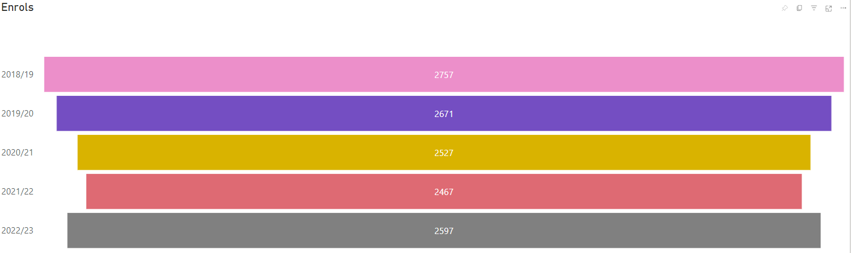

**FT HE Enrols**

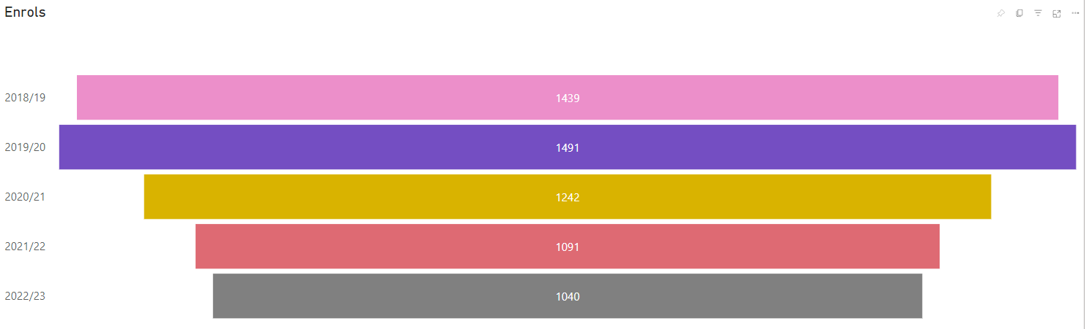

**Appendix 5 Retention and Achievement rates 2021/22 – 2022/23 (November CDR 2021/22, 2022/23)**

|  |  |  |
| --- | --- | --- |
| **Academic Year** | **2021/22** | **2022/23** |
| FE retention | 90.0 | 90.8 |
| FE achievement | 86.0 | 85.0 |
| HE in FE retention | 96.8 | 96.4 |
| HE in FE achievement | 92.6 | 94.4 |

**Appendix 6: Key trends in enrolments furthest away from labour market 2021/22 – 2022/23 (November CDR)**

|  |  |  |
| --- | --- | --- |
| **Academic Year** | **2021/22** | **2022/23** |
| Enrolments from Quintile 1 and 2 | 8,999 | 9,850 |
| Enrolments declaring a disability/long term health problem | 3,516 | 3,901 |
| Enrolments on Entry Level and Level 1 Programmes (including Essential Skills) | 5,805 | 6,990 |
| Enrolments on Step Up and Skills for Life and Work | 0 | 61 |
| Enrolments on Targeted Programmes[ | 590 | 1,079 |
| Enrolments on ESOL programmes | 1,920 | 2,267 |

**Appendix 7: Enrolments with low or no formal qualifications 2021/22 – 2022/23 (November CDR 2021/22, 2022/23)**

|  |  |  |
| --- | --- | --- |
| **Academic Year** | **2021/22** | **2022/23** |
| Individuals enrolled who are furthest away from the labour market with low or no formal qualifications | 3,090 | 3,463 |

**Appendix 8: Women in STEM (**of all CDR enrols) **2021/22 – 2022/23 (November CDRs 2020/21, 2021/22 & 2022/23)**

|  |  |  |
| --- | --- | --- |
| **Academic Year** | **2021/22** | **2022/23** |
| % of women in narrow STEM of all CDR enrols | 10.5 | 9.8 |

**Proportion of Learners on Narrow STEM Courses (November CDRs 2020/21, 2021/22 & 2022/23)**

|  |  |  |  |
| --- | --- | --- | --- |
|  | **2020/21** | **2021/22** | **2022/23** |
| % of learners in narrow STEM | 32.6% | 31.6% | 30.2% |

**Gender Breakdown of Narrow STEM Learners (November CDRs 2020/21, 2021/22 & 2022/23)** (of all narrow STEM enrols)

|  |  |  |  |
| --- | --- | --- | --- |
|  | **2020/21** | **2021/22** | **2022/23** |
| Women (of all narrow STEM enrols) | 32.7% | 33.8% | 33.1% |
| Men | 66.2% | 65.8% | 66.4% |
| Other Gender Identity | 1.0% | 0.9% | 0.5% |

**Appendix 9: Northern Ireland Prison Service Trends 2022/23 – 2023/24 (referenced in CDP)**

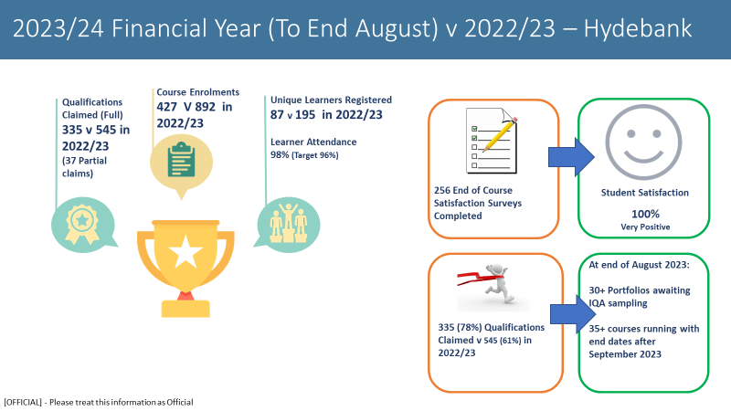

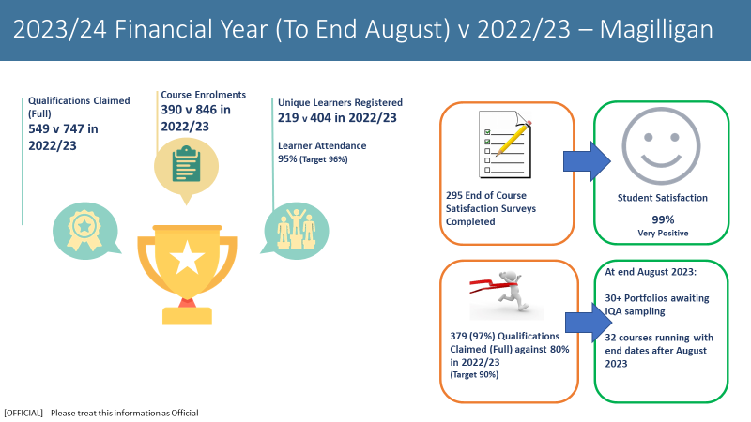

Targets Financial Year 2022/2023:

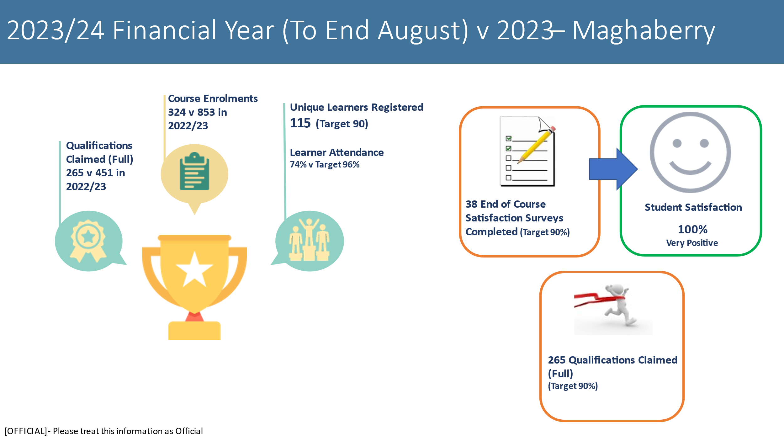

**Appendix 10: Belfast Met Energy Consumption 2016/17 – 2022/23 (Source: Utility Providers and Internal Building Management Systems)**

Key target is to reduce energy consumption of the college by 30% by 2030 (baseline year 2016/17.



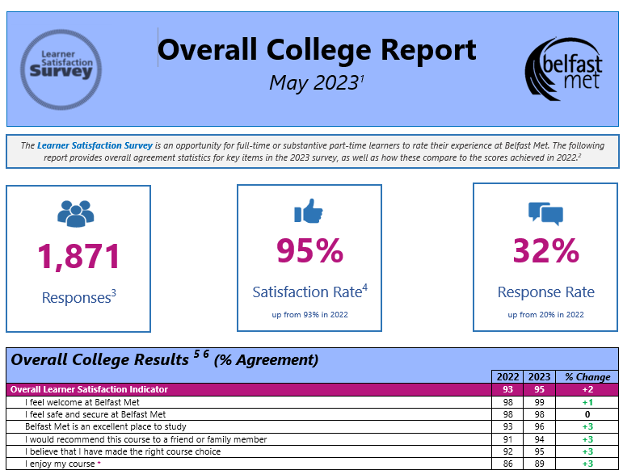**Appendix 11:** **2023 Learner Satisfaction Survey Referenced in CDP**



**Appendix 12: 2023 National Student Survey Referenced in CDP**

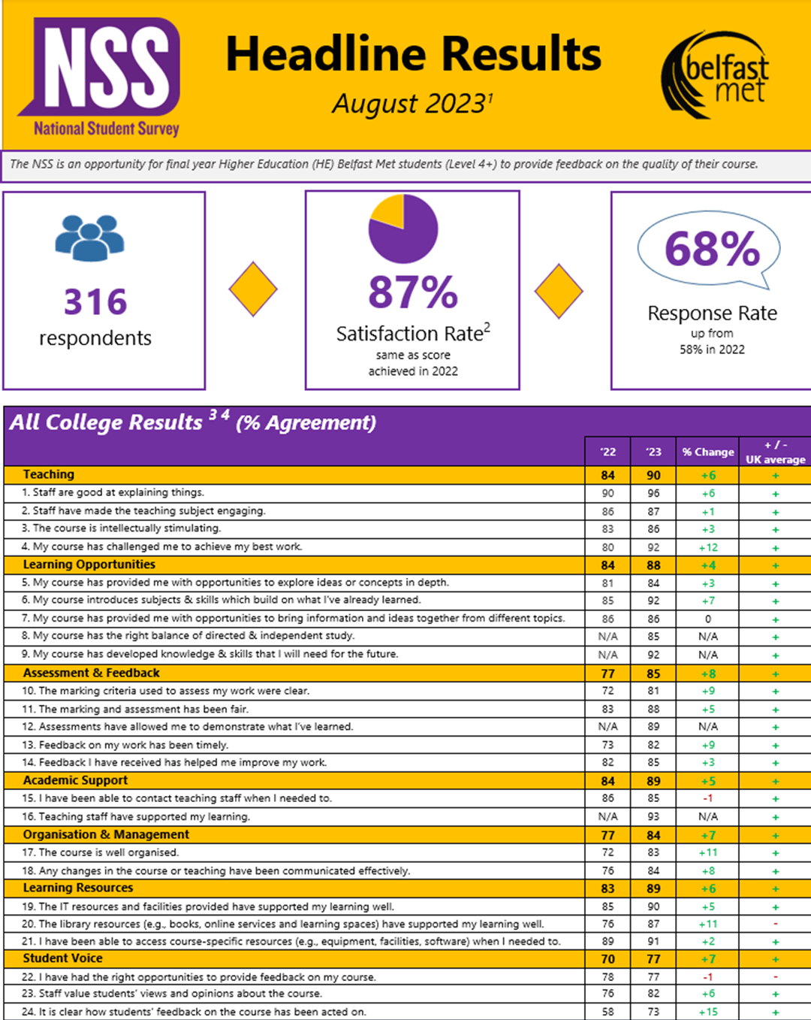

**Appendix 13: 2023 Employer Satisfaction Survey Referenced in CDP**

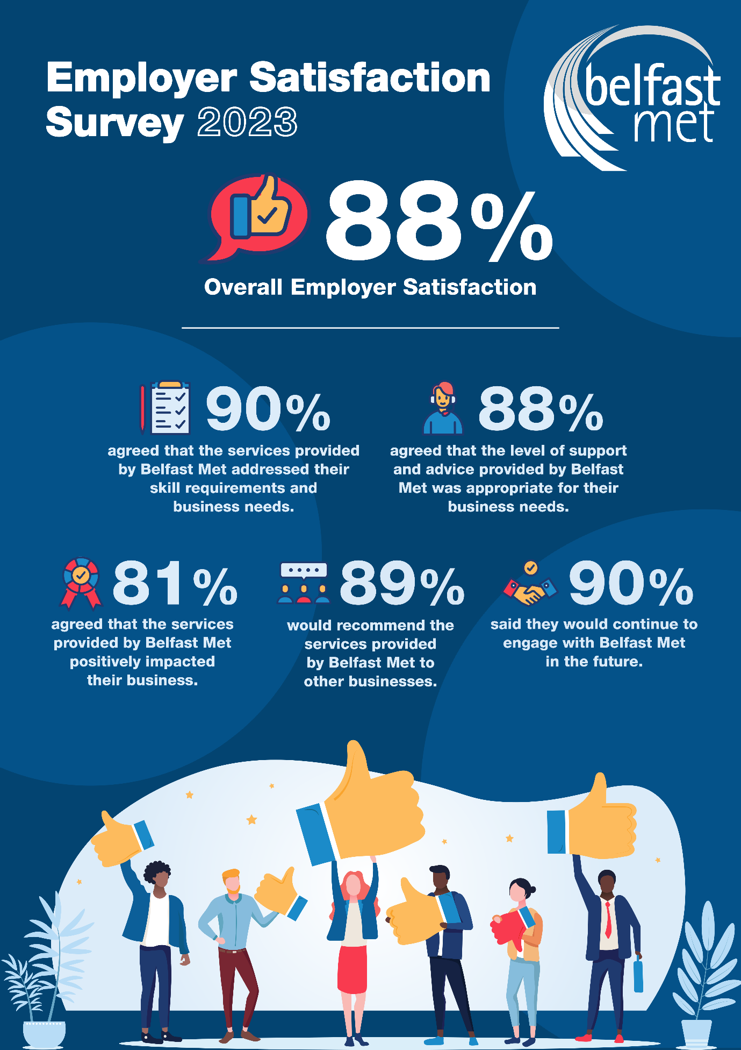

**Appendix 14 Student Support Referrals 2018/19 to 2022/23 Referenced in CDP**

|  |  |  |  |  |  |
| --- | --- | --- | --- | --- | --- |
|  | **18-19** | **19-20** | **20-21** | **21-22** | **22-23** |
| **Total number of referrals)\*** | 1232 | 1388 | 1370 | 1596 | 1874 |
| **Total number of students supported by Initial Needs Assessment (FE/HE/App/Training)** | 969 | 1051 | 1082 | 1178 | Process changed.  935  INA to last for the duration of programme of study. |
| **Total number of Curriculum Support Recommendations issued.** | Prior to EBS – no data collated. | | | 943 | 1063 |
| **Total number of ASF 02 students**  **(FE Mainstream)** | 573 | 628 | 530 | 587 | 600 |
| **Total number of ASF 03 Students** | 54 | 48 | 39 | 43 | 57 |
| **Total number of DSA Students** | 92 | 102 | 93 | 105 | 123 |
| **Total number of students with Exam Access Arrangements** | 546 | 706 | 571 | 670 | 759 |

*Source:*

*\*LS1 referral forms*

*All other Data: 2018/19 to August 2020 – Qlikview. August 2020 to 2023/24 EBS*

**Appendix 15 individuals on training programmes 2021/22 to 2022/23 referenced in CDP**

|  |  |  |
| --- | --- | --- |
| **Academic Year** | **2021/22** | **2022/23** |
| Skills for Life & Work | 0 | 12 |
| Apps NI | 907 | 849 |
| HLA | 217 | 315 |
| Skill Up | 470 | 877 |
| Advanced Technical | 106 | 25 |
| Traineeships | 125 | 237 |
| Total | 1825 | 2315 |

*Source: Final October CDR* 2021/22 and 2022/23

1. [The Further Education (Northern Ireland) Order 1997](https://www.legislation.gov.uk/nisi/1997/1772/article/20), Section 20.
2. As per DfE correspondence dated 22 December 2023.
3. As per DfE correspondence dated 15 February 2024.
4. College / Student profile based on Consolidated Data Return lift on 22/11/23 (19,235 funded enrolments accounted for by 10,459 individual learners)
5. Appendix 1: Staffing headcount as at 31st October 2023
6. *Data source: Impact Report 2022/23.*
7. Belfast Met Annual Report and Financial Statements 2022/23
8. Belfast Met Annual Report and Financial Statements 2022/23
9. Belfast Met Annual Report and Financial Statements 2022/23
10. Data source: Learner Satisfaction Survey 2022/23 – see Appendix 11 and 12
11. Data Source: Employer Satisfaction Survey 2022/23 – see Appendix 13
12. NISRA (2023). Census 2021: Area Explorer
13. NISRA (2023). Census 2021: Area Explorer
14. NISRA (2023). Census 2021: Main Statistics for Northern Ireland
15. NISRA (2023). Census 2021: Main Statistics for Northern Ireland
16. Department of Education (2023). Institution search
17. Department of Education (2023). Qualifications and Destinations of Northern Ireland School Leavers.
18. NISRA (2017). Northern Ireland Deprivation Measure
19. Education Authority (2022). Youth Service: Local Assessment of Need.
20. Top Left: NISRA (2023). Inter-Departmental Business Register.

    Top Right: NISRA (2023). Business Register and Employment Survey.

    Bottom Left: UUEPC (2019) Sub-Regional Skills Barometer: Belfast City Council.

    Bottom Right: NISRA (2023). Annual Survey of Hours and Earnings.
21. UUEPC (2019) Sub-Regional Skills Barometer: Belfast City Council.
22. Up to and including Level 3.
23. At Level 4 and above.
24. The figure of 11,224 includes unique ES individuals.
25. As Per the FE Sector Activity in Northern Ireland Bulletin: The percentage of final year regulated enrolments completed by students. NB excludes Essential Skills.
26. As Per the FE Sector Activity in Northern Ireland Bulletin: The percentage of final year regulated enrolments completed by students who achieve a qualification.
27. As per footnote 3 above.
28. As per footnote 4 above.
29. It is acknowledged that enrolment activity in the below measures may be counted in more than one metric.
30. Breakdown of activity by programme is included in the supporting Educational Report Card.
31. College Targeted Programmes (excluding Step Up and Skills for Life and Work)
32. Narrow’ STEM and is identified as those enrolment records within courses classed as: ‘Biological and Physical Sciences’; ‘Mathematics and IT’; and ‘Engineering and Technology’. [Further Education Sector Activity in Northern Ireland: 2017/18 to 2021/22 (economy-ni.gov.uk)](https://www.economy-ni.gov.uk/sites/default/files/publications/economy/Annex-a-fe-sector-activity-statistical-bulletin-17-18-to-21-22.pdf)
33. Final CDR 2020/21, 2021/22 & 2022/23
34.
35. November CDR 2023/24 To reflect the range of competitions which individuals are registered on e.g., a learner registered on three competitions would be reflected as three learners.
36. As per March 2023 Turing Application
37. [Belfast Consortium](https://belfastmaritimeconsortium.com/)
38. [Advanced Manufacturing Apprenticeship](https://www.belfastmet.ac.uk/course-detail/21-23/p00711-ac/level-3-extended-diploma-advanced-manufacturing-engineering-artemis/)
39. [Artemis Technologies](https://www.artemistechnologies.co.uk/)
40. [Training at NIACE, Belfast | National Composites Centre](https://www.nccuk.com/training/open-courses/training-at-niace-belfast/)