Programme specification

(Notes on how to complete this template are provide in Annexe 3)

1. Overview/ factual information
Programme/award title(s) | BSc (Hons) Software, Cloud and Application Development(Top-Up)
Teaching Institution | Belfast Metropolitan College
Awarding Institution | The Open University (OU)
Date of first OU validation | 14th May 2021
Date of latest OU (re)validation | N/R
Next revalidation | N/R
Credit points for the award | 120
UCAS Code | N/R
HECoS Code | 100374
LDCS Code (FE Colleges) | N/R
Programme start date and cycle of starts if appropriate. | September 2021
Underpinning QAA subject benchmark(s) | - QAA Computing – October 2019  - CSE C2017 - CyberSecurity  - IT 2017 – Information Technology
Other external and internal reference points used to inform programme outcomes.  For apprenticeships, the standard or framework against which it will be delivered. | N/R
Professional/statutory recognition | N/R
For apprenticeships fully or partially integrated Assessment. | N/R
Mode(s) of Study (PT, FT, DL,  Mix of DL & Face-to-Face)  Apprenticeship | FT and PT
Duration of the programme for each mode of study | FT (1 year) and PT (1 ½ years)
Dual accreditation (if applicable) | N/R
Date of production/revision of this specification | 12/02/2021

Please note: This specification provides a concise summary of the main features of the programme and the learning outcomes that a typical student might reasonably be expected to achieve and demonstrate if s/he takes full advantage of the learning opportunities that are provided.
More detailed information on the learning outcomes, content, and teaching, learning and assessment methods of each module can be found in student module guide(s) and the students handbook.
The accuracy of the information contained in this document is reviewed by the University and may be verified by the Quality Assurance Agency for Higher Education.

2.1 Educational aims and objectives
Belfast Metropolitan College currently offers a Foundation Degree in Software, Cloud and Application Development validated by the Open University. This programme took initial enrolments in September 2018. The enrolments were for Part Time, Full Time and Higher Level Apprenticeship pathways. There are 91 students/apprentices enrolled on these courses. Currently students and apprentices that successfully achieve these foundation degrees have a number of Level 6 articulated routes that are documented in the programme specifications, these are:-
- Students are able to enrol on an Open University Top Up Degree IT offered through the Open University and complete four Level 6 modules.
- Students are able to enrol on year 3 IT programme at Napier University.
- Students are able to enrol on year 3 IT programmes at Ravensbourne University.
Other possible articulation routes are:-
- Students can apply for Level 6 courses at the other two local Universities (Ulster University or Queens University) but will only gain entry onto to year 1 or year 2 (under consideration with distinctions in all Level 4 and Level 5 modules).
- Other UK Universities that Belfast Met is currently exploring articulation agreements. Belfast Met’s aims to ensure that creativity; innovation and commitment to excellence underpin its provision of skills and programmes necessary to help learners to gain employment, progress in their employment and support employers. This proposed programme embraces these core aims and objectives.
Belfast Met’s Corporate Plan sets out the College’s ambitions for the future which are closely aligned to meeting the current and future skills demands of the city’s workforce in “leading the city to work”. The College has a dual mandate of economic development and social inclusion. The college has identified four strategic aims, which will provide the foundation for strengthening its position as a key partner in the success of Belfast. These aims are-
1. Determined Relevance – this includes maximising student attainment and employability, investing in people and infrastructure to ensure that staff are equipped with knowledge and expertise to deliver excellence, ensuring employer needs are met and working with local communities to help people into training or employment.
2. Valued Reputation – this entails delivering high quality teaching and learning, building relationships with external stakeholders, influencing and informing policy and decision making and ensuring that teaching practices reflect global best practice through working with international partners.
3. Agile Response – this consists of supporting an agenda of inclusion, developing college employee skills and capabilities to meet the needs of all stakeholders and investment in technology to provide flexible and innovative delivery models, engagement with local, national and international employers to meet their skills needs and proactively responding to the opportunities and challenges that new policies present.
4. Distinctive Reach- this covers providing access and progression opportunities for all, working with local, national and international employers and employers of every size to meet current, specific and future skills demands, consolidating our estate to provide modern thriving hubs and taking advantage of technology to expand the reach of the college.
This Level 6 Top-Up programme aims to address all four of these strategic aims through local, national and global employer engagement, highly relevant and technical staff development, responding to external stakeholder’s needs, and delivery of highly relevant and technical programmes.

Belfast Met’s expertise in this area is further evidenced through its successful involvement with Level 3 and Level 5 ICT Apprenticeships with over 400 ICT apprentices undertaking these in the past 5 years from a range of employers. The strengths of these IT Apprentice programmes were commended by Northern Ireland’s Education and Training Inspectorate in April 2018 including staff upskilling and student support. The College’s Higher Education provision in Computing and IT have also been commended by External Examiners and through validation and revalidation panels in terms of employer engagement, student support and meeting academic standards.
The Government, Inspectorate and external endorsements of the College’s IT provision are underpinned by Belfast Met's strong employer engagement in the ICT sector including its membership of the Regional IT Sector Partnership. The ICT Sector Partnership is a forum for qualification experts, employers and policy advisors to engage on apprenticeship development and related curriculum. In particular, it shall deliver an industry led agenda to support the development of skills in the ICT sector through the provision of apprenticeships and traineeships. The partnership is comprised of employers, employer representatives, further and higher education members, and experts supporting the development of awards/qualifications. Belfast Met is the Further Education representative on this Forum to ensure apprenticeships and traineeship employment opportunities and work placements in the ICT sector are consistent with current and future occupational needs and to advise on the awards/qualifications for proposed ICT apprenticeships and traineeships and their underpinning standards and assessment at all skills levels and across the full range of ICT occupations (e.g. software development; ICT infrastructure; data analytics etc.) based on industry intelligence.

Belfast Met has a good track record in the fields of Software, Cloud and Application Development and Software and Cloud Development through numerous Department of Economy approved Cyber Security and Cloud and Software Development Academies (including Machine Learning, Software Testing, Cloud Development, IOT, DevOps, Software Robotics and Data Analytics) as well as Level 3 and Level 5 ICT Apprenticeships. The college curriculum team are working with Microsoft on a new DevSecOps Academy based on Azure technology which is starting in March 2021. This academy aims to recruit around 50 Cloud Developer consultants. All of the teaching team have been upskilled in Azure for this academy. This plus Belfast Met’s strong employer engagement in the ICT sector has been instrumental in the college proposing the Batchelors Honorary Degree in Software, Cloud and Application Development.
In a recent study into digital jobs and skills (“Jobs and Skills Report | Insights | Tech Nation”) the following finding was reported.
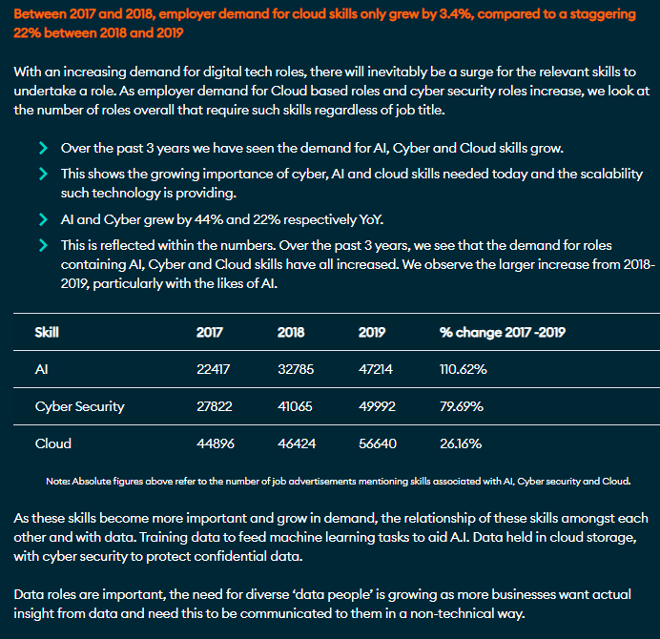
This shows a year on demand for Cloud based digital tech roles throughout the UK.
Within the same report, software developer roles were the most digital tech roles advertised in 2019. The top two advertised digital tech roles in 2019 throughout the UK regions are:-
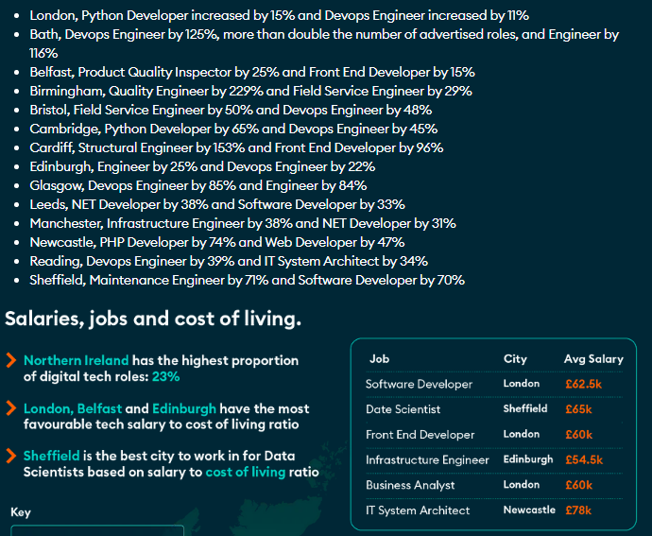
This shows that DevOps appears eight times throughout the UK. One of the main areas being addressed by this Top-Up degree is the area of DevOps.
The Northern Ireland Skills Barometer July 2019 has indicated that there could a shortfall of up to 11,360 skilled IT workers in Northern Ireland by 2028. The report states that “The fastest rates of growth in the high growth scenario are recorded in information and communication (4.2% p.a.), professional, scientific and technical services (2.4% p.a.) and finance and insurance (1.9% p.a.).”
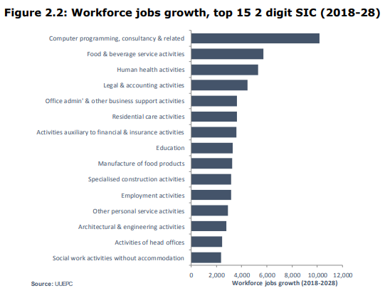
Analysis into supply gap by NQF level 6+ shows that “The subjects forecast to be predominantly under-supplied are engineering and technology, maths and computer sciences and physical and environmental sciences. It is estimated that the economy will require an additional 330 engineering and technology graduates and 290 additional maths and computer science graduates each year. This gap can be closed by either increasing the number of graduates overall, improving the employability skills of graduates who are unable to secure graduate level employment or encouraging applicants to university to change their pattern of subject choices.”

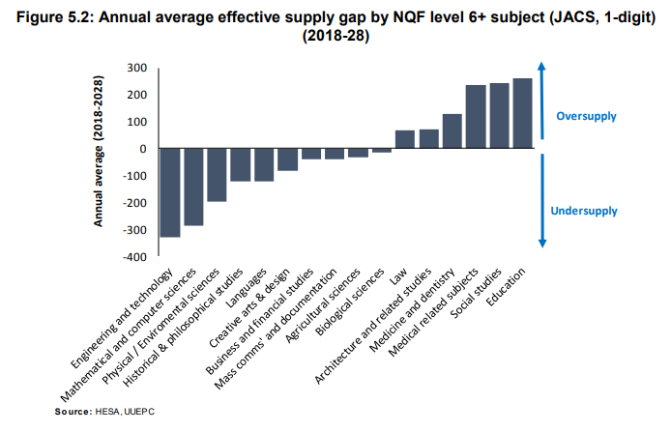
The Skills Barometer Report of July 2019 summarises that “Higher level professional and technical skills are important from an economic perspective. In the high growth scenario the supply gap indicated a shortage of midlevel skills.”
The Batchelor Honorary Degree in Software, Cloud and Application Development is designed to produce a graduate with higher level professional and technical skills, empowered for their current workplace as well as help address any projected shortfall in skilled workforce in the area of Software, Cloud and Application Development and Computing in general. Another aim for the Batchelors Honorary Degree in Software, Cloud and Application Development is to allow for progression routes for Level 3 students.

The Batchelors Honorary Degree in Software, Cloud and Application Development will sit within the broad suite of computing, electronics and multimedia courses offered by the school and ranging from level 1 to level 5.
The School of Creative and Digital Industries provides a range of computing related courses which facilitate students’ access to Higher Education including the following:

- OCR Cambridge Technical Extended Diploma in IT (3 A Level Equivalent)
  - Cyber Security Pathway
  - Software Development Pathway
  - Computing Infrastructure Pathway
- Extended Diploma in Creative Media Production - Interactive Media (3 A Level Equivalent)
- Extended Diploma in Electrical/Electronic Engineering (3 A Level Equivalent)
- L3 Apprenticeship in IT and Telecoms
The School also offers a range of Higher Education Courses:
- HND/C in Computing and Systems Development
- HND Electronics
- HND Games Development
- Foundation Degree in Science in Software Engineering
- Foundation Degree in Science in Interactive Systems Design

Alongside apprenticeship requirements, another of the aims of the Batchelors Honorary Degree in Software, Cloud and Application Developmentis to allow natural progression from the Level 3 OCR to Part-time or Full-time study on the Batchelors Honorary Degree. This is due to both the level of the courses and the fact that many of the same lecturers have the experience and expertise to deliver across these qualifications.

Level 3 Apprenticeship / Full Time Further Education Progression Route

The Batchelors Honorary Degree in Software, Cloud and Application Development will be offered as the HE knowledge component for students on the HE Apprenticeship Programme. Students completing the Batchelors Honorary Degree in Software, Cloud and Application Development will have the possibility of articulating to part time computing degree courses offered by both local and national universities. The proposed HE Apprenticeship framework has been discussed with a range of companies currently involved in Level 3 and Level 5 Apprenticeship schemes with great enthusiasm from employers.

Aims – this programme meets the needs of the above rationale by
- Enabling students to acquire fundamental knowledge, understanding and experience through the practice of software/cloud development concepts and data modelling concepts; and to acquire good level of practical and conceptual skills in the principles of DevOps, Containers and Cloud source control management and the critical means to integrate them in problem-solving
- Enable students to pursue a good level of intellectual enquiry, independence and critical awareness through academic conventions and through the creative practice of using computing systems.
- Develop analytical, critical and reflective thinking skills in planning and troubleshooting with regard to network security.
- Offer the opportunity to work collaboratively, on live projects, industry generated projects and competitions, in order to gain essential work based learning experience and develop the transferable skills essential to succeed in the Software, Cloud and Application Development industry
- Promote understanding of the legal, social, ethical and professional impact of Software, Cloud and Application Development Infrastructure.
- Provide an educational environment that fosters appropriate learning through a balance of theoretical learning and use of practical learning and skills to promote independent learning.
- Encourage progression to further study.
- To develop lifelong, independent and reflective students;
- To enhance the employability and career prospects of students;
- To produce capable and well-rounded graduates who will contribute to the skill base of the local economy and region;

Modes of Delivery/Student Pathways
The programme will be offered in three different modes of delivery:
- Full Time
- Part time (HLA Pathway)

2.2 Relationship to other programmes and awards

(Where the award is part of a hierarchy of awards/programmes, this section describes the articulation between them, opportunities for progression upon completion of the programme, and arrangements for bridging modules or induction)

Belfast Metropolitan College will be exploring articulation agreements with other academic institutions which include The Open University and Queens University of Belfast for further post graduate qualifications.

2.3 For Foundation Degrees, please list where the 60 credit work-related learning takes place. For apprenticeships an articulation of how the work based learning and academic content are organised with the award.
N/R

2.4 List of all exit awards

BSc Software, Cloud and Application Development

BSc (Hons) Software, Cloud and Application Development

3. Programme structure and learning outcomes

(The structure for any part-time delivery should be presented separately in this section.)

Programme Structure - LEVEL 6
Compulsory modules | Credit points | Optional modules | Credit points | Is module compensatable? | Semester runs in
Advanced Cloud Development Technologies  Data Science & Engineering  Final Year Research project | 40  40  40 |  |  |  | 2  1  1&2

Intended learning outcomes at Level 6 are listed below:

Learning Outcomes – LEVEL 6

3A. Knowledge and understanding
Learning outcomes: | Learning and teaching strategy/ assessment methods
A1 : Computational thinking, including its relevance to everyday life.  A2 : An understanding of the scientific method and its applications to problem-solving in this area.  A3 : Knowledge and understanding: demonstrate knowledge and understanding of essential facts, concepts, principles and theories relating to computing and computer applications as appropriate to the course of study.  A4 : Modelling: use such knowledge and understanding in the modelling and design of computer-based systems for the purposes of comprehension, communication,  prediction and the understanding of trade-offs.  A5 : Analyze the meaning of cloud computing and understand the different cloud service categories. | - Teaching and Learning Methods: Lectures, tutor directed tutorials, supervised practical sessions, student led seminars and use of the College’s Virtual Learning Environment.  - Assessment Methods: Coursework related to assignments, case studies and projects, written unseen examinations, open book assessments, presentations, practical examination/observation and project reports.  - Application and use of online virtual labs that enable students to construct real-life scenarios to experiment and test out practical approaches to simulate advanced network configurations.

3B. Cognitive skills
Learning outcomes: | Learning and teaching strategy/ assessment methods
B1 : Requirements, practical constraints and computer-based systems (this includes computer systems, information, security, embedded, and distributed systems) in their context: recognise and analyse criteria and specifications appropriate to specific problems, and plan strategies for their solutions.  B2 : Critical evaluation and testing: analyse the extent to which a computer-based system meets the criteria defined for its current use and future development.  B3 : Methods and tools: deploy appropriate theory, practices and tools for the specification, design, implementation and evaluation of computer-based systems.  B4 : Professional considerations: recognise the professional, economic, social, environmental, moral and ethical issues involved in the sustainable exploitation of computer technology and be guided by the adoption of appropriate professional, ethical and legal practices.  B5 : Develop a cloud application and understand data components. | - Teaching and Learning Methods: Lectures, tutor directed tutorials, supervised practical sessions, student led seminars and use of the College’s Virtual Learning Environment.  - Assessment Methods: Coursework related to assignments, case studies and projects, written unseen examinations, open book assessments, presentations, practical examination/observation and project reports.  - Application and use of online virtual labs that enable students to construct real-life scenarios to experiment and test out practical approaches to simulate advanced network configurations.

3C. Practical and professional skills
Learning outcomes: | Learning and teaching strategy/ assessment methods
C1: The ability to specify, design and construct reliable, secure and usable computer-based systems.  C2: The ability to evaluate systems in terms of quality attributes and possible trade-offs presented within the given problem.  C3: The ability to plan and manage projects to deliver computing systems within constraints of requirements, timescale and budget.  C4: the ability to recognise any risks and safety aspects that may be involved in the deployment of computing systems within a given context.  C5: The ability to deploy effectively the tools used for the construction and documentation of computer applications, with particular emphasis on understanding the whole process involved in the effective deployment of computers to solve practical problems.  C6: The ability to critically evaluate and analyse complex problems, including those with incomplete information, and devise appropriate solutions, within the constraints of a budget. | - Teaching and Learning Methods: Lectures, tutor directed tutorials, student led seminars, supervised practical sessions and self-directed learning employing study packs and use of the College’s Virtual Learning Environment.  - Assessment Methods: Coursework related to assignments, case studies and projects, written unseen examinations, open book assessments, presentations, practical examination/observation and project reports.  - Application and use of online virtual labs that enable students to construct real-life scenarios to experiment and test out practical approaches to simulate advanced network configurations.  - Site visits to organisation and companies to reflect on industry standards, procedures, best practice and current trends.  - Use of project based module and case studies to build on knowledge and apply theoretical concepts and practical skills to real life situations.  - Employ case studies in online virtual laboratories to test out advanced network security concepts.

3D. Key/transferable skills
Learning outcomes: | Learning and teaching strategy/ assessment methods
D1 : Students are expected to develop a wide range of generic skills to ensure they become effective in the workplace, to the benefit of themselves, their employer and the wider economy. Students who develop generic skills, and are able to evidence and demonstrate such skills, will gain significant advantage when seeking employment. It is the responsibility of higher education providers to provide every student the opportunity to acquire and evidence generic skills; it is the responsibility of the student to make the most of that opportunity.  D2 : Intellectual skills: critical thinking; making a case; numeracy and literacy; information literacy. The ability to construct well-argued and grammatically correct documents. The ability to locate and retrieve relevant ideas, and ensure these are correctly and accurately referenced and attributed.  D3 : Self-management: self-awareness and reflection; goal setting and action planning; independence and adaptability; acting on initiative; innovation and creativity. The ability to work unsupervised, plan effectively and meet deadlines, and respond readily to changing situations and priorities.  D4 : Interaction: reflection and communication; the ability to succinctly present rational and reasoned arguments that address a given problem or opportunity, to a range of audiences (orally, electronically or in writing).  D5 : Team working and management: the ability to recognise and make best use of the skills and knowledge of individuals to collaborate. To be able to identify problems and desired outcomes and negotiate to mutually acceptable conclusions. To understand the role of a leader in setting direction and taking responsibility for actions and decisions.  D6 : Contextual awareness: the ability to understand and meet the needs of individuals, business and the community, and to understand how workplaces and organisations are governed.  D7 : Sustainability: recognising factors in environmental and societal contexts relating to the opportunities and challenges created by computing systems across a range of human activities. | - Teaching and Learning Methods: Lectures, tutor directed tutorials, supervised practical sessions, student led seminars and use of the College’s Virtual Learning Environment.  - Assessment Methods: Coursework related to assignments, case studies and projects, written unseen examinations, open book assessments, presentations, practical examination/observation and project reports.  - Application and use of online virtual labs that enable students to construct real-life scenarios to experiment and test out practical approaches to simulate advanced network configurations.

[Please insert here title of exit awards(s) at Level 6]

4. Distinctive features of the programme structure
- Where applicable, this section provides details on distinctive featurs such as:
- where in the structure above a professional/placement year fits in and how it may affect progression
- any restrictions regarding the availability of elective modules
- where in the programme structure students must make a choice of pathway/route
- Additional considerations for apprenticeships:
- how the delivery of the academic award fits in with the wider apprenticeship
- the integration of the ‘on the job’ and ‘off the job’ training
- how the academic award fits within the assessment of the apprenticeship

By offering Level 6 Top-Up degree in Software, Cloud and Application Development, the College will be on the only academic institution to offer specific Cloud Technology based degree, in new areas such as Azure, Blockchain, Data Analytics and Machine Learning.

One of the aims of the Foundation Degree in Software, Cloud and Application Development delivered at Belfast Metropolitan College since 2018 was to help address the shortage of Level 4 and Level 5 skilled applicants with Northern Ireland. chieve of the goals in the National Cyber Security Strategy document of 2016. This proposed Batchelors degree in Software, Cloud and Application Development will be employed on a Higher Level Apprenticeship in Software, Cloud and Application Development as well as full time programmes. The purpose of the programme is not only to allow students who have already completed or enrolled (91 to date) on the Foundation Degree in Software, Cloud and Application Development and other Level 5 Software Development/General Computing programmes to top-up to the Bachelor’s degree but recruits more students and employers to the subject area and help address the shortage of skills in Software, Cloud and Application Development.

This curriculum area (IT Services) within Belfast Metropolitan College has an excellent track record in the field of Software, Cloud and Application Development through numerous Department of the Economy, Invest NI and Assured Skills funded Software, Cloud and Application Development Academies. These programmes include: two Cloud Academies for Microsoft in Azure AI and DevSecOps; Cloud Development academies for PWC, Deloitte and KPMG; Software Testing Academies; IOT Academy for Sensata; and Data Analytics for Deloitte, PWV and Microsoft. As well as developing and delivering on these high profile academies this curriculum area has delivered Level 3 and Level 5 IT Apprenticeships in Software Development, Software Engineering and Cloud Development for the past 10 years and recruited over ninety apprentices this academic year. This, plus Belfast Met’s strong employer engagement in the IT sector has been instrumental in the college proposing the Batchelor (Honorary) degree in Software, Cloud and Application Development Fundamentals.

The course team has strong links with other academic institutions having visited Felician University in Newark, Deltion College in the Netherlands and Ravensborne University in London. The course team also have good links with the Networking and Cyber Security team at Napier University. The links with these academic institutions allow for the exchange of good teaching practice and allow for international visits and student placements. This curriculum area also has a seat on the ICT Sectoral Partnership. This partnership includes all the major academic institutions in Northern and a range of large and SME in the digital sphere. One of the major purposes of this panel is the help address the shortage of skilled recruits in Northern Ireland.

The course team engages with employers throughout the year on employer initiatives, work placements and curriculum development and also annually at an industry forum. The course team use these engagements to better understand the requirements of employers and their needs for skilled Cloud and Software Developers. These employers/organisations include, Allstate, NICS (Northern Ireland Civil Service), Fujitsu, Citi, Allen & Overy, Capita, Rapid 7 and Danksebank. These employers and others have an input into the teaching of the current curriculum and the proposed Level 6 curriculum. Therefore, reflect the needs of current trends in Software, Cloud and Application Development Infrastructure within Northern Ireland, the UK and internationally. A number of companies have already provisionally reserved places for Higher Level Apprenticeships on this programme for Autumn 2018.

Further features of the proposed course are:-
- Student learning is based around individual development needs.
- Individual student programme of study applied within the context of their workplace and endorsed by their employer (only applies to apprentices).
- The programme comprises a mixture of advanced Cloud tools and techniques and data modelling skill alongside a final year project (with employer input for apprentices).
- The programme allows for a flexible study mode that enables students to engage with elements of the programme in response to specific professional development requirements, or undertake a fully structured programme of study leading to the final qualification.
- Students will have access to the latest Cloud VM resources developed by Microsoft with access to Microsoft Azure Labs, which is an enhanced classroom Cloud environment.
- Students will have access to the latest learning material for a variety of industrial qualifications as well as having the flexibility to undertake any of the industrial qualifications that are available.

Programme model
Programme Pathway | Years of Study | Semesters per year | Target group
Full Time | 1 year | 2 | Aimed at full time students who will attend the college on a full time basis.
Part Time | 1 ½ years | 2 | Aimed at students enrolling on a Higher Level Apprenticeship. These will be employed apprentices progressing from the Level 5 HLA programme.

- Since 2011/12 the college has recruited over 400 Level 3 and Level 5 apprentices. With a steady annual enrolment of 40 apprentices from 2011/12 to 2017/18. For the past two year recruitment has increased to 76 and 91 respectively.
- HLA apprentices numbers have been 38 and 51 over the past two years, respectively. The proposed Batchelors Honorary Degree in Software, Cloud and Application Development will facilitate progression onto the new Level 6 HE Apprenticeship for those apprentices wishing to further their studies and progress to a level ^ qualification. The college aims to attract the following intake:
  - 20 Level 6 Higher Level Apprentices
  - 10 Level 6 Full-time students
Level 3 Apprenticeship / Full Time Further Education Progression Route

Batchelors Honorary Degree in Software, Cloud and Application Development
will sit within the broad suite of computing, electronics and multimedia courses offered by the school and ranging from level 1 to level 5.
The School of Creative and Digital Industries provides a range of computing related courses which facilitate students’ access to Higher Education including the following:

- OCR Cambridge Technical Extended Diploma in IT (3 A Level Equivalent)
  - Cyber Security Pathway
  - Software Development Pathway
  - Computing Infrastructure Pathway
- Extended Diploma in Creative Media Production - Interactive Media (3 A Level Equivalent)
- Extended Diploma in Electrical/Electronic Engineering (3 A Level Equivalent)
- L3 Apprenticeship in IT and Telecoms
The School also offers a range of Higher Education Courses:
- HND/C in Computing and Systems Development
- HND Electronics
- HND Games Development
- Foundation Degree in Science in Software Engineering
- Foundation Degree in Science in Interactive Systems Design

Alongside apprenticeship requirements, another of the aims of the Level 5 and Level 5 programmes in Software, Cloud and Application Development is to allow natural progression from the Level 3 OCR programmes to these Level 5 and Level 6 programmes. This is due to both the level of the courses and the fact that many of the same lecturers have the experience and expertise to deliver across these qualifications.

5. Support for students and their learning.
(For apprenticeships this should include details of how student learning is supported in the work place)

The College offers a variety of means to support students including:
- Student Careers Advice, Guidance and Counselling
- Student Disability Services
- Student Finance
- Students’ Union
- The Faith Room & Equality & Diversity
- The Buttle Trust
- Safeguarding
- Times of Difficulty
- Belfast Met’s Student Council
- NUS-USI
- Belfast as a City of Learning
- Administration Services

Full details are available within the Student Support Handbook, available online and at reception/ students union in every campus.

The college currently uses Canvas as its Virtual Learning Environment. The college is currently working on a migration project to replace the Virtual Learning Environment with Canvas. Each course has a timetabled personal tutorial/advice support and subject module tutorials that will enhance the student’s learning experience.

6. Criteria for admission
(For apprenticeships this should include details of how the criteria will be used with employers who will be recruiting apprentices.)

Entry Qualification requirements:

Entry criteria to the level 6 top up degree requires the following criteria to be met:

Students must have completed and passed a foundation degree offered by the Open University at Belfast Metropolitan College with Computing¹ as the core discipline, or completed and passed an equivalent level 5 course with Computing¹ as the core discipline e.g. other UK University Foundation Degrees at level 5, BTEC Higher Nation Diplomas, or any UK accredited level 5 qualification that is equivalent in academia to a foundation degree or the first two years of a bachelor’s degree with Computing¹ as the core discipline as proven at the time of application.

The student must also have GCSEs at grade C or above in English and Mathematics, or equivalent qualifications, such as Level 2 Essential Skills in Maths and English.

Applicants who have already attained a qualification equivalent to or similar in content to any of the modules may be eligible to be considered for Accreditation of Prior Certificated Learning (APCL).

Those who have acquired learning through life, work experience and study not previously attested through formal education or certification may be eligible to be considered for Accreditation of Prior Experiential Learning (APEL).

The process is detailed in the College Accreditation of Prior Learning in Higher Education Standard Operating Procedure. In such cases the onus will be on the student to present relevant evidence to the Course Director so that assessment of prior learning may be carried out by the course team in accordance with the standard operating procedure.

¹The core discipline of the qualification studied must be in the area of Computing with subjects within the areas of Software Development or Software Engineering.

7. Language of study

English

8. Information about non-OU standard assessment regulations (including PSRB requirements)

Modules will be assessed by a mix of continuous assessment, coursework and written examinations. Examinations for the 40 credit modules will be of three hours in duration. There will be a Final Year Project module that will be assessed through continuous assessment and dissertation(coursework). This module will be 40 credits.

In each module students will be required to complete a number of coursework assignments. Some assignments will assess understanding, analysis and synthesis abilities while others will assess competence in applying skills.

The BSc (Hons) in Software, Cloud and Application Development course is a mixture of coursework, practical exercises and examination assessment. The aims and learning outcomes of the programmes are achieved through the application of a variety of learning and teaching methods across the modules. The range of modules allows a varied and interesting mix of methods to be used to enhance knowledge and understanding as well as allowing students to practice and develop their professional and transferable skills. A variety of teaching methods and learning environments are utilised within the programme to provide an optimal framework for study, the development of skills and expertise, the production of coursework, and preparations for examinations. Assessment is provided in both formative and summative formats.

Students’ experiences on their course should be such as to meet the aims of the course in developing their facility for critical thinking, problem solving, professional attitudes and the capacity for sustained independent work.

In each taught module the relative weighting assigned to written examinations and coursework is specified. Assignments will take the form of case-studies, practical activities and/or research.

Examinations are used mainly to assess the students’ understanding of the theoretical basis of each subject. This approach facilitates students coming from a range of assessment experiences and “gradually” builds experience and academic rigor, thus “widening participation”. The assessment methods associated with each module may be found within that module description. Feedback will be provided promptly in a meaningful and effective manner. An assessment strategy will be in place to provide valid, reliable and fair assessment and grading. Feedback will be given in a prompt and timely manner throughout the semester thus allowing for a series of formative assessment opportunities.

Staff members provide prompt and detailed feedback to all students within 15 working days. The Course Director and Team currently monitor the assessment burden on students in each year and takes action where necessary. The staggering of submissions is considered essential in determining student workload is as balanced as possible throughout the semester. It is also hoped that the indirect impact of which is that marking and feedback workload for the teaching is also staggered.

Assessment strategies will be closely related to the aims and learning outcomes of individual modules, but similar types of strategies are assessed and given feedback by standard methods to promote consistency across modules. Central to any assessment strategy is the need to assess whether learning outcomes have been met by candidates in relation to not only the course aims and objectives but also as a form of feedback to students in terms of their learning progression. It is in furthering this clarity that feedback sheets (included in the assessment details and brief), contain a marking scheme with detailed reference to the learning outcomes also stated on the Cover Sheets.

Students will be provided with comprehensive information at the start of each module detailing assessment schedules throughout. Individual Assessment Specifications clearly articulate requirements (including submission and return deadlines) and a marking scheme will be provided.

A comprehensive range of assessment strategies will be employed by the course team, involving both individual and group work. These include:
Unseen Written Examinations and coursework. These are essential to assess students’ skills of report writing and incorporates the understanding and development of academic skills in helping students to appreciate a range of presentation media and appreciate where and how best to apply these media. Coursework is also a vehicle with which to allow students to illustrate academic rigour in research and referencing. Students are made aware of the concepts of copyright, trademarks and plagiarism. Coursework can be presented in a variety of assessment methods such as:
- Group Based work,
- Time Constrained Practical Exercises
- Project Reports
- Multiple Choice Tests
All coursework and examination material is both internally and externally moderated prior to it being made accessible to students. Also following its marking, cross marking is generally accepted as essential before summative feedback is delivered to the students to ensure adequate validity, reliability and fairness.

Innovative approaches are used in the assessment process, including class test, practical exercises, case studies, exams, etc. In some units the assessment involves group activity.

The following outlines those regulations specific to the programme:
- Pass mark for the module shall be 40%. Where a module is assessed by a combination of coursework and examination a minimum mark of 35% shall be achieved in each element.
Student progression/achievements presented through "gradebook" in Canvas VLE tool (ensured by use of the blueprint setting configured in Canvas, which specifies the basic minimum tools to be used by the course team.)

Classification of final result
Students are assessed against their curricula of study and their classification is based on this. The calculation of the overall classification is based on performance in all level 6 modules to the value of 120 credits. The weighting of each module’s contribution to the final result shall be determined by the module’s credit value.
The following shall be the minimum overall percentages used to determine the final degree outcome classifications:
First-class 70+%
Upper second-class 60-69%
Lower second-class 50-59%
Third-class 40-49%

Summary of assessment requirements
The Programme adopts in full the Awarding Body Academic Principles and Regulations. Students will be provided with a copy of the Student Assessment Regulations at the point of registration for their programme.

Internal Verification/External Verification

Internal Verification of Assessment
In Belfast Metropolitan College Internal Verification is one of the key Quality Assurance processes used to ensure consistency, transparency, validity and reliability of assessment design, grading and marking. All assessed work submitted will be sampled by an internally allocated standards verifier in accordance with College standard Operating Procedures, with no confirmation of criteria achieved reported to students until this has been completed.

Internal Verification Process
Each module has an identified Internal Verifier.

The process at level 5-7 is monitored and overseen by External Examiners

The College employs a three tier system of internal assessment quality control which includes:
- Assessment validation carried out by module Internal Verifier;
- Internal verification of assessment decisions by module Internal Verifier; and
- Assessment sampling by External Examiners.

Every student will have their assessed work, including the assessment decision sampled at some stage during the programme; Belfast Met considers assessment validation and internal verification of assessment decisions to be the cornerstones of the assessment Quality Assurance process. All assessment briefs are validated by an Internal Verifier prior to use and a sample of ALL assessments submitted will have the assessment decisions internally verified, prior to feedback to the students.

External Examination / Verification
The programme is externally verified by an External Examiner (EE) appointed by the Open University. This will be a subject specialist who will ensure that the student work meets the Academic Standard. This external appointee will visit annually to carry out this verification.

Assessment Principles
The Programme adopts in full the Awarding Body Academic Principles and Regulations. Students will be directed to the location of the Student Assessment Regulations at the point of registration for their programme.

9. For apprenticeships in England End Point Assessment (EPA).
(Summary of the approved assessment plan and how the academic award fits within this and the EPA)
N/R

10. Methods for evaluating and improving the quality and standards of teaching and learning.
The Programme is managed and operated in accordance with College and Open University regulations and procedures. This will include representation and input from employers who will contribute to curriculum development and review. Reports will be made to the College’s Quality Department (and the Awarding Body) which will take appropriate action including reviews and audits to continually enhance the programme.

College standard mechanisms for review and evaluation of teaching, learning and assessment of the curriculum and outcome standards include:-
- Formal cycle of student engagement and feedback to include Module Evaluations, Course Evaluations and Staff Student Consultative Committees;
- Annual Programme Review;
- External Examiners visits;
- College internal quality assurance arrangements including internal auditing of programme management;
- External quality assurance arrangements;
- Staff Appraisal; and
- Staff development including scholarly activity.

The committees with responsibility for monitoring, evaluating and improving quality include
- Internally
  - The Centre for Curriculum Quality Assurance and Performance Development;
  - HE Coordinators Forum;
  - HE Quality Forum;
  - Monthly Performance review Process; and
  - Management through the Appraisal Process.
- Externally
  - External Examiners; and
  - The Quality Assurance Agency.

Mechanisms for gaining student feedback on the quality of their learning experience include: -
- Formal cycle of student engagement and feedback to include Module Evaluations, Course Evaluations and Staff Student Consultative Committees;
- Weekly personal tutor review of student progress/e-ILP (Individual Learning Plan); and
Supervised Work based learning visits and reports – where applicable

10. Changes made to the programme since last (re)validation
N/R

Annexe 1: Curriculum map
Annexe 2: Curriculum mapping against the apprenticeship standard or framework (delete if not required.)
Annexe 3: Notes on completing the OU programme specification template

Annexe 1 - Curriculum map
This table indicates which study units assume responsibility for delivering (shaded) and assessing (ü) particular programme learning outcomes.

Annexe 2: Notes on completing programme specification templates

1 - This programme specification should be mapped against the learning outcomes detailed in module specifications.

2 – The expectations regarding student achievement and attributes described by the learning outcome in section 3 must be appropriate to the level of the award within the QAA frameworks for HE qualifications: http://www.qaa.ac.uk/AssuringStandardsAndQuality/Pages/default.aspx

3 – Learning outcomes must also reflect the detailed statements of graduate attributes set out in QAA subject benchmark statements that are relevant to the programme/award: http://www.qaa.ac.uk/AssuringStandardsAndQuality/subject-guidance/Pages/Subject-benchmark-statements.aspx

4 – In section 3, the learning and teaching methods deployed should enable the achievement of the full range of intended learning outcomes. Similarly, the choice of assessment methods in section 3 should enable students to demonstrate the achievement of related learning outcomes. Overall, assessment should cover the full range of learning outcomes.

5 - Where the programme contains validated exit awards (e.g. CertHE, DipHE, PGDip), learning outcomes must be clearly specified for each award.

6 - For programmes with distinctive study routes or pathways the specific rationale and learning outcomes for each route must be provided.

7 – Validated programmes delivered in languages other then English must have programme specifications both in English and the language of delivery.

