Programme specification

(Notes on how to complete this template are provide in Annexe 3)

1. Overview/ factual information
Programme/award title(s) | BSc (Hons) Cyber Security with Cloud and Network Infrastructure (Top Up)  FD Cyber Security with Cloud and Network Infrastructure
Teaching Institution | Belfast Metropolitan College
Awarding Institution | The Open University (OU)
Date of first OU validation | April 2018
Date of latest OU (re)validation | Nov 2022
Next revalidation | 2027
Credit points for the award | 240
UCAS Code | N/A
HECoS Code | 100376
LDCS Code (FE Colleges) | N/A
Programme start date and cycle of starts if appropriate. | September 2023
Underpinning QAA subject benchmark(s) | - QAA Computing – March 2022  - CSE C2017 - CyberSecurity  - IT 2017 – Information Technology
Other external and internal reference points used to inform programme outcomes.  For apprenticeships, the standard or framework against which it will be delivered. | N/A
Professional/statutory recognition | N/A
For apprenticeships fully or partially integrated Assessment. | N/A
Mode(s) of Study (PT, FT, DL,  Mix of DL & Face-to-Face)  Apprenticeship | FT and PT
Duration of the programme for each mode of study | FT (2 year) and PT (2 ½ years)
Dual accreditation (if applicable) | N/A
Date of production/Revision of this specification | 30/01/2023

Please note: This specification provides a concise summary of the main features of the programme and the learning outcomes that a typical student might reasonably be expected to achieve and demonstrate if s/he takes full advantage of the learning opportunities that are provided.
More detailed information on the learning outcomes, content, and teaching, learning and assessment methods of each module can be found in student module guide(s) and the students handbook.
The accuracy of the information contained in this document is reviewed by the University and may be verified by the Quality Assurance Agency for Higher Education.

2.1 Educational aims and objectives
Belfast Metropolitan College (the College) was established in 2007 following the merger of Belfast Institute of Further and Higher Education and Castlereagh College. The College has four sites across Belfast where it delivers higher education. The College delivers higher education across more than 30 subject areas in partnership with a number of universities (awarding bodies) including The Open University, Queen's University, Ulster University and the University of Dundee. The College runs a number of higher national diplomas and certificates in conjunction with Pearson and delivers a number of higher education professional and vocational courses with professional awarding organisations. The College also offers higher level apprenticeships in; cyber security and with cloud and network infrastructure, software and cloud development with data analysis, civil engineering and accounting.

The College's vision is to be a world class college that nurtures the talent and ambition of the City of Belfast and beyond. Its mission is to make a fundamental impact on the economic and social success of the city of Belfast and beyond by equipping its people, employers and communities with the education and skills for work and is supported by four strategic aims and four core values. The College works to meet its strategic aims through collaboration and membership of cross sector working groups and Northern Ireland specific, national and international college forums and groups.

The college currently offers full time and part time HE programmes in association with 4 university partners and 10 awarding bodies. In 2018-19 The college enrolled 2,698 learners onto HE programmes; 1,280 on to part time programmes and 1,444 onto full-time programmes. This is the largest HE in FE provision across the six FE colleges in Northern Ireland and the College is proud to have achieved its HE target and this demonstrates once again that demand for HE places exists in Belfast.

Since this Foundation Degree was validated there have been over 465 full time enrolments, not including the ever growing higher level apprenticeship programmes linked to this foundation degree. The Level 6 BSc (Hons) Top Up in Cyber Security and Networking Infrastructure validated in 2021 allows for an excellent progression route for successfully completing students. 47% of graduated students have already articulated to the Level 6 Top Up. Other articulation routes are: -
- Students are able to enrol on an Open University Top Up Degree IT offered through the Open University and complete four Level 6 modules.
- Students are able to enrol on year 3 IT programme at Napier University or Ravensbourne University.
Other possible articulation routes are: -
- Students can apply for Level 6 courses at the other two local Universities (Ulster University or Queens University) but will only gain entry onto to year 1 or year 2 (under consideration with distinctions in all Level 4 and Level 5 modules).
- Other UK Universities that the College is currently exploring articulation agreements with.
The College’s Corporate Plan sets out the College’s ambitions for the future which are closely aligned to meeting the current and future skills demands of the city’s workforce in “leading the city to work”. The College has a dual mandate of economic development and social inclusion. The college has identified four strategic aims, which will provide the foundation for strengthening its position as a key partner in the success of Belfast. These aims are-
1. Determined Relevance – this includes maximising student attainment and employability, investing in people and infrastructure to ensure that staff are equipped with knowledge and expertise to deliver excellence, ensuring employer needs are met and working with local communities to help people into training or employment.
2. Valued Reputation – this entails delivering high quality teaching and learning, building relationships with external stakeholders, influencing and informing policy and decision making and ensuring that teaching practices reflect global best practice through working with international partners.
3. Agile Response – this consists of supporting an agenda of inclusion, developing college employee skills and capabilities to meet the needs of all stakeholders and investment in technology to provide flexible and innovative delivery models, engagement with local, national and international employers to meet their skills needs and proactively responding to the opportunities and challenges that new policies present.
4. Distinctive Reach- this covers providing access and progression opportunities for all, working with local, national and international employers and employers of every size to meet current, specific and future skills demands, consolidating our estate to provide modern thriving hubs and taking advantage of technology to expand the reach of the college.

This Level 5 Foundation Degree programme aims to address all four of these strategic aims through local, national and global employer engagement, highly relevant and technical staff development, responding to external stakeholder’s needs and delivery of highly relevant and technical programmes.

The College’s expertise in this area is further evidenced through its successful involvement with Level 3 to Level 6 IT Apprenticeships with over 600 ICT apprentices undertaking these in the past 10 years from a range of employers. The strengths of these IT Apprentice programmes were commended by Northern Ireland’s Education and Training Inspectorate in April 2018 including staff upskilling and student support. The College’s Higher Education provision in Computing and IT have also been commended by External Examiners and through validation and revalidation panels in terms of employer engagement, student support and meeting academic standards.

The Government, Inspectorate and external endorsements of the College’s IT provision are underpinned by the College's strong employer engagement in the ICT sector including its membership of the Regional IT Sector Partnership. The ICT Sector Partnership is a forum for qualification experts, employers and policy advisors to engage on apprenticeship development and related curriculum. In particular, it shall deliver an industry led agenda to support the development of skills in the ICT sector through the provision of apprenticeships and traineeships. The partnership is comprised of employers, employer representatives, further and higher education members and experts supporting the development of awards/qualifications. The College is the Further Education representative on this Forum to ensure apprenticeships and traineeship employment opportunities and work placements in the ICT sector are consistent with current and future occupational needs and to advise on the awards/qualifications for proposed ICT apprenticeships and traineeships and their underpinning standards and assessment at all skills levels and across the full range of ICT occupations (e.g. software development; ICT infrastructure; data analytics etc.) based on industry intelligence.
The College has an excellent track record in the fields of Cyber Security and Cloud and Network Infrastructure and Software and Cloud Development through numerous Department of Economy (DFE) approved Cyber Security and Cloud and Software Development Academies (including Cyber Security, Networking, Machine Learning, Software Robotics and Data Analytics) (Assured skills training programme | nidirect).
This curriculum area (IT Services) started working with Microsoft (Chicago Inno - Microsoft discovers new wave of tech talent in Northern Ireland (bizjournals.com) and KPMG (Klynveld Peat Marwick Goerdeler) in 2020 on a number of Cyber Security and AI Academies in the Azure Cloud Platform. To date the curriculum area has delivered five Microsoft Academies (recruiting over 80 roles to Microsoft) and five Cyber Security/AI academies for KPMG (recruiting over 60 roles for KPMG). The aim of these academies is to help these employers establish Centres of Excellence in Cyber Security in Northern Ireland.
This curriculum area also has extensive experience of delivering programmes in Cyber Security, Networking, Software and Cloud technologies on full time and apprenticeship courses at Levels 3, 4, 5 and 6 over the past 17 years. The College’s strong employer engagement in the ICT sector has been instrumental in the college proposing the BSc (Hons) in Cyber Security and Networking Fundamentals.
In the report of the National Cyber Security Strategy (2016-2021), The UK Cyber Security Sectoral Analysis 2020 report estimated “that there are 42,855 Full Time Equivalents (FTEs) working in a cyber security related role across the 1,221 cyber security firms identified. This reflects an increase of 37% in employee jobs over the last two years (baseline = 31,339 jobs). “Barriers to growth was discussed within the same report. The report states that “Within the survey of cyber security businesses, we asked firms to what extent they perceived the following conditions as barriers to growth for their businesses (defined as ‘affecting their ability to meet your business goals’). The total percentages below reflect those who responded, ‘To a great extent’ or ‘To some extent’. Overall, the most significant challenge (59% of responses) serving as a barrier to growth for cyber security firms is ‘a lack of candidates in the labour market that have the technical cyber security skills needed’. “

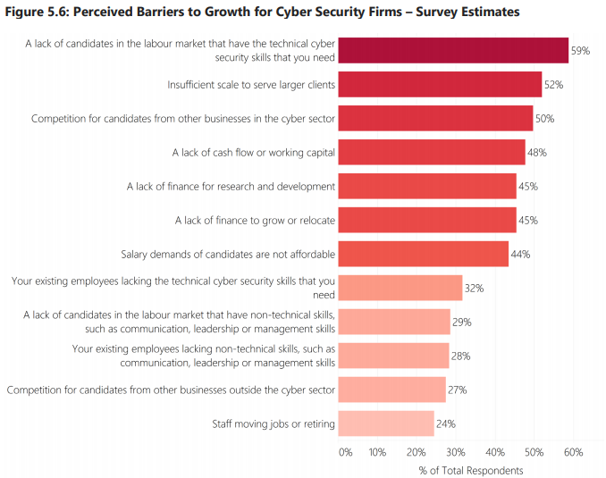
The key points from the Northern Ireland Skills Barometer of 2021 are: -
- “Skills needs should be planned based upon an ambitious economic outlook, to avoid the economic costs associated with skills shortages.
- Under the high growth scenario the NI economy is forecast to grow from 902k jobs to 975k over the 2020-30 period.
- The scenario is typified by rapid growth in sectors with a high demand for higher level skills (e.g. professional services, ICT, advanced manufacturing etc.).
- Occupations directly linked to rapidly growing sectors will achieve high growth (e.g. ICT professionals). “
The Foundation Degree in Cyber Security with Cloud and Network Infrastructure is designed to produce a graduate with higher level professional and technical skills, empowered for their current workplace as well as help address any projected shortfall in skilled workforce in the area of Cyber Security and Cloud and Network Infrastructure and Computing in general. Another aim for the programme is to allow for tangible progression routes for Level 3 students and provide these students with a five year plan which would take them from a level 3 programme through to a Level 6 qualification within the field of Cyber Security & Cloud and Network Infrastructure.
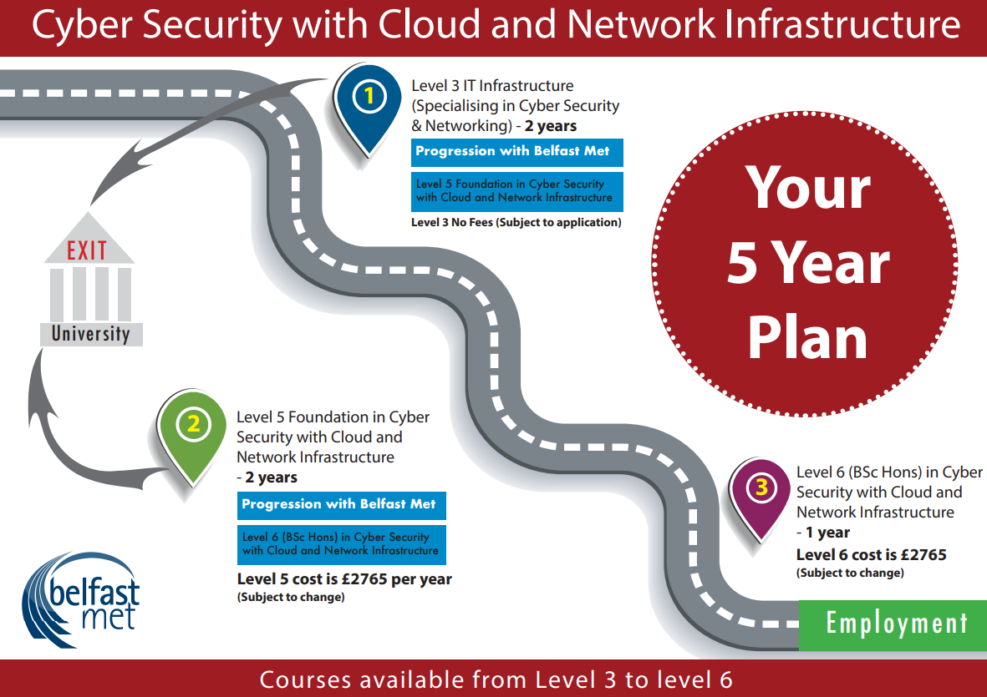
This curriculum area (IT Services) has created this marketing poster to help reinforce the progression routes that students have when they enrol on Level 3 IT courses.

Course Structure
There are two proposed modes of delivery full time and part time.

Modes of Delivery/Student Pathways
The programme will be offered in two different modes of delivery:
- Full Time
- Part time (HLA Pathway)

The format of these modes of delivery are:
- Full-time
  - 2-year, 2 semesters each year full time pathway is aimed at students who will attend the programme on a full time basis. Full time students are timetabled for 16 hours each week for 32 weeks each year of the programme. This mode will not have optional pathways in the second year.
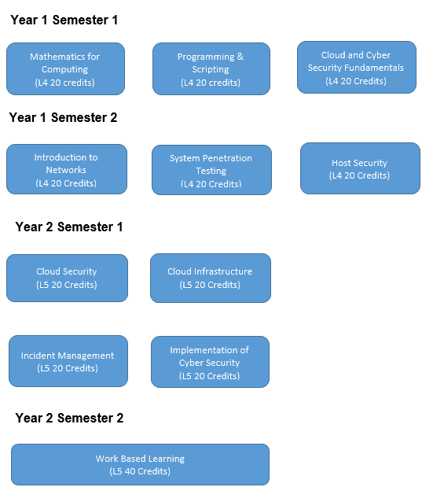

- Part Time (for Higher Level Apprentices)
  - 2 ½ year, 2 semesters each year part time pathway for a Higher-Level Apprenticeship programme. This delivery mode will be for apprentices attending the college 1 day per week over the duration of the programme. They will be employed in an apprenticeship Cloud or Network Infrastructure support role or Cyber Security Support role.
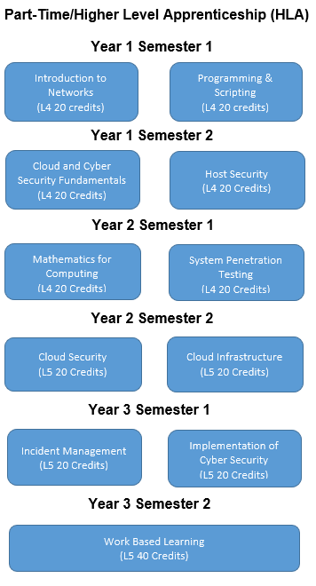

2.2 Relationship to other programmes and awards

(Where the award is part of a hierarchy of awards/programmes, this section describes the articulation between them, opportunities for progression upon completion of the programme, and arrangements for bridging modules or induction)

N/A

2.3 For Foundation Degrees, please list where the 60 credit work-related learning takes place. For apprenticeships an articulation of how the work based learning and academic content are organised with the award.
N/A

2.4 List of all exit awards

- Certificate in Higher Education in Cyber Security with Cloud and Network Infrastructure

- Foundation Degree in Cyber Security with Cloud and Network Infrastructure

3. Programme structure and learning outcomes

(The structure for any part-time delivery should be presented separately in this section.)

Programme Structure - LEVEL 4
Compulsory modules | Credit points | Optional modules | Credit points | Is module compensatable? | Semester runs in
Introduction to Networks  Host Security  Programming and Scripting  Cloud and Cyber Security Fundamentals  Mathematics for Computing  System Penetration Testing | 20  20  20  20  20  20 |  |  | Yes  Yes  Yes  Yes  Yes  Yes | 2  2  1  1  1  2

Intended learning outcomes at Level 4 are listed below:

3A. Knowledge and understanding
Learning outcomes: | Learning and teaching strategy/ assessment methods
A1: Appreciate and demonstrate through practice the fundamentals of cyber security.  A2: Appreciate the theory and practice of a range of computer networking hardware and network operating systems.  A3: Professional considerations: recognise the professional, economic, social, environmental, moral and ethical issues involved in the sustainable exploitation of computer. technology and be guided by the adoption of appropriate professional, ethical and legal practices.  A4: Modelling: use such knowledge and understanding in the modelling and design of computer based systems.  A5: Recognise a network engineering approach to the design and deployment of secure infrastructure solutions. | - Teaching and Learning Methods: Lectures, tutor directed tutorials, practical sessions, student led seminars and use of the College’s Virtual Learning Environment.  - Assessment Methods: Coursework related to assignments, case studies and projects, written unseen examinations, open book assessments, practical examination/observation and project reports.

3B. Cognitive skills
Learning outcomes: | Learning and teaching strategy/ assessment methods
B1: Specify and design computing security solutions to agreed standards.  B2: Computational thinking including its relevance to everyday life.  B3: Evaluate and test: explain the extent to which a computer based system meets the criteria defined for its current use and future development.  B4: Discuss relevant modern business practices.  B5: Relate professional, legal, moral and ethical issues to cyber security and infrastructure disciplines. | - Teaching and Learning Methods: Lectures, tutor directed tutorials, supervised practical sessions, student led seminars and use of the College’s Virtual Learning Environment.  - Assessment Methods: Coursework related to assignments, case studies and projects, written unseen examinations, open book assessments, presentations, practical examination/observation, project and placement reports.  - Application and use of online virtual labs that enable students to construct real life scenarios to experiment and test out practical approaches to simulate advanced network configurations.

3C. Practical and professional skills
Learning outcomes: | Learning and teaching strategy/ assessment methods
C1: The ability to specify and design reliable, secure and usable computer based systems.  C2: Apply best practice processes, techniques and tools for the development and documentation of security, network design and risk management.  C3: Communicate technical information to technical, management, user and academic audiences.  C4: Utilise computer and networking equipment effectively, based on an understanding of its hardware and software elements.  C5: Assess problem solving using case studies on the economic issues, which influence organisations in an industrial context.  C6: Develop effective solutions to practical problems individually and as a member of a team. | - Teaching and Learning Methods: Lectures, tutor directed tutorials, student led seminars, supervised practical sessions and self directed learning employing study packs and use of the College’s Virtual Learning Environment.  - Assessment Methods: Coursework related to assignments, case studies and projects, written unseen examinations, open book assessments, presentations, practical examination/observation, project and placement reports.  - Application and use of online virtual labs that enable students to construct real life scenarios to experiment and test out practical approaches to simulate advanced network configurations.  - Site visits to organisation and companies to reflect on industry standards, procedures, best practice and current trends.  - Use of work based learning unit and case studies to build on knowledge and apply theoretical concepts and practical skills to real life situations.  - Employ case studies in online virtual laboratories to test out advanced network security concepts.

3D. Key/transferable skills
Learning outcomes: | Learning and teaching strategy/ assessment methods
D1: Students are expected to develop a wide range of generic skills to ensure they become effective in the workplace, to the benefit of themselves, their employer and the wider economy.  D2: The ability to construct well argued and grammatically correct documents and communicate these effectively, using a range of media and with a variety of audiences.  D3: Team working and management; the ability to recognise and make best use of the skills and knowledge of individuals to collaborate. To be able to identify problems and desired outcomes and negotiate to mutually acceptable conclusions. To understand the role of a leader in setting direction and taking responsibility for actions and decisions.  D4: Self management; self awareness and reflection, goal setting and action planning, independence and adaptability, acting on initiative, innovation and creativity. The ability to work unsupervised, plan effectively and meet deadlines and respond readily to changing situations and priorities.  D5: Interaction; reflection and communication, the ability to succinctly present rational and reasoned arguments that address a given problem or opportunity, to a range of audiences (orally, electronically or in writing). | - Teaching and Learning Methods: Lectures, tutorials, practical sessions and Work-based Learning.  - Assessment Methods: Placement report assessment, written unseen examinations, open book assessments, presentations and coursework.

Exit award Level 4 is a Certificate of Higher Education in Cyber Security with Cloud and Network Infrastructure

Programme Structure - LEVEL 5
Compulsory modules | Credit points | Optional modules | Credit points | Is module compensatable? | Semester runs in
Cloud Security  Incident Management  Work based Learning  Cloud Infrastructure  Implementation of Cyber Security | 20  20  40  20  20 |  |  | Yes  Yes  No  Yes  Yes | 1  1  2  1  1

Intended learning outcomes at Level 5 are listed below:

3A. Knowledge and understanding
Learning outcomes: | Learning and teaching strategy/ assessment methods
A1: Appreciate in some depth and demonstrate through practice knowledge of cyber security.  A2: Appreciate the theory and practice of a range of computer networking hardware and network operating systems.  A3: Professional considerations: recognise the professional, economic, social, environmental, moral and ethical issues involved in the sustainable exploitation of computer technology and be guided by the adoption of appropriate professional, ethical and legal practices.  A4: Modelling; use such knowledge and understanding in the modelling and design of computer based systems for the purposes of comprehension, communication, prediction and the understanding of trade offs.  A5: Apply a network engineering approach to the design and deployment of secure infrastructure solutions. | - Teaching and Learning Methods: Lectures, tutor directed tutorials, practical sessions, student led seminars and use of the College’s Virtual Learning Environment.  - Assessment Methods: Coursework related to assignments, case studies and projects, written unseen examinations, open book assessments, practical examination/observation and project reports.

3B. Cognitive skills
Learning outcomes: | Learning and teaching strategy/ assessment methods
B1: Specify, design and implement computing security solutions to agreed standards.  B2: Computational thinking including its relevance to everyday life.  B3: Critical evaluation and testing: analyse the extent to which a computer based system meets the criteria defined for its current use and future development.  B4: Analyse and deploy relevant modern business practices.  B5: Relate professional, legal, moral and ethical issues to cyber security and infrastructure disciplines. | - Teaching and Learning Methods; Lectures, tutor directed tutorials, supervised practical sessions, student led seminars and use of the College’s Virtual Learning Environment.  - Assessment Methods; Coursework related to assignments, case studies and projects, written unseen examinations, open book assessments, presentations, practical examination/observation, project and placement reports.  - Application and use of online virtual labs that enable students to construct real life scenarios to experiment and test out practical approaches to simulate advanced network configurations.

3C. Practical and professional skills
Learning outcomes: | Learning and teaching strategy/ assessment methods
C1: The ability to specify, design and construct reliable, secure and usable computer based systems.  C2: Apply best practice processes, techniques and tools for the development and documentation of security, network design and risk management  C3: Communicate technical information to technical, management, user and academic audiences.  C4: Utilise computer and networking equipment effectively, based on an understanding of its hardware and software elements.  C5: Assess and apply problem solving using case studies on the economic issues, which influence organisations in an industrial context.  C6: Develop effective solutions to practical problems individually and as a member of a team. | - Teaching and Learning Methods; Lectures, tutor directed tutorials, student led seminars, supervised practical sessions and self directed learning employing study packs and use of the College’s Virtual Learning Environment.  - Assessment Methods; Coursework related to assignments, case studies and projects, written unseen examinations, open book assessments, presentations, practical examination/observation, project and placement reports.  - Application and use of online virtual labs that enable students to construct real life scenarios to experiment and test out practical approaches to simulate advanced network configurations.  - Site visits to organisation and companies to reflect on industry standards, procedures, best practice and current trends.  - Use of work based learning unit and case studies to build on knowledge and apply theoretical concepts and practical skills to real life situations.  - Employ case studies in online virtual laboratories to test out advanced network security concepts.

3D. Key/transferable skills
Learning outcomes: | Learning and teaching strategy/ assessment methods
D1: Students are expected to develop a wide range of generic skills to ensure they become effective in the workplace, to the benefit of themselves, their employer and the wider economy.  D2: The ability to construct well argued and grammatically correct documents and communicate these effectively, using a range of media and with a variety of audiences.  D3: Team working and management; the ability to recognise and make best use of the skills and knowledge of individuals to collaborate. To be able to identify problems and desired outcomes and negotiate to mutually acceptable conclusions. To understand the role of a leader in setting direction and taking responsibility for actions and decisions.  D4: Self management; self awareness and reflection, goal setting and action planning, independence and adaptability, acting on initiative, innovation and creativity. The ability to work unsupervised, plan effectively and meet deadlines, and respond readily to changing situations and priorities.  D5: Interaction; reflection and communication; the ability to succinctly present rational and reasoned arguments that address a given problem or opportunity, to a range of audiences (orally, electronically or in writing).  D6: Apply problem solving and critical thinking, making a case, numeracy and literacy, information literacy. | - Teaching and Learning Methods; Lectures, tutorials, practical sessions and Work based Learning.  - Assessment Methods; Placement report assessment, written unseen examinations, open book assessments, presentations and coursework.

Exit award at Level 5 is Foundation Degree in Cyber Security with Cloud and Network Infrastructure

4. Distinctive features of the programme structure
- Where applicable, this section provides details on distinctive featurs such as:
- where in the structure above a professional/placement year fits in and how it may affect progression
- any restrictions regarding the availability of elective modules
- where in the programme structure students must make a choice of pathway/route
- Additional considerations for apprenticeships:
- how the delivery of the academic award fits in with the wider apprenticeship
- the integration of the ‘on the job’ and ‘off the job’ training
- how the academic award fits within the assessment of the apprenticeship

It is predicated that there will be a shortfall of 10,000 skilled IT workers in Northern Ireland by 2026. Globally, Cyber Security is one of the fastest growing areas in IT with a predicted global shortfall of 3.5 million skilled cyber security professionals by 2021. The Northern Ireland government has set a target of 5,000 cyber security professionals in Northern Ireland by 2030.

One of the aims of the Foundation Degree in Cyber Security & Networking Infrastructure delivered at the College since it was validated in 2018 was to help achieve of the goals in the National Cyber Security Strategy document of 2016. This goal states that “The UK requires more talented and qualified cyber security professionals. The Government will act now to plug the growing gap between demand and supply for key cyber security roles and inject renewed vigour into this area of education and training.” The strategy explains various methods and approaches to achieve this goal; one of these is by “creating higher and degree level apprenticeships within the energy, finance and transport sectors to address skills gaps in essential areas.” In a follow up, mid-point review of the National Cyber Security Strategy access to talent was still found to be a problem. The UK Cyber Security Sectoral Analysis 2020 review found that “Three out of every five cyber security businesses are reporting that there is a lack of candidates within the labour market with the cyber security skills that they need. Whilst high remuneration has reflected the challenge in securing staff, there is a risk that without sufficient throughput of new talent into the cyber security sector, further growth may be significantly challenging. Against the backdrop of high demand for cyber security talent, the sector may experience opportunity costs (e.g. inability to service contracts or grow beyond a certain scale) if the skills gap is not tackled in the coming years.”

This Foundation Degree in Cyber Security with Cloud and Network Infrastructure will be employed on a Higher-Level Apprenticeship in Cyber Security with Cloud and Network Infrastructure as well as full time programmes. One of the aims for this Foundation Degree is to allow for progression routes for Level 3 students. Completing Foundation Degree will then be able to articulate to the BSc (Hons) programme.

This curriculum area (IT Services) within the College has an excellent track record in the field of Cyber Security and Cloud and Network Infrastructure through numerous Department of the Economy, Invest NI and Assured Skills funded Cyber Security and Cloud and Network Infrastructure Academies. These programmes include; two Cyber Security for Microsoft in Azure Security and DevSecOps; Cyber Security Analysts academies for PWC, Novosco and Neueda; Network and Telecommunication academies for Metaswitch; Cyber Security Consultant academy for KPMG. As well as developing and delivering on these high profile academies this curriculum area has delivered Level 3 and Level 5 IT Apprenticeships in Cyber Security, Networking and Digital Forensics for the past 12 years and recruited over ninety apprentices this academic year. This, plus the College’s strong employer engagement in the IT sector has been instrumental in the college proposing the revalidation of this Foundation Degree in in Cyber Security with Cloud and Network Infrastructure.

The course team has strong links with other academic institutions having visited Felician University in Newark, Deltion College in the Netherlands and Ravensborne University in London to discuss/work on course collaboration and other Cyber Security and Networking ventures. The course team also have good links with the Networking and Cyber Security team at Napier University. The team also had a chance to review Napier’s teaching environment used to deliver HE Cyber Security and Networking modules and degrees. This collaboration has been beneficial to helping the programme team better understand the framework requirements of offering higher education qualifications in Cyber Security. Representatives from Napier University make annual trips to the various Level 5 IT programmes running in the college to discuss opportunities for the College students.

The course team engages with employers throughout the year on employer initiatives, work placements and curriculum development and also annually at an industry forum. The course team use these engagements to better understand the requirements of employers and their needs for skilled Cyber Security professionals. These employers/organisations include, Allstate, NICS (Northern Ireland Civil Service), Fujitsu, Citi, Allen & Overy, NI Cyber Security Centre, Ernst and Young, Capita, Rapid 7 and Danksebank. These employers and others have had an input into the teaching of the current curriculum and the proposed Level 5 and 6 curriculum which reflect the needs of current trends in Cyber Security and Cloud and Network Infrastructure.

Further features of the proposed course are: -
- Student learning is based around individual development needs.
- Individual student programme of study applied within the context of their workplace and endorsed by their employer (only applies to apprentices).
- The programme comprises a mixture of advanced network and cyber security operation skills based modules alongside a final year project (with employer input for apprentices).
- The programme structure allows for modules that can be designed to focus on the specific needs of a particular employer.
- The programme allows for a flexible study mode that enables students to engage with elements of the programme in response to specific professional development requirements or undertake a fully structured programme of study leading to the final qualification.
- Students will have access to the latest Cloud VM resources developed by Microsoft with access to Microsoft Azure Labs, which is an enhanced classroom Cloud environment. Students will also have access to their own Azure Tenancy for project work.
- Students will have access to the latest learning material for a variety of industrial qualifications as well as having the flexibility to undertake any of the industrial qualifications that are available. These courses will be offered to students free of charge.

Programme model
Programme Pathway | Years of Study | Semesters per year | Target group
Full Time | 2 years | 2 | Aimed at full time students who will attend the college on a full-time basis.
Part Time | 2 ½ years | 2 | Aimed at students enrolling on a Higher-Level Apprenticeship.  These will be newly employed apprenticeships recruited by the organisation or company, employees with new responsibilities/duties in the area of Cloud and Applications Development or Level 3 Apprenticeships who are progressing to a Level 5 Higher Level Apprenticeship.

- For the past two years (20-21 & 21-22) recruitment has increased to 91 and 103 respectively.
- Level 5 HLA apprentices numbers have been 51 and 54 over the past two years, respectively.
- The college aims to attract the following intake:
  - 40 Full Time students for the Foundation Degree in Cyber Security with Cloud and Network Infrastructure.
  - 20 Full Time students for the Foundation Degree in Software and Cloud Development with Data Analysis.
  - 30 HLA Apprentices for the Foundation Degree in Cyber Security with Cloud and Network Infrastructure.
  - 30 HLA Apprentices for the Foundation Degree in Software and Cloud Development with Data Analysis.
Level 3 Apprenticeship / Full Time Further Education Progression Route

The Foundation Degree in Cyber Security with Cloud and Network Infrastructure sits within the broad suite of computing, electronics and multimedia courses offered by the school.
The School of Creative and Digital Industries provides a range of computing related courses which facilitate students’ access to Higher Education including the following:

- OCR Cambridge Technical Extended Diploma in IT (3 A Level Equivalent)
  - Cyber Security Pathway
  - Software Development Pathway
  - Computing Infrastructure Pathway
- Extended Diploma in Creative Media Production - Interactive Media (3 A Level Equivalent)
- Extended Diploma in Electrical/Electronic Engineering (3 A Level Equivalent)
- L3 Apprenticeship in IT and Telecoms
The School also offers a range of Higher Education Courses:
- HND/C in Computing and Systems Development
- HND Electronics
- HND Games Development
- Foundation Degree in Science in Software Engineering
- Foundation Degree in Science in Interactive Systems Design

5. Support for students and their learning.
(For apprenticeships this should include details of how student learning is supported in the work place)

The College offers a variety of means to support students including:
- Student Careers Advice, Guidance and Counselling
- Student Disability Services
- Student Finance
- Students’ Union
- The Faith Room & Equality & Diversity
- The Buttle Trust
- Safeguarding
- Times of Difficulty
- Belfast Met’s Student Council
- NUS-USI
- Belfast as a City of Learning
- Administration Services

Full details are available within the Student Support Handbook, available online and at reception/ students’ union in every campus.
The College currently uses Canvas as its Virtual Learning Environment. The College is currently working on a migration project to replace the Virtual Learning Environment with Canvas. Each course has a timetabled personal tutorial/advice support and subject module tutorials that will enhance the student’s learning experience.

6. Criteria for admission
(For apprenticeships this should include details of how the criteria will be used with employers who will be recruiting apprentices.)

Applicants must:
Hold 64 tariff points, GCSEs at C or above in English and Mathematics, or equivalent qualifications, such as Level 2 Essential Skills in Maths and English.

Specific requirements of the programme –
- Each apprentice is either a new employee or is taking on a new job role, with an existing employer, commensurate to the apprenticeship being pursued
- an appropriate Apprenticeship Agreement is in place with the employer
Applicants who have already attained a qualification equivalent to or similar in content to any of the Foundation Degree modules will be eligible to be considered for Accreditation of Prior Certificated Learning (APCL). Those who have acquired learning through life, work experience and study not previously attested through formal education or certification may be eligible to be considered for Accreditation of Prior Experiential Learning (APEL). Applicants that obtain APCL or APEL for all year 1 modules can start at year 2 of the programme. Applicants with APCL or APEL for some modules in year 1, but not all modules, can take the year in part in order to complete the remaining modules.
The process is detailed in the College Accreditation of Prior Learning in Higher Education Standard Operating Procedure. In such cases the onus will be on the student to present relevant evidence to the Course Director so that assessment of prior learning may be carried out by the course team in accordance with the standard operating procedure.
Pre-enrolment
The application and enrolment process involves the following steps.
- Initially students need to apply for the course, see How to apply section for further advice on what to do next.
- Once the application has been received, they will be invited to attend a pre-entry advice and guidance (PEAG) session. Attendance to the session is mandatory.
- Following attendance at the PEAG session, the applicant will be either
  - Invited to enrol immediately
  - Receive an offer
  - Placed on waiting list
  - Application unsuccessful
- If the applicant receives an offer, they will be given an appointment to come into the College once they receive their examination results. The applicant must attend the appointment otherwise the offer will be withdrawn.
- If applicant is invited to enrol, they can contact the course team to organise an appointment in order to enrol on the course.

Boot Camp (BC)
Boot Camp (BC) is a 6 day program required for all students accepted to both the Cyber Security with Cloud and Network Infrastructure and the Software and Cloud Development with Data Analysis. The Boot Camp is an intensive experience and will include a variety of activities to prepare students for the transition to academic study with assessment at the end of the programme.
Boot Camp offers students a unique opportunity to work independently and in small groups with the Belfast Met faculty and the staff who are dedicated to helping their students develop the range of skills needed to become successful Open University students. These activities will help students build academic skills and social connections, develop their awareness and understanding of a variety of college resources and encourage them to develop a strong support system that includes fellow students, Belfast Met faculty and professional staff.

7. Language of study

English

8. Information about non-OU standard assessment regulations (including PSRB requirements)

N/A

9. For apprenticeships in England End Point Assessment (EPA).
(Summary of the approved assessment plan and how the academic award fits within this and the EPA)
N/A

10. Methods for evaluating and improving the quality and standards of teaching and learning.
The Programme is managed and operated in accordance with College and Open University regulations and procedures. This will include representation and input from employers who will contribute to curriculum development and review. Reports will be made to the College’s Quality Department (and the Awarding Body) which will take appropriate action including reviews and audits to continually enhance the programme.

College standard mechanisms for review and evaluation of teaching, learning and assessment of the curriculum and outcome standards include: -
- Formal cycle of student engagement and feedback to include Module Evaluations, Course Evaluations and Staff Student Consultative Committees;
- Annual Programme Review;
- External Examiners visits;
- College internal quality assurance arrangements including internal auditing of programme management;
- External quality assurance arrangements;
- Staff Appraisal; and
- Staff development including scholarly activity.

The committees with responsibility for monitoring, evaluating and improving quality include
- Internally
  - The Centre for Curriculum Quality Assurance and Performance Development;
  - HE Coordinators Forum;
  - HE Quality Forum;
  - Monthly Performance review Process; and
  - Management through the Appraisal Process.
- Externally
  - External Examiners; and
  - The Quality Assurance Agency.

Mechanisms for gaining student feedback on the quality of their learning experience include: -
- Formal cycle of student engagement and feedback to include Module Evaluations, Course Evaluations and Staff Student Consultative Committees;
- Weekly personal tutor review of student progress/e-ILP (Individual Learning Plan); and
Supervised Work based learning visits and reports – where applicable.

10. Changes made to the programme since last (re)validation
There has been one major development with the introduction of a new module (Block Architecture), which replaced the Information security module.

Annexe 1: Curriculum map
Annexe 2: Curriculum mapping against the apprenticeship standard or framework (delete if not required.)
Annexe 3: Notes on completing the OU programme specification template

Annexe 1 - Curriculum map
This table indicates which study units assume responsibility for delivering (shaded) and assessing (ü) particular programme learning outcomes.

 |  | Programme outcomes
Level | Study module/unit | A1 | A2 | A3 | A4 | A5 | B1 | B2 | B3 | B4 | B5 | C1 | C2 | C3 | C4 | C5 | C6 | D1 | D2 | D3 | D4 | D5
4 | Introduction to Networks | ü | ü |  | ü | ü | ü |  | ü | ü |  | ü | ü |  | ü |  | ü |  | ü | ü |  | ü
 | Host Security | ü | ü | ü | ü | ü | ü | ü | ü |  |  |  | ü |  | ü |  |  | ü |  | ü | ü
 | Programming and Scripting | ü |  | ü |  | ü |  | ü | ü |  |  | ü | ü | ü |  | ü | ü | ü |  | ü | ü
 | Cloud and Cyber Security Fundamentals | ü | ü | ü |  | ü |  | ü | ü | ü | ü | ü | ü | ü | ü |  | ü | ü |  |  |  | ü
 | Mathematics for Computing | ü | ü |  |  | ü | ü | ü |  |  |  | ü |  | ü |  |  | ü |  |  | ü | ü | ü
 | System Penetration Testing | ü | ü | ü |  | ü | ü | ü |  | ü | ü | ü | ü |  | ü |  | ü | ü | ü | ü | ü | ü

 |  | Programme outcomes
Level | Study module/unit | A1 | A2 | A3 | A4 | A5 | B1 | B2 | B3 | B4 | B5 | C1 | C2 | C3 | C4 | C5 | C6 | D1 | D2 | D3 | D4 | D5 | D6
5 | Cloud Security | ü | ü |  | ü | ü | ü | ü | ü |  | ü | ü | ü | ü | ü | ü | ü | ü |  |  |  | ü
 | Cloud Infrastructure | ü | ü |  | ü | ü | ü | ü | ü | ü | ü |  | ü | ü | ü | ü | ü | ü |  | ü | ü
 | Implementation of Cyber Security | ü | ü | ü |  | ü | ü | ü | ü | ü | ü | ü | ü |  | ü |  | ü | ü | ü | ü | ü | ü | ü
 | Incident Management | ü | ü | ü | ü | ü | ü | ü | ü | ü | ü |  | ü | ü | ü | ü | ü | ü | ü | ü | ü | ü | ü
 | Work based Learning | ü | ü |  | ü | ü | ü | ü |  | ü | ü | ü | ü | ü |  | ü | ü | ü | ü | ü | ü | ü

Annexe 2: Notes on completing programme specification templates

1 - This programme specification should be mapped against the learning outcomes detailed in module specifications.

2 – The expectations regarding student achievement and attributes described by the learning outcome in section 3 must be appropriate to the level of the award within the QAA frameworks for HE qualifications: http://www.qaa.ac.uk/AssuringStandardsAndQuality/Pages/default.aspx

3 – Learning outcomes must also reflect the detailed statements of graduate attributes set out in QAA subject benchmark statements that are relevant to the programme/award: http://www.qaa.ac.uk/AssuringStandardsAndQuality/subject-guidance/Pages/Subject-benchmark-statements.aspx

4 – In section 3, the learning and teaching methods deployed should enable the achievement of the full range of intended learning outcomes. Similarly, the choice of assessment methods in section 3 should enable students to demonstrate the achievement of related learning outcomes. Overall, assessment should cover the full range of learning outcomes.

5 - Where the programme contains validated exit awards (e.g. CertHE, DipHE, PGDip), learning outcomes must be clearly specified for each award.

6 - For programmes with distinctive study routes or pathways the specific rationale and learning outcomes for each route must be provided.

7 – Validated programmes delivered in languages other then English must have programme specifications both in English and the language of delivery.

