Programme specification

(Notes on how to complete this template are provide in Annexe 3)

1. Overview/ factual information
Programme/award title(s) | BSc (Hons) Software and Cloud Development with Data Science (Top Up)  FD Software and Cloud Development with Data Science
Teaching Institution | Belfast Metropolitan College
Awarding Institution | The Open University (OU)
Date of first OU validation | 2018
Date of latest OU (re)validation | Nov 2022
Next revalidation | 2028
Credit points for the award | 240
UCAS Code | N/A
HECoS Code | 100376
LDCS Code (FE Colleges) | N/A
Programme start date and cycle of starts if appropriate. | September 2023
Underpinning QAA subject benchmark(s) | - QAA Computing – March 2022  - CSE C2017 - CyberSecurity  - IT 2017 – Information Technology
Other external and internal reference points used to inform programme outcomes.  For apprenticeships, the standard or framework against which it will be delivered. | N/A
Professional/statutory recognition | N/A
For apprenticeships fully or partially integrated Assessment. | N/A
Mode(s) of Study (PT, FT, DL,  Mix of DL & Face-to-Face)  Apprenticeship | FT and PT
Duration of the programme for each mode of study | FT (2 year) and PT (2 ½ years)
Dual accreditation (if applicable) | N/A
Date of Production/Revision of this specification | 16/01/2023

Please note: This specification provides a concise summary of the main features of the programme and the learning outcomes that a typical student might reasonably be expected to achieve and demonstrate if s/he takes full advantage of the learning opportunities that are provided.
More detailed information on the learning outcomes, content, and teaching, learning and assessment methods of each module can be found in student module guide(s) and the students handbook.
The accuracy of the information contained in this document is reviewed by the University and may be verified by the Quality Assurance Agency for Higher Education.

2.1 Educational aims and objectives
Belfast Metropolitan College (the College) was established in 2007 following the merger of Belfast Institute of Further and Higher Education and Castlereagh College. The College has four sites across Belfast where it delivers higher education. The College delivers higher education across more than 30 subject areas in partnership with a number of universities (awarding bodies) including The Open University, Queen's University, Ulster University and the University of Dundee. The College runs a number of higher national diplomas and certificates in conjunction with Pearson and delivers a number of higher education professional and vocational courses with professional awarding organisations. The College also offers higher level apprenticeships in: cyber security with cloud and network infrastructure; software and cloud development with data analysis; civil engineering; and accounting.

The College's vision is to be a world class college that nurtures the talent and ambition of the City of Belfast and beyond. Its mission is to make a fundamental impact on the economic and social success of the city of Belfast and beyond by equipping its people, employers and communities with the education and skills for work and is supported by four strategic aims and four core values. The College works to meet its strategic aims through collaboration and membership of cross sector working groups, and Northern Ireland specific, national and international college forums and groups.

The college currently offers full-time and part-time HE programmes in association with 4 university partners and 10 awarding bodies. In 2021-2022 The college enrolled 1426 learners onto HE programmes. This is the largest HE in FE provision across the six FE colleges in Northern Ireland and the college is proud to have achieved its HE target and this demonstrates once again that demand for HE places exists in Belfast.

Since this Foundation Degree was validated there have been over 465 full time enrolments, not including the ever growing higher level apprenticeship programmes linked to this foundation degree. The Level 6 BSc (Hons) Top Up in Software, Cloud and Application Development validated in 2021 allows for excellent progression routes for successfully completing students. 47% of graduated students have already articulated to the Level 6 Top Up. Other articulation routes are:-
- Students are able to enrol on an Open University Top Up Degree IT offered through the Open University and complete four Level 6 modules.
- Students are able to enrol on year 3 IT programme at Napier University or Ravensbourne University
Other possible articulation routes are: -
- Students can apply for Level 6 courses at the other two local Universities (Ulster University or Queens University) but will only gain entry onto to year 1 or year 2 (under consideration with distinctions in all Level 4 and Level 5 modules).
- Other UK Universities that the college is currently exploring articulation agreements with.
The college’s Corporate Plan sets out the College’s ambitions for the future which are closely aligned to meeting the current and future skills demands of the city’s workforce in “leading the city to work”. The College has a dual mandate of economic development and social inclusion. The college has identified four strategic aims, which will provide the foundation for strengthening its position as a key partner in the success of Belfast. These aims are-
1. Determined Relevance – this includes maximising student attainment and employability, investing in people and infrastructure to ensure that staff are equipped with knowledge and expertise to deliver excellence, ensuring employer needs are met and working with local communities to help people into training or employment.
2. Valued Reputation – this entails delivering high quality teaching and learning, building relationships with external stakeholders, influencing and informing policy and decision making and ensuring that teaching practices reflect global best practice through working with international partners.
3. Agile Response – this consists of supporting an agenda of inclusion, developing college employee skills and capabilities to meet the needs of all stakeholders and investment in technology to provide flexible and innovative delivery models, engagement with local, national and international employers to meet their skills needs and proactively responding to the opportunities and challenges that new policies present.
4. Distinctive Reach- this covers providing access and progression opportunities for all, working with local, national and international employers and employers of every size to meet current, specific and future skills demands, consolidating our estate to provide modern thriving hubs and taking advantage of technology to expand the reach of the college.

This Level 5 Foundation Degree programme aims to address all four of these strategic aims through local, national and global employer engagement, highly relevant and technical staff development, responding to external stakeholder’s needs, and delivery of highly relevant and technical programmes.

The college’s expertise in this area is further evidenced through its successful involvement with Level 3 to Level 6 IT Apprenticeships with over 600 ICT apprentices undertaking these in the past 10 years from a range of employers. The strengths of these IT Apprentice programmes were commended by Northern Ireland’s Education and Training Inspectorate in April 2018 including staff upskilling and student support. The College’s Higher Education provision in Computing and IT have also been commended by External Examiners and through validation and revalidation panels in terms of employer engagement, student support and meeting academic standards.
The Government, Inspectorate and external endorsements of the College’s IT provision are underpinned by the college's strong employer engagement in the ICT sector including its membership of the Regional IT Sector Partnership. The ICT Sector Partnership is a forum for qualification experts, employers and policy advisors to engage on apprenticeship development and related curriculum. It shall deliver an industry led agenda to support the development of skills in the ICT sector through the provision of apprenticeships and traineeships. The partnership is comprised of employers, employer representatives, further and higher education members, and experts supporting the development of awards/qualifications. The college is the Further Education representative on this Forum to ensure apprenticeships and traineeship employment opportunities and work placements in the ICT sector are consistent with current and future occupational needs and to advise on the awards/qualifications for proposed ICT apprenticeships and traineeships and their underpinning standards and assessment at all skills levels and across the full range of ICT occupations (e.g. software development; ICT infrastructure; data analytics etc.) based on industry intelligence.
The college has an excellent track record in the fields of Cyber Security and Networking Infrastructure and Software and Cloud Development through numerous Department of Economy (DFE) approved Cyber Security and Cloud and Software Development Academies (including Cyber Security, Networking, Machine Learning, Software Robotics and Data Analytics) (Assured skills training programme | nidirect).
This curriculum area (IT Services) started working with Microsoft (Chicago Inno - Microsoft discovers new wave of tech talent in Northern Ireland (bizjournals.com) and KPMG (Klynveld Peat Marwick Goerdeler) in 2020 on a number of Cyber Security and AI Academies in the Azure Cloud Platform. To date the curriculum area has delivered five Microsoft Academies (recruiting over 80 roles to Microsoft) and five Cyber Security/AI academies for KPMG (recruiting over 60 roles for KPMG). The aim of these academies is to help these employers establish Centres of Excellence in Cyber Security in Northern Ireland.
This curriculum area also has extensive experience of delivering programmes in Cyber Security, Networking, Software and Cloud technologies on full-time and apprenticeship courses at Levels 3, 4, 5 and 6 over the past 17 years. The college’s strong employer engagement in the ICT sector has been instrumental in the college proposing the BSc (Hons) in Cyber Security and Networking Fundamentals.
In a recent study into digital jobs and skills (“Jobs and Skills Report | Insights | Tech Nation”) the following finding was reported.
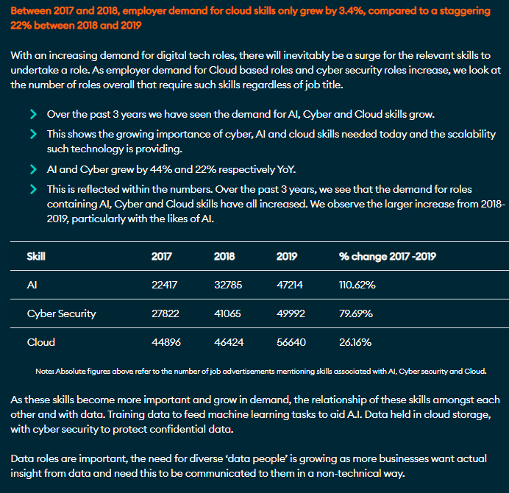
This shows a year on demand for Cloud based digital tech roles throughout the UK.
Within the same report, software developer roles were the most digital tech roles advertised in 2019. The top two advertised digital tech roles in 2019 throughout the UK regions are: -
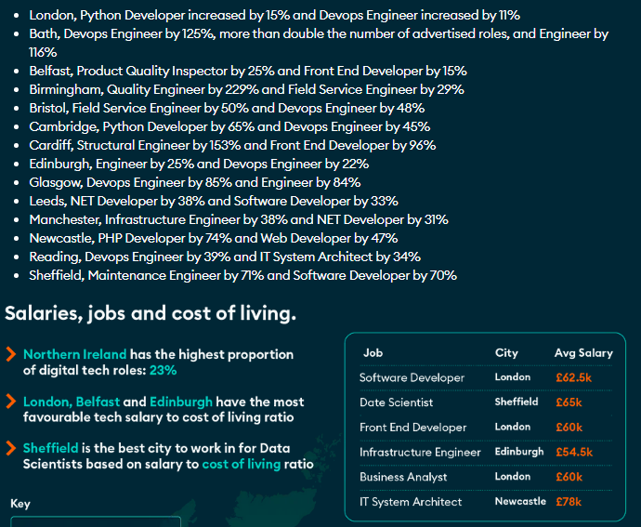
This shows that DevOps appears eight times throughout the UK. One of the main areas being addressed by this Top-Up degree is the area of DevOps.
The key points from the Northern Ireland Skills Barometer of 2021 are: -
- “Skills needs should be planned based upon an ambitious economic outlook, to avoid the economic costs associated with skills shortages.
- Under the high growth scenario the NI economy is forecast to grow from 902k jobs to 975k over the 2020-30 period.
- The scenario is typified by rapid growth in sectors with a high demand for higher level skills (e.g., professional services, ICT, advanced manufacturing etc.).
- Occupations directly linked to rapidly growing sectors will achieve high growth (e.g., ICT professionals). “
Analysis into employment growth from 2020 to 2030 is reported NI Skills Barometer Report 2021. The key findings stated in the report are, “the occupation with the largest growth over the next decade is forecast to be IT and telecommunications professionals (6.2k). This is directly linked to the growth of the ICT sector, and indirectly linked to an increased demand for digital skills across the wider economy.”
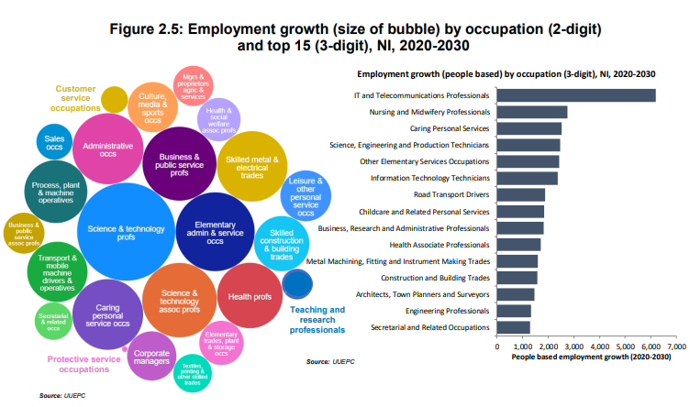
Key points from The Skills Barometer Report 2021 summary are: -
- “Flexibility to respond to changing demand – The implications of the pandemic on jobs illustrated the ability of NI’s education system to rapidly design and deliver formal courses across a range of qualification levels for priority areas (e.g. software development, data analytics, cyber security, leadership and management). This pragmatic approach to delivering courses within areas of high demand should be maintained moving forward. As NI is a relatively small region, a small flurry of inward investment announcements could alter the education requirements over a short period. Maintaining an agile, and responsive education system is essential for responding to rapidly changing demand.
- Digital skills: The demand for digital skills has been stressed during qualitative consultations and is supported by the modelling analysis. The demand for digital skills can be deconstructed into three components. Firstly, demand from the IT sector. As jobs in this sector are technical and require high level software and programming skills, it is difficult to recruit from non-IT backgrounds for these roles. Therefore, a lack of supply can hold back sector growth. Secondly, there has been significant growth for digital skills across all other sectors. There are sectors which have traditionally created a high number of digital roles such as financial services, professional services and the creative industries. However, there is now also significant demand for IT professionals in sectors not previously associated with a demand for IT graduates as firms undertake digital transformation across an increasing number of business functions. Thirdly, most roles, and wider society, now require digital competency. This does not create additional demand for IT graduates but implies that digital skills must be incorporated across all subject areas in the education system.”
The Foundation Degree in Software and Cloud Development with Data Analysis is designed to produce a graduate with higher level professional and technical skills, empowered for their current workplace as well as help address any projected shortfall in skilled workforce in the area of Software and Cloud Development and Data Analytics and Computing in general. Another aim for the programme is to allow for tangible progression routes for Level 3 students and provide these students with a five year plan which would take them from a level 3 programme through to a Level 6 qualification within the field of Software and Cloud Development and Data Analytics.

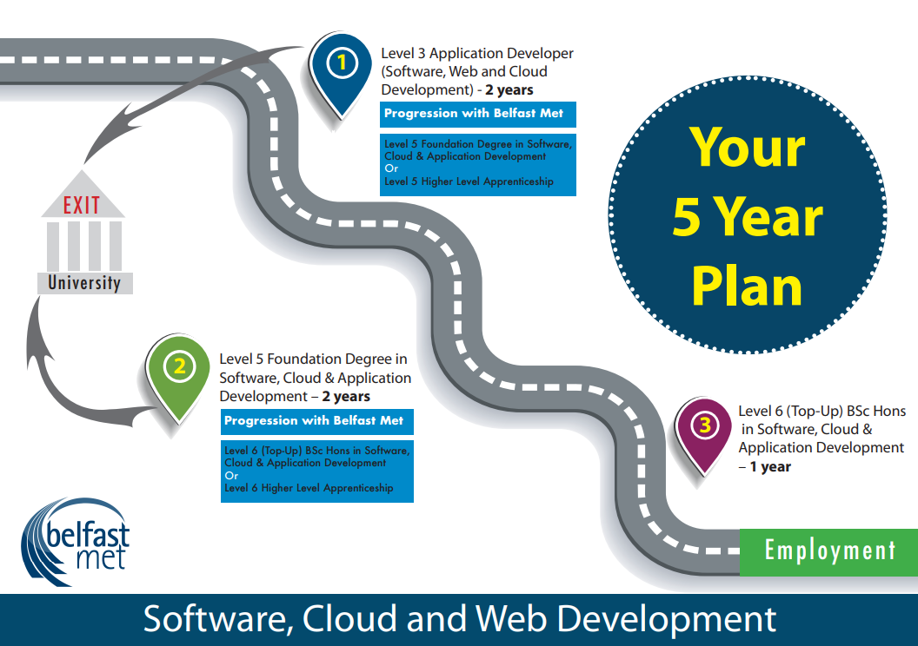
This curriculum area (IT Services) has created this marketing poster to help reinforce the progression routes that students have when they enrol on Level 3 IT courses.
Course Structure
There are two proposed modes of delivery full-time and part-time.

Modes of Delivery/Student Pathways
- Full-time
  - 2 year, 2 semester each year full time pathway is aimed at students who will attend the programme on a full time basis. Full time students are timetabled for 16 hours each week for 32 weeks each year of the programme. This mode will not have optional pathways in the second year;
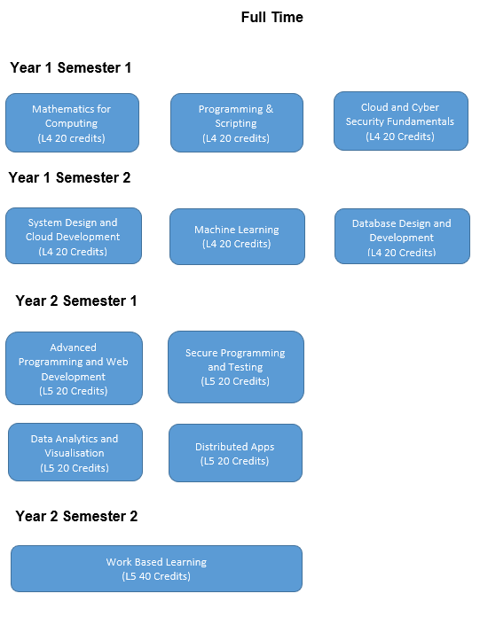

- Part Time (for Higher Level Apprentices)
  - 2 ½ year, 2 semester each year part time pathway for a Higher Level Apprenticeship programme. This delivery mode will be for apprentices attending the college 1 day per week over the duration of the programme. They will be employed in an apprenticeship Software/Cloud Development or Data Analysis role.
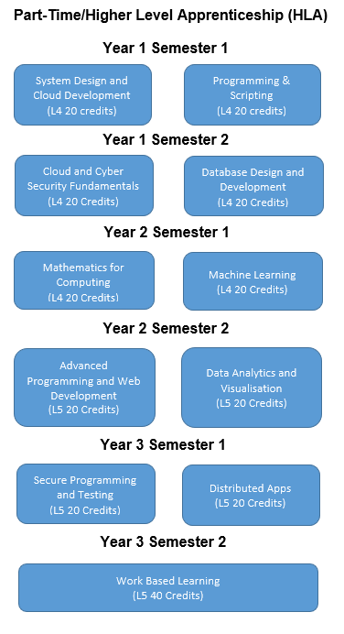

2.2 Relationship to other programmes and awards

(Where the award is part of a hierarchy of awards/programmes, this section describes the articulation between them, opportunities for progression upon completion of the programme, and arrangements for bridging modules or induction)

N/A

2.3 For Foundation Degrees, please list where the 60 credit work-related learning takes place. For apprenticeships an articulation of how the work based learning and academic content are organised with the award.
N/A

2.4 List of all exit awards

- Certificate in Higher Education in Software and Cloud Development with Data Analysis
- Foundation Degree in Software and Cloud Development with Data Analysis

3. Programme structure and learning outcomes

(The structure for any part-time delivery should be presented separately in this section.)

Programme Structure - LEVEL 4
Compulsory modules | Credit points | Optional modules | Credit points | Is module compensatable? | Semester runs in
Systems Design and Cloud Development  Programming and Scripting  Database Design and Development  Mathematics for Computing  Cloud and Cyber Security Fundamentals  Machine Learning | 20  20  20  20  20  20 |  |  | Yes  Yes  Yes  Yes  Yes  Yes | 2  1  2  1  1  2

Intended learning outcomes at Level 4 are listed below:

3A. Knowledge and understanding
Learning outcomes: | Learning and teaching strategy/ assessment methods
A1: Knowledge and understanding: demonstrate knowledge and understanding of essential facts, concepts, principles and theories relating to Computing and computer applications as appropriate to the programme of study.  A2: Become familiar with the theory and practice of a range of development environments and software technologies.  A3: Methods and tools: explain appropriate theory, practices and tools for the specification, design, implementation and evaluation of computer based systems.  A4: Demonstrate an understanding of the key professional, legal, moral and ethical issues involved in application development.  A5: Demonstrate through written and practical exercises a knowledge of current developments in a selection of software development technologies and applications.  A6: Investigate a software engineering approach to the design and deployment of secure application solutions. | - Teaching and Learning Methods: Lectures, tutor directed tutorials, practical sessions, student led seminars and use of the College’s Virtual Learning Environment.  - Assessment Methods: Coursework related to assignments, case studies and projects, written unseen examinations, open book assessments, practical examination/observation and project reports.

3B. Cognitive skills
Learning outcomes: | Learning and teaching strategy/ assessment methods
B1: An understanding of the scientific method and its applications to problem solving in this area.  B2: Review the extent to which a solution meets the criteria defined for its current use and future development.  B3: Design testing strategies to ensure the functionality, effectiveness, resilience and security of developed applications.  B4: Methods and tools: explain appropriate theory, practices and tools for the specification, design, implementation and evaluation of computer based systems.  B5: Professional considerations: recognise the professional, economic, social, environmental, moral and ethical issues involved in the sustainable exploitation of computer technology and be guided by the adoption of appropriate professional, ethical and legal practices. | - Teaching and Learning Methods: Lectures, tutor directed tutorials, supervised practical sessions, student led seminars and use of the College’s Virtual Learning Environment.  - Assessment Methods: Coursework related to assignments, case studies and projects, written unseen examinations, open book assessments, presentations, practical examination/observation, project and placement reports.  - Application `and use of online virtual labs that enable students to construct real life scenarios to experiment and test out practical approaches to simulate application development and cloud deployment.

3C. Practical and professional skills
Learning outcomes: | Learning and teaching strategy/ assessment methods
C1: Specify and design computing solutions.  C2: The ability to plan and manage projects to deliver computing systems within constraints of requirements, timescale and budget.  C3: Communicate technical information to technical, management, user and academic audiences.  C4: The ability to recognise any risks and safety aspects that may be involved in the deployment of computing systems within a given context.  C5: The ability to recognise complex problems, including those with incomplete information and devise appropriate solutions.  C6: Develop effective solutions to practical problems individually and as a member of a team. | - Teaching and Learning Methods: Lectures, tutor directed tutorials, student led seminars, supervised practical sessions and self directed learning employing study packs and use of the College’s Virtual Learning Environment.  - Assessment Methods: Coursework related to assignments, case studies and projects, written unseen examinations, open book assessments, presentations, practical examination/observation, project and placement reports.  - Application and use of online virtual labs that enable students to construct real life scenarios to experiment and test out practical approaches to simulate application development and cloud deployment.  - Site visits to organisations and companies to reflect on industry standards, procedures, best practice and current trends.  - Use of work based learning unit and case studies to build on knowledge and apply theoretical concepts and practical skills to real life situations.  - Employ case studies in online virtual labs to test out advanced Cloud and Internet Application Development concepts.

3D. Key/transferable skills
Learning outcomes: | Learning and teaching strategy/ assessment methods
D1: Students are expected to develop a wide range of generic skills to ensure they become effective in the workplace, to the benefit of themselves, their employer and the wider economy.  D2: The ability to construct well argued and grammatically correct documents and communicate these effectively, using a range of media and with a variety of audiences.  D3: Team working and management: the ability to recognise and make best use of the skills and knowledge of individuals to collaborate. To be able to identify problems and desired outcomes and negotiate to mutually acceptable conclusions. To understand the role of a leader in setting direction and taking responsibility for actions and decisions.  D4: Self-management: self awareness and reflection; goal setting and action planning; independence and adaptability; acting on initiative; innovation and creativity. The ability to work unsupervised, plan effectively and meet deadlines, and respond readily to changing situations and priorities.  D5: Interaction: reflection and communication: the ability to succinctly present rational and reasoned arguments that address a given problem or opportunity, to a range of audiences (orally, electronically or in writing). | - Teaching and Learning Methods: Lectures, tutorials, practical sessions and Work based Learning.  - Assessment Methods: Placement report assessment, written unseen examinations, open book assessments, presentations and coursework.

Exit award Level 4 is Certificate in Higher Education in Software and Cloud Development with Data Analysis

Programme Structure - LEVEL 5
Compulsory modules | Credit points | Optional modules | Credit points | Is module compensatable? | Semester runs in
Data Analytics and Data Visualisation  Secure Programming and Testing  Distributed Apps  Work Based Learning  Advanced Programming and Web Development | 20  20  20  40  20 |  |  | Yes  Yes  Yes  No  Yes | 1  1  1  2  1

Intended learning outcomes at Level 5 are listed below:

3. Programme outcomes

Foundation Degree intended learning outcomes are listed below.

3A. Knowledge and understanding
Learning outcomes: | Learning and teaching strategy/ assessment methods
A1: Knowledge and understanding: demonstrate knowledge and understanding of essential facts, concepts, principles and theories relating to Computing and computer applications as appropriate to the programme of study.  A2: Become familiar with the theory and practice of a range of development environments and software technologies.  A3: Methods and tools: deploy appropriate theory, practices and tools for the specification, design, implementation and evaluation of computer based systems.  A4: Demonstrate a sound understanding of the key professional, legal, moral and ethical issues involved in application development.  A5: Demonstrate through written and practical exercises a sound knowledge of current developments in a selection of software development technologies and applications.  A6: Apply a software engineering approach to the design and deployment of secure application solutions. | - Teaching and Learning Methods: Lectures, tutor directed tutorials, practical sessions, student led seminars and use of the College’s Virtual Learning Environment  - Assessment Methods: Coursework related to assignments, case studies and projects, written unseen examinations, open book assessments, practical examination/observation and project reports.

3B. Cognitive skills
Learning outcomes: | Learning and teaching strategy/ assessment methods
B1: An understanding of the scientific method and its applications to problem solving in this area.  B2: Evaluate the extent to which a solution meets the criteria defined for its current use and future development.  B3: Design and implement testing strategies to ensure the functionality, effectiveness, resilience and security of developed applications.  B4: Methods and tools: deploy appropriate theory, practices and tools for the specification, design, implementation and evaluation of computer based systems.  B5: Professional considerations: recognise the professional, economic, social, environmental, moral and ethical issues involved in the sustainable exploitation of computer technology and be guided by the adoption of appropriate professional, ethical and legal practices. | - Teaching and Learning Methods: Lectures, tutor directed tutorials, supervised practical sessions, student led seminars and use of the College’s Virtual Learning Environment.  - Assessment Methods: Coursework related to assignments, case studies and projects, written unseen examinations, open book assessments, presentations, practical examination/observation, project and placement reports.  - Application `and use of online virtual labs that enable students to construct real-life scenarios to experiment and test out practical approaches to simulate application development and cloud deployment.

3C. Practical and professional skills
Learning outcomes: | Learning and teaching strategy/ assessment methods
C1: Specify, design, construct and test computing solutions.  C2: The ability to plan and manage projects to deliver computing systems within constraints of requirements, timescale and budget.  C3: Communicate technical information to technical, management, user, and academic audiences.  C4: The ability to recognise any risks and safety aspects that may be involved in the deployment of computing systems within a given context.  C5: The ability to critically evaluate and analyse complex problems, including those with incomplete information, and devise appropriate solutions, within the constraints of a budget.  C6: Develop effective solutions to practical problems individually and as a member of a team. | - Teaching and Learning Methods: Lectures, tutor directed tutorials, student led seminars, supervised practical sessions and selfdirected learning employing study packs and use of the College’s Virtual Learning Environment.  - Assessment Methods: Coursework related to assignments, case studies and projects, written unseen examinations, open book assessments, presentations, practical examination/observation, project and placement reports.  - Application and use of online virtual labs that enable students to construct real life scenarios to experiment and test out practical approaches to simulate application development and cloud deployment.  - Site visits to organisations and companies to reflect on industry standards, procedures, best practice and current trends.  - Use of work based learning unit and case studies to build on knowledge and apply theoretical concepts and practical skills to real life situations.  - Employ case studies in online virtual labs to test out advanced Cloud and Internet Application Development concepts.

3D. Key/transferable skills
Learning outcomes: | Learning and teaching strategy/ assessment methods
D1: Students are expected to develop a wide range of generic skills to ensure they become effective in the workplace, to the benefit of themselves, their employer and the wider economy.  D2: The ability to construct well argued and grammatically correct documents and communicate these effectively, using a range of media and with a variety of audiences.  D3: Team working and management: the ability to recognise and make best use of the skills and knowledge of individuals to collaborate. To be able to identify problems and desired outcomes and negotiate to mutually acceptable conclusions. To understand the role of a leader in setting direction and taking responsibility for actions and decisions.  D4: Self-management: self awareness and reflection; goal setting and action planning; independence and adaptability; acting on initiative; innovation and creativity. The ability to work unsupervised, plan effectively and meet deadlines, and respond readily to changing situations and priorities.  D5: Interaction: reflection and communication: the ability to succinctly present rational and reasoned arguments that address a given problem or opportunity, to a range of audiences (orally, electronically or in writing).  D6: Apply problem solving and critical thinking; making a case; numeracy and literacy; information literacy. | - Teaching and Learning Methods: Lectures, tutorials, practical sessions and Work based Learning.  - Assessment Methods: Placement report assessment, written unseen examinations, open book assessments, presentations and coursework.

Exit award at Level 5 is Foundation Degree in Software and Cloud Development with Data Analysis

4. Distinctive features of the programme structure
- Where applicable, this section provides details on distinctive featurs such as:
- where in the structure above a professional/placement year fits in and how it may affect progression
- any restrictions regarding the availability of elective modules
- where in the programme structure students must make a choice of pathway/route
- Additional considerations for apprenticeships:
- how the delivery of the academic award fits in with the wider apprenticeship
- the integration of the ‘on the job’ and ‘off the job’ training
- how the academic award fits within the assessment of the apprenticeship

By offering Level 5 Foundation Degree in in Software and Cloud Development with Data Analysis, the College will be on the only academic institution to offer specific Cloud Technology based Foundation Degree, in new areas such as Azure, Blockchain, Data Analytics and Machine Learning.

One of the aims of the Foundation Degree in Software, Cloud and Application Development delivered at the College since it was validated in 2018 was to help address the shortage of Level 4 and Level 5 skilled applicants with Northern Ireland. chieve of the goals in the National Cyber Security Strategy document of 2016. This proposed programme will allow for articulation to the BSc (Hons) in Software, Cloud and Application Development (Top up) also offered by the college. Students enrolling will be employed on a Higher Level Apprenticeship in Software and Cloud Development with Data Analysis as well as full time programmes. One of the aims for the Foundation Degree in Software and Cloud Development with Data Analysis is to allow for progression routes for Level 3 students.

This curriculum area (IT Services) within the College has an excellent track record in the field of in Software and Cloud Development with Data Analysis through numerous Department of the Economy, Invest NI and Assured Skills funded Software, Cloud and Data Analytics Academies. These programmes include: two Cloud Academies for Microsoft in Azure AI and DevSecOps; Cloud Development academies for PWC, Deloitte and KPMG; Software Testing Academies; IOT Academy for Sensata; and Data Analytics for Deloitte, PWV and Microsoft. As well as developing and delivering on these high profile academies this curriculum area has delivered Level 3 and Level 5 IT Apprenticeships in Software Development, Software Engineering and Cloud Development for the past 12 years and recruited over 100 apprentices this academic year. This, plus the College’s strong employer engagement in the IT sector has been instrumental in the college proposing the revalidation of this Foundation Degree in Software and Cloud Development with Data Analysis.

The course team has strong links with other academic institutions having visited Felician University in Newark, Deltion College in the Netherlands and Ravensborne University in London. The course team also have good links with the Networking and Cyber Security team at Napier University. The links with these academic institutions allow for the exchange of good teaching practice and allow for international visits and student placements. This curriculum area also has a seat on the ICT Sectoral Partnership. This partnership includes all the major academic institutions in Northern and a range of large and SME in the digital sphere. One of the major purposes of this panel is the help address the shortage of skilled recruits in Northern Ireland.

The course team engages with employers throughout the year on employer initiatives, work placements and curriculum development and also annually at an industry forum. The course team use these engagements to better understand the requirements of employers and their needs for skilled Cloud and Software Developers. These employers/organisations include, Allstate, NICS (Northern Ireland Civil Service), Fujitsu, Citi, Allen & Overy, Ernst & Young, Capita, Rapid 7 and Danksebank. These employers and others have an input into the teaching of the current curriculum and the current and proposed Level 5 and 6 curriculum. Therefore, this reflects the needs of current trends in Software and Cloud Development with Data Analysis within Northern Ireland, the UK and internationally. HLA apprenticeship enrolments have increased each year since the initial programme validation.

Further features of the proposed course are: -
- Student learning is based around individual development needs.
- Individual student programme of study applied within the context of their workplace and endorsed by their employer (only applies to apprentices).
- The programme comprises a mixture of advanced Cloud tools and techniques and data modelling skill alongside a final year project (with employer input for apprentices).
- The programme allows for a flexible study mode that enables students to engage with elements of the programme in response to specific professional development requirements or undertake a fully structured programme of study leading to the final qualification.
- Students will have access to the latest Cloud VM resources developed by Microsoft with access to Microsoft Azure Labs, which is an enhanced classroom Cloud environment. Students will also have access to their own Azure Tenancy for project work.
- Students will have access to the latest learning material for a variety of industrial qualifications as well as having the flexibility to undertake any of the industrial qualifications that are available.

Programme model
Programme Pathway | Years of Study | Semesters per year | Target group
Full Time | 2 years | 2 | Aimed at full time students who will attend the college on a full-time basis.
Part Time | 2 ½ years | 2 | Aimed at students enrolling on a Higher-Level Apprenticeship.  These will be newly employed apprenticeships recruited by the organisation or company, employees with new responsibilities/duties in the area of Cloud and Applications Development or Level 3 Apprenticeships who are progressing to a Level 5 Higher Level Apprenticeship.

- For the past two year (2020-2021 and 2021-2022) recruitment has increased to 91 and 103 respectively.
- Level 5 HLA apprentices numbers have been 51 and 54 over the past two years, respectively.
- The college aims to attract the following intake:
  - 40 Full Time students for the Foundation Degree in Cyber Security with Cloud and Network Infrastructure.
  - 20 Full Time students for the Foundation Degree in Software and Cloud Development with Data Analysis.
  - 30 HLA Apprentices for the Foundation Degree in Cyber Security with Cloud and Network Infrastructure.
  - 30 HLA Apprentices for the Foundation Degree in Software and Cloud Development with Data Analysis.

Level 3 Apprenticeship / Full Time Further Education Progression Route

This Foundation Degree programme will sit within the broad suite of computing, electronics and multimedia courses offered by the school and ranging from level 1 to level 5.
The School of Creative and Digital Industries provides a range of computing related courses which facilitate students’ access to Higher Education including the following:

- OCR Cambridge Technical Extended Diploma in IT (3 A Level Equivalent)
  - Cyber Security Pathway
  - Software Development Pathway
  - Computing Infrastructure Pathway
- Extended Diploma in Creative Media Production - Interactive Media (3 A Level Equivalent)
- Extended Diploma in Electrical/Electronic Engineering (3 A Level Equivalent)
- L3 Apprenticeship in IT and Telecoms
The School also offers a range of Higher Education Courses:
- HND/C in Computing and Systems Development
- HND Electronics
- HND Games Development
- Foundation Degree in Science in Software Engineering
Foundation Degree in Science in Interactive Systems Design

5. Support for students and their learning.
(For apprenticeships this should include details of how student learning is supported in the work place)

The College offers a variety of means to support students including:
- Student Careers Advice, Guidance and Counselling
- Student Disability Services
- Student Finance
- Students’ Union
- The Faith Room & Equality & Diversity
- The Buttle Trust
- Safeguarding
- Times of Difficulty
- Belfast Met’s Student Council
- NUS-USI
- Belfast as a City of Learning
- Administration Services

Full details are available within the Student Support Handbook, available online and at reception/ students' union in every campus.

The college currently uses Canvas as its Virtual Learning Environment. The college is currently working on a migration project to replace the Virtual Learning Environment with Canvas. Each course has a timetabled personal tutorial/advice support and subject module tutorials that will enhance the student’s learning experience.

6. Criteria for admission
(For apprenticeships this should include details of how the criteria will be used with employers who will be recruiting apprentices.)

Applicants must:
Hold 64 tariff points, GCSEs at C or above in English and Mathematics, or equivalent qualifications, such as Level 2 Essential Skills in Maths and English.

Specific requirements of the programme –
- Each apprentice is either a new employee or is taking on a new job role, with an existing employer, commensurate to the apprenticeship being pursued
- an appropriate Apprenticeship Agreement is in place with the employer

Applicants who have already attained a qualification equivalent to or similar in content to any of the Foundation Degree modules will be eligible to be considered for Accreditation of Prior Certificated Learning (APCL). Those who have acquired learning through life, work experience and study not previously attested through formal education or certification may be eligible to be considered for Accreditation of Prior Experiential Learning (APEL). Applicants that obtain APCL or APEL for all year 1 modules can start at year 2 of the programme. Applicants with APCL or APEL for some modules in year 1, but not all modules, can take the year in part in order to complete the remaining modules.
The process is detailed in the College Accreditation of Prior Learning in Higher Education Standard Operating Procedure. In such cases the onus will be on the student to present relevant evidence to the Course Director so that assessment of prior learning may be carried out by the course team in accordance with the standard operating procedure.

Pre-enrolment
The application and enrolment process involves the following steps.
- Initially students need to apply for the course, see How to apply section for further advice on what to do next.
- Once the application has been received, they will be invited to attend a pre-entry advice and guidance (PEAG) session. Attendance to the session is mandatory.
- Following attendance at the PEAG session, the applicant will be either
  - Invited to enrol immediately
  - Receive an offer
  - Placed on waiting list
  - Application unsuccessful
- If the applicant receives an offer, they will be given an appointment to come into the College, once they receive their examination results. The applicant must attend the appointment otherwise the offer will be withdrawn.
- If applicant is invited to enrol, they can contact the course team to organise an appointment in order to enrol on the course.

Boot Camp (BC)
Boot Camp (BC) is a 6 day program required for all students accepted to both the Cyber Security and Networking Infrastructure and the Cloud and Application Development. The Boot Camp is an intensive experience and will include a variety of activities to prepare students for the transition to academic study with assessment at the end of the programme.
Boot Camp offers students a unique opportunity to work independently and in small groups with the Belfast Met faculty and the staff who are dedicated to helping their students develop the range of skills needed to become successful Open University students. These activities will help students build academic skills and social connections, develop their awareness and understanding of a variety of college resources, and encourage them to develop a strong support system that includes fellow students, Belfast Met faculty, and professional staff.

7. Language of study

English

8. Information about non-OU standard assessment regulations (including PSRB requirements)

N/A

9. For apprenticeships in England End Point Assessment (EPA).
(Summary of the approved assessment plan and how the academic award fits within this and the EPA)
N/A

10. Methods for evaluating and improving the quality and standards of teaching and learning.
The Programme is managed and operated in accordance with College and Open University regulations and procedures. This will include representation and input from employers who will contribute to curriculum development and review. Reports will be made to the College’s Quality Department (and the Awarding Body) which will take appropriate action including reviews and audits to continually enhance the programme.

College standard mechanisms for review and evaluation of teaching, learning and assessment of the curriculum and outcome standards include:-
- Formal cycle of student engagement and feedback to include Module Evaluations, Course Evaluations and Staff Student Consultative Committees;
- Annual Programme Review;
- External Examiners visits;
- College internal quality assurance arrangements including internal auditing of programme management;
- External quality assurance arrangements;
- Staff Appraisal; and
- Staff development including scholarly activity.

The committees with responsibility for monitoring, evaluating and improving quality include
- Internally
  - The Centre for Curriculum Quality Assurance and Performance Development;
  - HE Coordinators Forum;
  - HE Quality Forum;
  - Monthly Performance review Process; and
  - Management through the Appraisal Process.
- Externally
  - External Examiners; and
  - The Quality Assurance Agency.

Mechanisms for gaining student feedback on the quality of their learning experience include: -
- Formal cycle of student engagement and feedback to include Module Evaluations, Course Evaluations and Staff Student Consultative Committees;
- Weekly personal tutor review of student progress/e-ILP (Individual Learning Plan); and Supervised Work based learning visits and reports – where applicable.

10. Changes made to the programme since last (re)validation
There have been a number of developments to this programme since it’s initial validation. These developments are :-
- Two new modules, Machine Learning which replaced Application Development and Distributed Apps which replaced API Development and Management.
- The programme name was changed from Cloud and Application Development to Software, Cloud and Application Development.

Annexe 1: Curriculum map
Annexe 2: Curriculum mapping against the apprenticeship standard or framework (delete if not required.)
Annexe 3: Notes on completing the OU programme specification template

Annexe 1 - Curriculum map
This table indicates which study units assume responsibility for delivering (shaded) and assessing (ü) particular programme learning outcomes.

 |  | Programme Outcomes
Level | Study module/unit | A1 | A2 | A3 | A4 | A5 | A6 | B1 | B2 | B3 | B4 | B5 | C1 | C2 | C3 | C4 | C5 | C6 | D1 | D2 | D3 | D4 | D5
4 | Systems Design and Cloud Development | ü | ü | ü | ü |  | ü | ü | ü |  | ü |  |  | ü | ü | ü | ü |  | ü | ü |  | ü | ü
 | Programming and Scriting | ü |  | ü |  | ü |  |  | ü | ü |  |  | ü | ü | ü |  | ü | ü | ü |  | ü | ü
 | Database Design and Development | ü | ü | ü |  | ü | ü | ü | ü | ü | ü |  | ü | ü |  |  |  | ü | ü | ü | ü | ü | ü
 | Mathematics for Computing | ü | ü |  |  | ü |  | ü | ü |  |  |  | ü |  | ü |  |  | ü |  |  | ü | ü | ü
 | Cloud and Cyber Security Fundamentals | ü | ü |  |  | ü | ü |  | ü | ü | ü | ü | ü | ü |  |  |  | ü | ü | ü |  |  | ü
 | Machine Learning | ü | ü | ü | ü | ü | ü | ü | ü | ü |  | ü | ü | ü | ü | ü |  |  | ü | ü | ü | ü

 |  | Programme Outcomes
Level | Study module/unit | A1 | A2 | A3 | A4 | A5 | A6 | B1 | B2 | B3 | B4 | B5 | C1 | C2 | C3 | C4 | C5 | C6 | D1 | D2 | D3 | D4 | D5 | D6
5 | Data Analytics and Data Visualisation | ü | ü | ü |  | ü | ü | ü | ü | ü | ü |  | ü | ü | ü | ü | ü | ü | ü | ü | ü |  | ü | ü
 | Secure Programming and Testing | ü | ü | ü |  |  | ü | ü | ü | ü |  | ü | ü | ü | ü |  |  | ü | ü | ü | ü | ü |  | ü
 | Distributed Apps | ü | ü | ü |  | ü |  | ü | ü |  | ü |  |  | ü | ü |  |  | ü |  | ü | ü | ü |  | ü
 | Work Based Learning | ü | ü |  | ü | ü |  | ü | ü |  | ü | ü | ü | ü | ü |  | ü | ü | ü | ü | ü | ü | ü
 | Advanced Programming and Wed Development | ü | ü | ü |  | ü | ü | ü | ü | ü |  |  | ü | ü |  |  |  |  | ü |  | ü | ü |  | ü

Annexe 2: Notes on completing programme specification templates

1 - This programme specification should be mapped against the learning outcomes detailed in module specifications.

2 – The expectations regarding student achievement and attributes described by the learning outcome in section 3 must be appropriate to the level of the award within the QAA frameworks for HE qualifications: http://www.qaa.ac.uk/AssuringStandardsAndQuality/Pages/default.aspx

3 – Learning outcomes must also reflect the detailed statements of graduate attributes set out in QAA subject benchmark statements that are relevant to the programme/award: http://www.qaa.ac.uk/AssuringStandardsAndQuality/subject-guidance/Pages/Subject-benchmark-statements.aspx

4 – In section 3, the learning and teaching methods deployed should enable the achievement of the full range of intended learning outcomes. Similarly, the choice of assessment methods in section 3 should enable students to demonstrate the achievement of related learning outcomes. Overall, assessment should cover the full range of learning outcomes.

5 - Where the programme contains validated exit awards (e.g. CertHE, DipHE, PGDip), learning outcomes must be clearly specified for each award.

6 - For programmes with distinctive study routes or pathways the specific rationale and learning outcomes for each route must be provided.

7 – Validated programmes delivered in languages other then English must have programme specifications both in English and the language of delivery.

