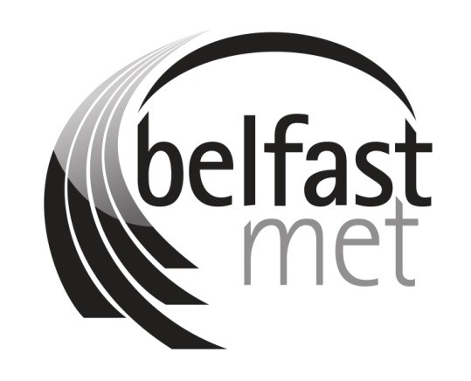

Complaints and Compliments Policy

SECTOR POLICY
Version 3
Scope of Policy: All Staff and Students
Policy Owner: Head of Corporate Development
Date Approved: 16/08/2022
Approved By: Strategic Leadership Team
Status: Current
Publication Date: 17/08/2022
Equality Screening Date: 13/06/2016
Policy Review Date: 13/06/2024

Published by Belfast Metropolitan College www.belfastmet.ac.uk. Belfast Metropolitan College [‘Belfast Met’] is committed to providing publications that are accessible to all. To request additional copies of this publication in a different format please contact:

Corporate Development
Belfast Metropolitan College
Building 1, Room 9
Castlereagh Campus
Montgomery Road
Belfast. BT6 9DJ

This document is only valid on the day it was printed. The master and control version of this document will remain with Corporate Development. Amended and approved versions of the policy must be sent to Corporate Development once approved. Final versions will be posted on the intranet by Corporate Development.

© Belfast Metropolitan College 5/10/16
You are welcome to copy this publication for your own use. Otherwise, no part of this publication may be reproduced, stored in a retrieval system, or transmitted in any form or by any means, electronic, electrical, chemical, optical, photocopying, recording or otherwise, without prior written permission of the copyright owner.

Further Information
For further information about the content of this policy please contact:

Corporate Development
Belfast Metropolitan College
Building 1, Room 9
Castlereagh Campus
Montgomery Road
Belfast. BT6 9DJ
Policy Compliance details:-
Compliance with Equality Legislation.
PLEASE NOTE: Policies must be equality screened before being submitted to SLT and Trade Unions:-
Equality Screening Date: 13/06/2016
Equality Screening Outcome: Screened Out
Sector or Local Screening: Sector
Consultation Date (if applicable): Not Applicable
Equality Impact Assessment Not Applicable
(EQIA) Date (if applicable): Not Applicable
EQIA Key Outcomes: Not Applicable

Document History
Version Number | Author | Reason for Changes | Date
1 | Corporate Development | Updated Learner Success details throughout.  1.1 Included – (the “College”).  3.1 Deleted – and Comments (from the title)  3.2 Included – in the first instance and it is not appropriate to raise the issue/s informally.  3.3 Deleted- if you are under 18. Included- If you are making a complaint on behalf of someone over the age of 13, consent from the individual or proof of power may be required.  5.1 5.1 Deleted- Telephone communications section.  Changed- Title from Customer Communications to Record of Communications.  Appendix 1 and 2 included section on Privacy Notice.  Appendix 3- Updated Complaint Process flowchart. | 02/01/2019
2 | Corporate Development | Change of job title from Corporate Compliance Officer to Data Protection and Complaints Officer.  Change in references from GDPR to UK GDPR  Accessibility (formatting) changes made throughout including the addition of hyperlinks. | 29 April 2022
3 | Corporate  Development | Updated in light of audit recommendations to add reference to:  - College Complaints Procedures (Section 3.3. page 8 footnote)  - Equality Scheme (Section 2.4)  - Receipt and verification of oral/verbal complaints and the circumstances an oral/verbal complaint is acceptable (Section 3.3 (new paragraph)) | 15/08/22
Table setting out changes to the policy
Distribution
This document has been distributed to:
Name | Date
Trade Union | 17 May 2022
Executive Leadership Team | 08/08/2022
Strategic Leadership Team Approval | 13 January 2020; 16 August 2022
Committee | N/A
Governing Body | N/A
Issued to Corporate Development for publication | 28 September 2016; 17 August 2022
Published on the website | January 2020; August 2022
Table setting out who approved the policy and when.
Contents
1.0 Policy Statement 6
2.0 Scope 6
3.0 Categories of Customer Feedback 7
3.1 Compliments 7
3.2 Informal Complaint 7
3.3 Formal Complaint 7
Verbal/ Oral Complaints 8
4.0 Appeals 9
5.0 Record of Communications 9
6.0 If a Customer remains dissatisfied 9
7.0 Monitoring Complaints and Compliments 10
8.0 Communication 10
9.0 Review 10
Appendix 1 11
Appendix 2 14
Appendix 3 15

Policy Statement

1.1 Belfast Metropolitan College (the “College”) is committed to providing the highest quality of service to all our customers. If a customer is not satisfied with the quality of service provided by the College or College staff, they have the right to complain.

1.2 A complaint may be defined as ‘A statement that something is unsatisfactory or unacceptable.’ www.oxforddictionaries.com.

1.3 The raising of complaints and the provision of feedback provides the College with an opportunity to improve its services. The College monitors complaints and the outcomes in order to improve the quality of our provision. This policy advises customers of the College's commitment to ensuring that any issues or problems are resolved quickly and as close to the source as possible, to the satisfaction of all concerned, please refer to Appendix 3 in relation to the complaints process.

2.0 Scope
2.1 For the purposes of this policy, a customer may be a student, external customer, member of the public or third-party stakeholder.

2.2 The College will comply with the Standards for Complaint Handling in the Public Service agreed by the Permanent Secretaries Group, ensuring that:

- There are clear lines of accountability for the handling and consideration of complaints within the College;
- Complainants have open and easy access to the College’s complaints policy and information required to enable them to complaint about any aspect of service;
- Complaints are dealt with through an efficient and effective process;
- All investigations are conducted promptly, thoroughly, openly, honestly and objectively;
- Complaints are responded to as promptly as possible and all issues raised are addressed;
- The College promotes a culture of learning from complaints so that, where necessary, service, processes and practices can be improved; and
- The organisation monitors the effectiveness of its complaint handling and responsiveness.

2.3 In addition, the College will:

- Ensure that all positive comments are passed on to the relevant staff members;
- Process all complaints in a fair, consistent and unbiased manner;
- Endeavour to communicate with the customer within agreed timeframes throughout the process;
- Ensure no customer is disadvantaged as a result of making a complaint;
- Promote equality of opportunity and good relations in line with Section 75 of the Northern Ireland Act (1998);
- Respect confidentiality and protect customers’ data in line with legislation; and
- Monitor and review complaints and compliments for quality assurance and equality monitoring purposes.

2.4 Exemptions to this policy include:

- Anonymous complaints, which will not usually be investigated, but will be recorded;
- Matters where another policy or procedure applies; for example academic appeals or the College Equality Scheme;
- The right of the College not to investigate unreasonable or vexatious complaints; and
- Staff complaints, which fall under separate employment policies and procedures.

3.0 Categories of Customer Feedback

3.1 Compliments

If a customer feels that the College has exceeded the expected standard of service or wishes to leave a compliment or positive comment, they can either:

- Complete a ‘Compliments Form’ (Appendix 2). Forms may be downloaded from the College website or are available at reception;
- Email the College on compliments@belfastmet.ac.uk ; and/ or
- Advise a member of staff in person of the positive experience.

3.2 Informal Complaint

If there is an occasion where a customer is not satisfied with the service we provide; they have a right to complain.

We would encourage customers to seek to resolve any issues informally with the relevant member of staff in the first instance e.g. face-to-face discussion.

Where a resolution cannot be found or it is not appropriate to raise the issue/s informally, the customer may submit a formal complaint in writing.

3.3 Formal Complaint

There are various ways a customer can make a formal complaint:

- Complete a Complaints Form (Appendix 1). Forms are downloadable from the College website or available at reception;
- Email the College at complaints@belfastmet.ac.uk ;
- The College has developed an online submission form on the website under Corporate Information/Complaints and Compliments section of the website; and
- If the complaint relates to an academic matter, students have the right to contact and engage with the relevant Awarding Body directly, however Awarding Organisations will normally only consider a complaint after it has been managed in accordance with the College’s Complaints Policy.
If a customer indicates orally that they would like to make a formal complaint, they will be asked to confirm details of their complaint in writing.

Verbal/ Oral Complaints
Where possible please encourage all complainants to submit their complaint online. However, to ensure this policy is accessible to all, if it is not possible for the complainant to submit their complaint online then please take a written account.
Where a complaint is made orally/ verbally, the complaint shall be documented by the staff member, recorded and a copy of the written record given to the complainant via email or letter. When giving the written record to the complainant, please ensure you ask them to confirm they are satisfied with your written account before proceeding with the investigation.
Those who would like to make a complaint on behalf of someone else, please ensure they provide you with their child’s/carer’s written consent.
Staff members who receive verbal positive comments or compliments from customers should ensure these are passed on to complaints@belfastmet.ac.uk for recording. All compliments received will be recorded and retained centrally, in line with the FE Sector Retention and Disposal Schedule.
If assistance is required with the completion of or the submission of a complaint, customers may contact the Head of Learner Success, Room TQ2-020, email: dmcdowell@belfastmet.ac.uk.

Complaints should be submitted to the College no later than three months from the date of the issue arising. In exceptional circumstances, the College may exercise discretion with this timescale.
Complaints may be submitted on behalf of someone else, for example a vulnerable adult. If you are making a complaint on behalf of someone over the age of 13, consent from the individual or proof of power of authority may be required.
All formal complaints will be forwarded to the relevant Responsible Owner for an open and objective investigation. Upon completion of the investigation, a written response will be issued to the complainant. For the purposes of this Policy, the Responsible Owner is the individual appointed to investigate the complaint.
The College will endeavour to adhere to the timeframes detailed below (Table 1).

Complaint Timeframes Table 1
Communication | Response Time
Complaint acknowledgement letter/email to customer | 5 working days* from receipt of complaint
Letter/email issued to complainant if further information required to progress complaint | Clarification information to be returned within 10 working days of receipt
Complaint response letter/email to customer | 20 working days from date acknowledgement letter/email issued
Table setting out the complaints timeframes
*Working days are those days on which the College is open. Weekends, statutory days, Bank Holidays and other College closures are classed as ‘non-working’ days. Complaints specific to course admissions will be acknowledged within 2 working days from receipt of complaint.

Complaints specific to course admissions will be responded to within 5 working days from date acknowledgement letter/email is issued.

If, for reasons beyond the College’s control the investigation and outcome exceeds, or is likely to exceed the timeframes set out in Table 1, the customer will be notified in writing as soon as practicably possible.

4.0 Appeals

4.1 If a customer is dissatisfied with the College response to their complaint, they have the right to appeal.

Appeals should be submitted in writing, with full details of the grounds for appeal, to the Data Protection and Complaints Compliance Officer, Castlereagh Campus, Building 1, Room 9, Montgomery Road, BT6 9JD. Email address complaints@belfastmet.ac.uk.

4.2 Following receipt of an appeal the College will endeavour to adhere to the timeframes detailed below (Table 2).

Appeal Timeframes Table 2
Communication | Response Time
Complainant submits appeal to the College | 10 working days from date customer receives complaint response
Appeal acknowledgement letter/email to customer | 5 working days from receipt of appeal from customer
Appeal response letter/email to customer | 20 working days from date acknowledgement letter/email issued
Table setting out the appeal timeframes
  - Appeals will be considered by an individual(s) with no previous connection to the original complaint. The individual(s) appointed to consider the appeal request will depend on the nature of the complaint and appeal lodged.

  - If, for reasons beyond the Colleges control the investigation and outcome exceeds the timeframe or is likely to exceed the timeframe, the customer will be notified in writing as soon as practically possible.

5.0 Record of Communications

5.1 Complaint meetings are confidential. If a meeting is required to resolve the issue, minutes will be taken and made available upon request to those in attendance. If the complainant identifies any inaccuracies, the minutes will be reviewed, and where an amendment is agreed a revised minute will be issued.

5.2 College employees have a reasonable expectation of privacy in the workplace and to protect their privacy, the College does not consent to conversations being recorded, unless express consent has been obtained.

6.0 If a Customer remains dissatisfied

6.1 It is hoped the College will be able to resolve any complaint through the complaints procedure. If however a customer remains dissatisfied with the outcome, they have the right to raise the matter with the Northern Ireland Public Sector Ombudsman’s (NIPSO), in his/her role as Commissioner for Complaints.

6.2 The customer can complain to NIPSO; however, NIPSO will normally only consider a complaint after it has been managed in accordance with the College’s Complaints and Compliments Policy, and where it is received within six months of completing the College’s complaints process. Contact details for NIPSO are:

Northern Ireland Public Services Ombudsman
Progressive House
33 Wellington Place
Belfast
BT1 6HN
www.nipso.org.uk

7.0 Monitoring Complaints and Compliments
7.1 The College welcomes and values all feedback from customers. The College analyses feedback and areas of complaint in order to improve services. All complaints will be dealt with sensitively, and in all cases the documentary evidence gathered and stored remains confidential to those involved. Statistical information will be made available for quality and equality monitoring purposes.

8.0 Communication

8.1 This Policy is available at www.belfastmet.ac.uk, under ‘policies and procedures’ section of the Public Documents website page and is accessible in house via the policy section of the staff intranet. It can also be made available, upon request, in alternative formats including large print, braille, audio, and in minority languages.

9.0 Review
9.1 This Policy will be reviewed (and amended if necessary) at least annually or sooner if required to reflect changes in legislation or circumstances.

Appendix 1
CUSTOMER COMPLAINTS FORM
If you require assistance with making a complaint, please contact the Head of Learner Success, Room TQ2-020, email: dmcdowell@belfastmet.ac.uk
Email completed form to complaints@belfastmet.ac.uk.
Every effort will be made to ensure confidentiality, consistent with a full investigation of the issue.
If you are submitting a complaint on behalf of someone else, please provide their name/contact details in Section 1B. We may contact the individual for permission to discuss the issue with you.
SECTION 1A – Complainant Details

Title: | Miss / Mr / Mrs / Ms Other:
Name:
Contact Address:
Tel Number:
Email:
Student ID (if applicable)
Complainant details
Status: Please tick below as appropriate:-
Student |  | Parent or Guardian |  | Staff |  | Member of the Public |  | Employer |  | Organisation
Complaint category section
Details of Complaint: Please ensure that all details are provided, including (if relevant) date, time and place of the event; and names of those involved if known. You may attach additional sheets if necessary.
Details of Compliment Section
SECTION 1B – Details of person on whose behalf you are submitting complaint, if different to above
Title: | Miss / Mr / Mrs / Ms Other:
Name:
Contact Address:
Tel Number:
Email:
Student ID (if applicable)
Do you have their consent to raise this matter Y/N
Complaint details
Status: Please tick below as appropriate:-
Student |  | Parent or Guardian |  | Staff |  | Member of the Public |  | Employer |  | Organisation
Complaint category section
SECTION 2
Details of Complaint: Please ensure that all details are provided, including (if relevant) date, time and place of the event; and names of those involved. You may attach additional sheets if necessary.

Have you attempted to resolve this issue informally? Yes / No
If Yes, please summarise any action taken to resolve your issue/s to date.

Details of complaint section
Section 3
What do you see as a suitable remedy to address the issue or matter raised?

PRIVACY NOTICE: Information gathered on this form will be processed within the provisions of the UK General Data Protection Regulations (UK GDPR) and used for the purpose of investigating your complaint. The College is permitted to process personal data where there is a ‘lawful basis’ to do so. This processing is necessary for the performance of a public task or in the exercise of official authority vested in the College as a Data Controller e.g. Public Authorities are subject to the Northern Ireland Public Services Ombudsman (NIPSO). Your information may be shared with relevant College staff for the purpose of investigating your complaint. It may also be shared with authorised third parties such as NIPSO, legal professionals where there is a lawful basis to do so. Further information on data protection and your rights are available on our website www.belfastmet.ac.uk

I agree to be contacted by any contact method provided on this form, in respect of my complaint.
I realise that if I choose not to agree to these terms, the College will be unable to investigate my complaint.

Signed: __________________________________ Date: _______________________________

Office Use Only
Date Received: Date Acknowledged:
Received By: Responsible Owner:

Appendix 2
CUSTOMER COMPLIMENTS FORM
If you require assistance with submitting this form, please contact the Data Protection and Complaints Officer by email: compliments@belfastmet.ac.uk. Please also submit the completed form to the same email address.
If we have done something well, we value and appreciate your positive feedback
Title: | Miss / Mr / Mrs / Ms Other:
Name:
Contact Address:
Tel Number:
Email:
Student ID (if applicable)
Personal details
Status: Please tick below as appropriate:-
Student |  | Parent or Guardian |  | Staff |  | Member of the Public |  | Employer |  | Organisation
Status category section
Details of Compliment: Please ensure that all details are provided, including (if relevant) date, time and place of the event; and names of those involved if known. You may attach additional sheets if necessary.
Details of Compliment Section
PRIVACY NOTICE: Information gathered on this form will be processed within the provisions of the UK General Data Protection Regulations (UK GDPR) and used for the purpose of investigating your complaint. The College is permitted to process personal data where there is a ‘lawful basis’ to do so. This processing is necessary for the performance of a public task or in the exercise of official authority vested in the College as a Data Controller e.g. Public Authorities are subject to the Northern Ireland Public Services Ombudsman (NIPSO). Your information may be shared with relevant College staff for the purpose of investigating your complaint. It may also be shared with authorised third parties such as NIPSO, legal professionals where there is a lawful basis to do so. Further information on data protection and your rights are available on our website www.belfastmet.ac.uk

I agree to be contacted by any contact method provided on this form, in respect of my compliment.
I realise that if I choose not to agree to these terms, the College will be unable to record my compliment.

Signed: __________________________________ Date: _______________________________

Office Use Only
Date Received: Date Acknowledged:
Received By: Responsible Owner:

Appendix 3
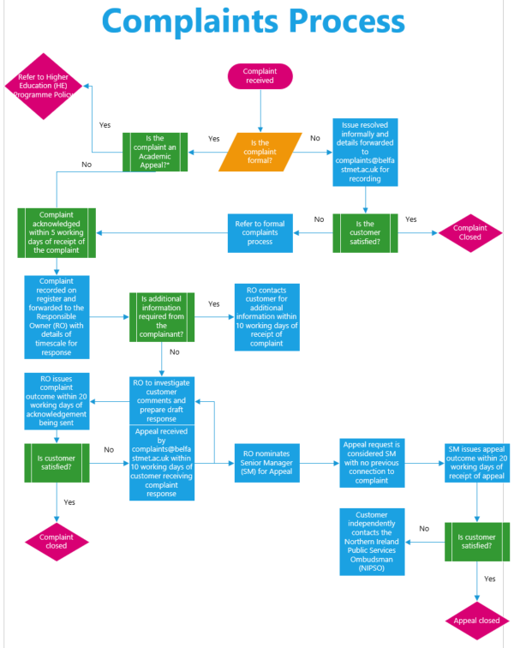

Please refer to HE student handbook for information on academic appeals
Please refer to the Equality Scheme
Responsible owners are defined by the Data Protection and Complaints Officer or nearest equivalent and are set out in the College Complaints Procedure on the staff intranet.
In the event a complaint made is about the Principal and Chief Executive, the Chair of the Audit Committee will appoint a suitable person to investigate and report. Any subsequent appeal will be addressed by the Governing Body.

