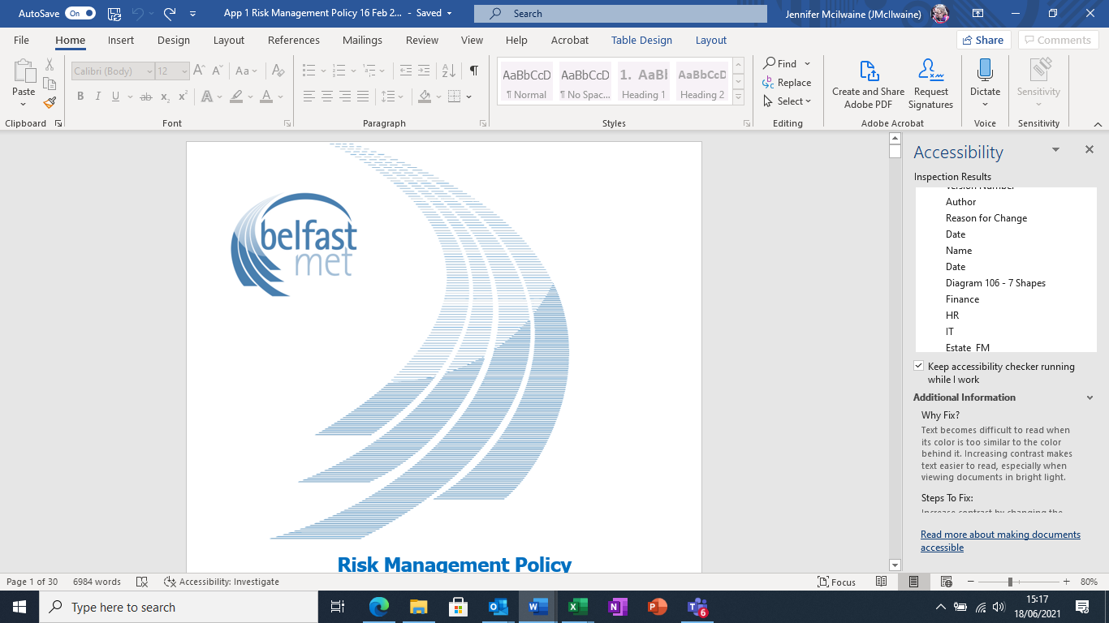

**Risk Management Policy**

**LOCAL POLICY**

Version 7.01

Scope of Policy: All Staff

Policy Owner: Head of Corporate Development

Date Approved: 16/08/2022

Approved By: Strategic Leadership Team

Status: Current

Publication Date: 09/12/2022

Equality Screening Date: 04/23/2021

Policy Review Date: 13/06/2025

Published by Belfast Metropolitan College [www.belfastmet.ac.uk](http://www.belfastmet.ac.uk). Belfast Metropolitan College [‘Belfast Met’] is committed to providing publications that are accessible to all. To request additional copies of this publication in a different format please contact:

**Corporate Development**

Belfast Metropolitan College

Building 1, Room 9

Castlereagh Campus

Montgomery Road

Belfast. BT6 9DJ

This document is only valid on the day it was printed. The master and control version of this document will remain with Corporate Development. Amended and approved versions of the policy must be sent to Corporate Development once approved. Final versions will be posted on the intranet by Corporate Development.

© Belfast Metropolitan College 5/10/16

You are welcome to copy this publication for your own use. Otherwise, no part of this publication may be reproduced, stored in a retrieval system, or transmitted in any form or by any means, electronic, electrical, chemical, optical, photocopying, recording or otherwise, without prior written permission of the copyright owner.

**Further Information**

For further information about the content of this policy please contact:

**Corporate Development**

Belfast Metropolitan College

Building 1, Room 9

Castlereagh Campus

Montgomery Road

Belfast. BT6 9DJ

**Policy Compliance details:-**

Compliance with Equality Legislation.

**PLEASE NOTE: Policies must be equality screened before being submitted to SLT and Trade Unions:-**

*Equality Screening Details*

Equality Screening Date: 04/23/2021

Equality Screening Outcome: Screened Out

Sector or Local Screening: Local Screening

Consultation Date (if applicable): Not Applicable

Equality Impact Assessment Not Applicable

(EQIA) Date (if applicable): Not Applicable

EQIA Key Outcomes: Not Applicable

**Document History**

|  |  |  |  |
| --- | --- | --- | --- |
| **Version Number** | **Author** | **Reason for Change** | **Date** |
| 1.0 | Corporate Development | Approved by Executive Team | January 2011 |
| Blank | blank | Approved by Governing Body | March 2011 |
| 2.0 | Corporate Development | Review of Risk Management Policy highlighted the need to update names of Academic and Support Departments following restructuring | Aug 2018 |
| 3.0 | Corporate Development | * Minor updates to structure and restructure of paragraphs. * Some minor editing to content throughout for clarity. * Clarification on the frequency of updates to DfE (Section 8). * References to DEL replaced with DfE throughout. * Linkages to other policies included. * Section 2 – removed ‘It is recognised that in some cases this may lead to the review of a policy’. * Section 5 - removed ‘Financial Regulations’ and replaced with * ‘The Management Statement and Financial Memorandum between the Department for the Economy and the Further Education Colleges updated 1st October 2018’. * Removal of Risk Strategies paragraph. * The mechanism for communicating policy implementation and communication was modified to reflect how this happens within the College at induction and for existing staff. * Former Appendix 1 – Risk Strategies was removed, as this is general and not specific to College policy. | May 2019 |
| 3.0 | SLT | Approved by SLT | 14 October 2019 |
| 4.0 | Corporate Development | Updated throughout to account for:   * The new requirement included in the DfE mid-year assurance statement (October 2020) that risks are identified, assessed and managed within Risk Registers which are maintained in accordance with the Department’s Risk Management Framework. * The updated version of the Orange Book (August 2020)   The following elements have been amended following approval by the Audit and Risk Committee on 24/11/20:   * The risk register template based on that of the DfE * The adoption of the Orange Book risk categories * The College corporate risk appetite statement (as per audit recommendation) * Directorate Level Risk Registers have been formalised as a step in the risk management process the requirement identified by Audit and Risk Committee (24/11/21) for Directors to regularly present risk registers to the Committee. * Greater clarification has been provided in Section 9 on the steps required in the risk management process. | February 2021 |
| 4.0 | Corporate Development | Approved by:   * Executive Leadership Team 02/03/21 * Senior Leadership Team 05/05/21 * Audit and Risk Committee 15/06/21 * Governing Body 23/06/21. |  |
| 5.0 | Corporate Development | Approved by:   * Executive Leadership Team 08/11/21 * Senior Leadership Team - to be updated in December 2021 * Audit and Risk Committee 15/11/21 * Governing Body 22/11/21.   In accordance with this policy, the corporate risk appetite (Appendix 2) was discussed with the Executive Team on 2 November 2021 and agreed by them on 8 November 2021.  The Executive Leadership Team agreed that the following changes more accurately captured the College Corporate Risk appetite for 2021/22:   * Operations – the Director of Curriculum revised this to specify that the College has a cautious approach to dealing with enrolments where any reduction has the potential to impact on core grant and has clarified that there is a cautious appetite for risks relating to sector wide STS system and functionality. * Technology and Information/Security – the Director of Development and Digital moved cyber security from the Technology risk appetite to the Information/Security risk appetite. * Governance – updated to reflect the ongoing engagement with DfE to develop the partnership model with DfE and the DAO guidance on proportionate autonomy for arm’s length bodies. * People – revised by the Director of People and Place from Cautious to Open. * Strategy – revised to account for the Strategic Plan. * Reputational – updated to reflect the revised College Vision as articulated in the Strategic Plan.   This was approved by the Audit and Risk Committee 15/11/21 and Appendix 2 to this document updated accordingly.  The following titles were updated:   * Director of People and Place * Strategic Leadership Team | December 2021 |
| 6.0 | Corporate Development | Paragraphs 7.2 and 8.3 have been amended to include the sharing of the Corporate Risk Register with SLT on a quarterly basis.  Paragraph 8.3 reference to a quarterly KPI and Risk Management report for Governing Body removed and replaced with an annual Impact Report.  Paragraph 12.1 has been amended to include that the policy will be circulated to relevant staff as and when required and that the policy is available to view at all times, on the staff intranet.  Approved by SLT 16 August 2022 | 31 May 2022 |
| 7.0 | Corporate Development | Para 6.3 Fraud Policy added.  Pages 21 & 22 Director of People and Planning changed to Director of Corporate Services | September 2022 |
| 7.1 | Corporate Development | Minor changes to Appendix 5 Corporate Risk Appetite following a workshop with ELT in September which was subsequently accepted by the Audit and Risk Committed.  The previous A and B were merged.  C – approach has changed from cautious to open to property projects.  D – Operations - Additional risk added in relation to securing and delivering non-core grant business development and funded programmes.  Update to reflect the changes from STS to EBS.  F - Information Security - Change from cautious to averse to IT Security risks.  I - Strategy – Changed from cautious to open.  L – reputation has changed to cautious approach. | December 2022 |

*Version Control Details*

**Distribution**

This document has been distributed as follows:

|  |  |
| --- | --- |
| **Name** | **Date** |
| Trade Union | N/A |
| Executive Leadership Team | 08/11/21; 08/08/2022 |
| Senior Leadership Team | 05/05/21; 16/08/2022 |
| Audit and Risk Committee | 15/11/21 |
| Governing Body | 15/12/21 |
| Issued to staff via Policy Portal | 08/11/19 |
| Published by Corporate Development on the staff intranet | 02/12/21; 17/18/2022 |

*Policy approval and distribution details*

**Contents**

1. Introduction 7

What is risk? 7

What is risk management? 7

2. Policy aim 7

3. Scope 7

4. Description 7

5. Purpose of policy 8

6. Links to other policies 8

7. College approach to risk management 9

Levels of Risk Management 9

8. Risk Reporting Arrangements 10

Corporate Risk Register 10

Directorate Risk Registers 11

Operational Risk Registers 11

9. Risk management: putting it into practice. 12

Risk Classification 12

Risk Identification 12

Risk Owner 13

Risk Assessment 13

Risk Appetite and evaluation 14

Risk appetite matrix 17

Risk Treatment 17

Planned Actions 18

Action Lead 18

Risk Escalation 18

10. Roles and Responsibilities 19

Staff Generally 19

Sponsor Department 19

Governing Body 20

Audit and Risk Committee 20

Principal & Chief Executive 20

Executive Leadership Team 21

Director of People and Place 21

Internal Audit 21

External Audit 21

Heads of Department 22

Corporate Development 22

11. Review 23

12. Training and circulation 23

Appendix 1 Risk Management Process 24

Appendix 2 Risk reporting and management structure 0

Appendix 3 Scoring Mechanism 1

Appendix 4 Risk Register Template 2

Appendix 5 Corporate Risk Appetite 3

# Introduction

## What is risk?

* 1. According to the DfE Risk Management Framework (2020), risk is defined as:
  2. ‘Uncertainty of outcome, whether positive opportunity or negative threat, of actions and events. It should be expressed in terms of causes (things which give rise to the risk) and consequences (what would/could happen if the risk occurred) and should always be clearly linked to an objective’.
  3. The Orange Book (2020) defines risk as:
  4. ‘The effect of uncertainty on objectives and is usually expressed in terms of causes, potential events, and their consequences […] which can have positive or negative direct or indirect effect on objectives.’

## What is risk management?

1.5 The Institute of Risk Management defines risk management as ‘the process whereby organisations methodically address the risks attaching to their activities with the goal of achieving sustained benefit within each activity and across the portfolio of all activities.

1.6 This Risk Management Policy sets out Belfast Met’s approach to risk management and the processes which should be followed to formally identify, assess, and manage risks to the College objectives.

# Policy Aim

2.1 The aim of this policy is to create and maintain a robust system for the identification, evaluation and management of risks which could prevent the College from achieving its business objectives or make their achievement more difficult.

# Scope

3.1 Risk management forms an integral part of the College’s internal control and corporate governance arrangements.

3.2 All College staff are required to comply with legislative requirements and College policy.

# Description

4.1 This policy outlines key aspects of the risk management process and identifies the main reporting procedures, roles, and responsibilities of various stakeholders.

4.2 It describes the methodology adopted by the College in relation to the classification, measurement and treatment of risk.

# Purpose of policy

* 1. The policy has the following purposes:-
* To integrate risk management into the culture of the College;
* To manage risk in accordance with established best practice;
* To establish legal compliance as the minimum acceptable standard;
* To establish and maintain a system to respond to changing social, environmental and legislative requirements;
* To establish processes to help minimise injury and damage and so reduce the cost of risk;
* To embed risk management into internal control and corporate governance arrangements;
* To ensure that the Governing Body plays an active role in overseeing the risk management process;
* To ensure implementation through the allocation of responsibilities to named individuals; and
* To raise awareness amongst all staff of the need to effectively manage business risk.

# Links to other policies

6.1 Risk management is an integral part of a performance management system and is critical to the achievement of planned outcomes. Risks should be related to objectives as set out in the Corporate, Directorate, Departmental, Organisational/College wide and Project plans as appropriate and should be proportionate to the level required.

6.2 This policy has been developed in accordance with:

* HM Treasury’s ‘[The Orange Book: Management of Risks – Principles and Concepts’ (2020)](https://assets.publishing.service.gov.uk/government/uploads/system/uploads/attachment_data/file/220647/orange_book.pdf);
* Department for Economy’s Risk Management Framework (2020);
* The Northern Ireland Audit Office’s (NIAO’s) ‘[Good Practice in Risk Management](https://www.niauditoffice.gov.uk/sites/niao/files/media-files/good_practice_in_risk_management.pdf)’ (2011);
* The Department of Finance’s (DoF’s) ‘[Corporate Governance in Central Government Departments: Code of Good Practice NI](https://www.finance-ni.gov.uk/sites/default/files/publications/dfp/daodfp0613att.pdf)’ (2013); and
* Managing Public Money Northern Ireland (DfP’s (now DoF)) (2008).

6.3 This policy should be read in conjunction with all policies and procedures relating to the College’s internal controls including:

* The [Management Statement and Financial Memorandum](https://www.belfastmet.ac.uk/siteFiles/resources/docs/Finance/MS-and-FM-December-2016.pdf) between the Department for the Economy and the Further Education Colleges, updated 1st October 2018;
* [Financial Management Policy](https://belfastmetuat.sharepoint.com/sites/PublishedDocuments/Policy%20Documents/Financial%20Management%20Policy%20for%20Belfast%20Met.pdf); and
* Fraud Policy.

6.4 It should also be read in conjunction with the College’s Business Continuity Plan and [Health and Safety Policy](https://belfastmetuat.sharepoint.com/sites/PublishedDocuments/Policy%20Documents/Health%20and%20Safety%20Policy.pdf).

6.5 Risks relating to safeguarding, fraud and plagiarism must be managed according to those specific policies.

# College approach to risk management

## Levels of Risk Management

7.1 Risk registers must be maintained at the following levels within the College:

**Corporate**

7.2 The Corporate Risk Register outlines risks that could impact upon the long-term strategic objectives of the organisation and this register provides Governing Body with an assurance that these are being managed. These risks are managed by the Executive Leadership Team and are reported to the Audit and Risk Committee of the Governing Body. Department for the Economy attend this quarterly meeting and are provided with a copy of the Corporate Risk Register quarterly. The Corporate Risk Register is shared with the Strategic Leadership Team on a quarterly basis.

**Directorate**

7.3 Directorate risk registers outline risks that could impact on the delivery of directorate business plans and provide the Principal & Chief Executive of the College, or Committees as required, with an assurance that these are being managed. These risks are managed by Directors and can be escalated to the Corporate Risk register if appropriate.

**Operational (Departmental)**

7.4 Operational risk registers detail risks that could impact on the delivery of the departmental business plans and provide the relevant Directors with an assurance that these are being managed. These risk registers are generally operational in nature, focussing on the day-to-day issues that the organisation is confronted with as it strives to deliver its strategic objectives. As such, they are distinct from the corporate risk register which focusses on risks that could impact upon the long-term strategic direction of the organisation. Operational risks are managed by Heads of Department and can be escalated to either the Directorate or Corporate Risk register as appropriate. Operational risk registers should be informed by the range of risk assessment methods employed by the College in relation to specific activities or projects.

**Organisational/College Wide Risk Registers**

7.5 A number of college-wide risk registers are in operation. Examples at the time of writing are the H&S risk register and the Admissions and Enrolment risk register. These risks registers are co-ordinated and maintained by the relevant Department.

7.6 Corporate Development Department reviews and consolidates all organisational/college wide risk registers so that risks are identified, allocated and managed within appropriate Operational, Directorate or Corporate Register.

7.7 Risk owners should **escalate** risk as appropriate for consideration of inclusion in the Operational Risk Register, or other relevant College Risk Registers. Both Heads of Department and Directors should consider these risk registers when reviewing the content of the operational, directorate and corporate risk registers and escalate accordingly.

**Project/activity risk registers**

7.8 The College has a range of risk assessment methods and that are generally used to manage the risks that could impact upon the delivery of a specific activity or project.

7.9 These risks are managed by the lead officer or project manager who should **escalate** risk as appropriate for consideration of inclusion in the Operational Risk Register, or other relevant College Risk Registers.

# Risk Reporting Arrangements

8.1 In September 2020, the DfE Mid-Year Assurance Statement introduced a new requirement for the College to provide an assurance that ‘risks are identified, assessed and managed within Risk Registers which are maintained in accordance with the Department’s Risk Management Framework’. Therefore, the format of the Corporate Risk Register (**Appendix 4**) is based on that of the DfE’s for the ease of transposition, if necessary, to the DfE’s. The format in **Appendix 4** must be used for both Directorate and Operational Risk Registers, both of which must be updated at least quarterly, on the same schedule as the corporate risk register, to allow for escalation and de-escalation of risks between the registers.

8.2 Risk Registers must be prepared annually and in place by the start of each new academic year as part of the business planning process.

## Corporate Risk Register

8.3 The Corporate Risk Register is a tool used to identify and monitor risks that have the potential to change the strategic direction as set out in the organisation’s highest level strategic plan (normally the Corporate Plan).

* A Corporate Risk Register is prepared annually for each new academic year;
* The Corporate Risk Register is formally reviewed and updated by the Executive Leadership Team on at least a quarterly basis and should be a standing item on the Executive Leadership Team agenda;
* The Corporate Risk Register and compliance with the process is presented to the Audit & Risk Committee of the Governing Body and DfE once a quarter. Any ;
* The Corporate Risk Register is shared with the Strategic Leadership Team quarterly;

The Governing Body receives a summary of corporate risks as part of its annual Impact Report. Any significant issues relating to risk are escalated to Governing Body during the course of the year, either via the Audit and Risk Sub-Committee and/or the Principal and Chief Executive’s monthly update to Governors.

* A statement of key risks is included in the Annual Report.

## Directorate Risk Registers

8.4 The Directorate risk registers are tools to identify and monitor risks that have the potential to disrupt the delivery of Directorate level actions and impact upon the execution of the organisation’s current Directorate business plans.

8.5 The Directorate Risk Registers are reviewed and updated formally by Directors on at least a quarterly basis (or sooner if required as risks are identified), in accordance with the corporate risk register schedule. Significant issues are escalated onto the Corporate Risk Register on a quarterly basis.

## Operational Risk Registers

8.6 The Operational Risk Registers are tools to identify and monitor risks that have the potential to disrupt the delivery of Department actions and impact upon the execution of the current Departmental business plans.

* Operational Risk Registers are completed and reviewed formally at least each quarter by Heads of Department (Academic and Support) and updated sooner if required as risks are identified;
* The Operational Risk Register should be a standing agenda item at a formal meeting on a regular basis;
* Directors monitor operational risk registers for their directorate at least quarterly.
* Directors review operational risk registers regularly with their Heads of Department and to consider all other risk registers in aligning and confirming fitness for purpose of the risks for their Directorate.
* Significant issues are escalated onto the Corporate Risk Register on a quarterly basis; and
* Operational risk registers should be informed by the range of risk assessment methods and project risk registers that are maintained by the College.

8.7 In some situations, e.g. Gateway Review of large capital projects, it may be necessary to use an alternative reporting format to **Appendix 4**. This is acceptable provided the Principal & Chief Executive and/or respective Director have approved it.

# Risk management: putting it into practice.

## Risk Classification

9.1 Risks are classified under the following Orange Book categories:

A. Financial

B. Commercial

C. Property

D. Operations

E. Technology

F. Information/Security

G. Governance

H. People

I. Strategy

J. Legal

K. Project/Programme

L. Reputational

9.2 Risks should fall into one or more of these categories. It is not necessary to have a risk for each category. **Appendix 5** provides examples of the types of risk under each category.

## Risk Identification

9.3 Risk identification is the formal process of articulating the key risks to achieving objectives. An articulated risk should include the cause, consequence and be linked clearly to an objective (at the appropriate level).

9.4 Examples of risk identification techniques are:

* Discussions at Executive Leadership Team, Director meetings, Strategic Leadership Team or other management meetings;
* Reviewing operational risk registers;
* Reviewing specific risk registers maintained by the College – for example, the H&S risk register;
* Reviewing prior year risk registers;
* Staff engagement, workshops and horizon scanning;
* Questionnaires;
* Business process reviews;
* Incident investigation;
* Performance indicators (complaints hotspots, for example);
* SWOT/PESTLE analysis;
* Reviewing key College documents (strategies and plans, for example);
* Inspection/audit reports; and
* Benchmarking with other local Colleges and publicly funded organisations.

9.5 Describing the risk is important to ensure that risks are fully understood. To assist with the identification of actions, the causes and consequences of each risk must also be detailed. Typical phrases used to do this include:

|  |  |  |
| --- | --- | --- |
| **Description** | **Cause** | **Consequence** |
| Failure to/of  Risk of  Lack of  Loss of  Uncertainty of  Delay in  Inability to  Development of | Due to  Because of | Leads to  Results in |

Description of Risk

9.6 Risks should be clearly linked to the relevant objective.

## Risk Owner

9.7 A risk owner must be assigned to each risk. The risk owner must take overall responsibility for ensuring that risks are managed to an acceptable level. As such, the risk owner is responsible for defining the risk appetite for each individual risk. The following categories of risk owners are assigned to each type of risk:

|  |  |
| --- | --- |
| **Risk Type** | **Risk Owner** |
| Corporate | Member of the Executive Leadership Team |
| Directorate | Director |
| Operational | Head of Department/Officers |
| Project | Project Manager |

Risk Owner

## Risk Assessment

9.8 Once the risk has been identified, the next step is to assess the:

* **Impact**/**consequences** should it happen.
* **Likelihood** of it happening.

9.9 Risks are assessed at the following two stages:

* **The inherent risk** rating is the assessment and rating of the riskassuming **no controls are in place.** This is also referred to as the untreated risk.
* **The residual risk rating is** the rating **after controls have been put in place**. Residual risk provides a sense of how serious the risk is right now.

9.10 Where there is no change in the risk score between inherent and residual, this is generally indicative of a lack of, or ineffective controls or circumstances where the College is limited in the action it can take. Similarly, where the residual risk is higher than the inherent risk, this is an indication that either controls are resulting in unintended consequences that exacerbate the risk or there has been a significant change in the operating environment outside of the control of the risk owner. Where inherent and residual risk scores remain static is an indicator of ineffective controls or risk management process. In this instance, the risk owner needs to be held to account by the appropriate level.

9.11 Risks are assessed using the following matrix:

Risk Assessment Matrix

The matrix is a table containing the values Score, Risk Status and Colour.  Scores 1-3 are low risk, and are represented by the colour gree. Scores 4-7 are medium risk, and coloured amber. Scores 8-11 are High Risk and coloured red, and scores 12-16 are Very High Risk, and are coloured black. 

9.12 Once the risk has been assessed, the aim then is to manage it to an acceptable level. The acceptable level is known as the risk appetite.

## Risk Appetite and evaluation

9.13 According to ISO 31000, risk appetite is defined as the amount and type of risk that an organisation is willing to pursue or retain. Formal articulation of the risk appetite helps to ensure the College is responding consistently to risk.

9.14 The concept may be looked at in different ways depending on whether the risk being considered is a threat or an opportunity, for example:

* When considering threats, risk appetite refers to the level of exposure which is considered tolerable and justifiable if the risk is realised. It is about comparing the cost of constraining the risk with the cost of the exposure and finding a balance; and
* When considering opportunities, risk appetite refers to how much the College is prepared to actively put at risk in order to obtain the benefits of the opportunity. It is about comparing the value of potential benefits with the losses which might be incurred in the process.

9.15 Internal audit recommend that the standardised organisational risk appetite is discussed, defined and agreed with the Strategic Leadership Team and the Executive Leadership Team, approved by the Audit and Risk Committee and Governing Body.

9.16 The College’s risk appetite is defined in **Appendix 5.** The College risk appetite is developed within the context of the current operating environment as an NDPB and is informed by the attitude to risk of the sponsor department (the Department for the Economy).

9.17 The risk appetite is not static, is subject to change, and needs to be flexible so that it is reflective of the College’s operating environment. Risk appetite should be reviewed on an ongoing basis, but at least annually as part of the Corporate Risk Register refresh (prior to the start of the new academic year).

9.18 Directorates and departments should use this corporate appetite to inform their own risk appetite and management decisions at a local level. For example, if the corporate appetite for risks relating to governance is averse, this should be the case at Directorate/Operational level also. The agreed corporate risk appetite will be communicated via the Corporate Risk Register.

9.19 The residual risk should be compared to the risk appetite for that risk to determine where and what additional action is required. This action is known as **risk treatment**. In general terms, higher risk ratings are more acceptable for risks where the risk appetite is hungry, and less acceptable where the appetite is averse.

9.20 The risk appetite will determine the level and type of treatment required. In some areas the College may wish to take more risk to support innovative thinking and so the risk appetite is determined as hungry, warranting controls and actions that promote innovation. In other areas, the College may wish to take less risk to ensure legal compliance and so the risk appetite is determined to be averse, warranting a strong system of internal controls and actions to avoid non-compliance. In both cases, the controls and actions required should be proportionate to the risk appetite.

9.21 Risk appetite is represented by the following range:

|  |  |  |
| --- | --- | --- |
| **Risk Appetite** | **Definition** | **Residual Risk Score** |
| Hungry | Eager to be innovative. Willingness to choose inherently riskier options based on potential higher rewards | 12-16 |
| Open | Willing to consider all options and choose the one that is most likely to result in successful delivery while providing an acceptable level of reward | 8-11 |
| Cautious | Preference for safe options that have a low degree of risk and may only have limited potential for reward | 4-7 |
| Averse | Avoidance of risk and uncertainty. Preference for safe options that have a low degree of inherent risk and may only have limited potential for reward | 1-3 |

Definitions of risk appetite

9.22 Where residual risk scores fall outside of the risk appetite range above, risks should be considered for escalation to the next level of risk management. Audit and Risk Committee should focus their attention on the risks that are outside of the risk appetite, rather than solely those that are black or red. Risks outside the risk appetite should be brought to the attention of the Audit and Risk Committee in the quarterly risk report. For example, in the risk appetite matrix, D4 below has a residual score of 8 and the appetite for that risk is open. According to the table above, this risk is within the risk appetite (8-11). B1, however, has a residual score of 9 and a cautious risk appetite and is therefore outside of the risk appetite (4-7) indicating that further management action is required.

## Risk appetite matrix

Risk appetite matrix 

The matrix is a 4 by 4 table that shows the impact along the x axis and the likelihood along the y axis.  The matrix is colour coded Green, Amber, Red and Black.  Scores 1-3 are low risk, and are represented by the colour green. Scores 4-7 are medium risk, and coloured amber. Scores 8-11 are High Risk and coloured red, and scores 12-16 are Very High Risk, and are coloured black.  Two example residual risk scores are plotted.  One residual risk score is plotted that is within the corporate risk appetite.  The second residual risk is outside of the corporate risk appetite.  This has been plotted on the matrix according to it's residual risk score and an arrow is pointing to the corporate risk appetite for that risk. 

## Risk Treatment

9.23 According to the NIAO, there are four traditional responses to risk, which are to:

* **Terminate** - A decision is made not to take the risk or cease the activity which causes the risk. Where the risks outweigh the possible benefits, risk can be terminated by doing things differently and thus removing the risk, where it is feasible to do so.
* **Tolerate** - Accept the risk. This may be where the risk is external and therefore the opportunity to control it is limited, or where the probability or impact is so low that the cost of managing it would be greater than the cost of the risk being realised. This option may be supplemented by contingency planning for handling the impacts that will arise if the risk is realised.
* **Transfer** - Where another party can take on some or all of the risk more economically or more effectively. For example, through another organisation undertaking the activity or through obtaining insurance. It is important to note that some risks are not (fully) transferable - in particular it is generally not possible to transfer reputational risk even if the delivery of the service is contracted out. The relationship with the third party to which the risk is transferred needs to be carefully managed to ensure successful transfer of risk.
* **Treat** - Mitigate the risk. In practice, this is the most common response to risk. It is achieved by eliminating the risk or reducing it to an acceptable level by prevention or another control action.

9.24 If the residual rating is within the risk appetite, the risk owner may decide that no further action is deemed necessary. If no actions are planned this should be made clear and recorded on the corporate risk register. The Board should be asked to accept the risk as it stands. For corporate risks, where the residual risk score is outside of the risk appetite, this should also be highlighted to Committee.

## Planned Actions

9.25 A planned action is a specific commitment to do something in the future. This is distinct from controls, which are arrangements that are already in place. Planned actions must have a clear target date and be assigned an action lead. The focus should be predominantly on actions that will reduce the likelihood of the risk occurring.

## Action Lead

9.26 The risk owner is responsible for ensuring an action lead and target date is assigned to each action and that these actions are commensurate with relevant College policies. The action lead is required to take responsibility for ensuring agreed actions are progressed and implemented by the target date, but the risk owner is accountable for the overall management of that risk. The following categories of action leads are assigned to each type of risk:

|  |  |
| --- | --- |
| **Risk Type** | **Action Lead** |
| Corporate | Director/Heads of Department |
| Directorate | Heads of Department |
| Operational | Heads of Department/Officers |
| Project | Project Manager/Officers |

Risk type and lead action table

## Risk Escalation

9.27 Heads of Department review their Operational Risk Register and can **escalate** risks to their Director for consideration of inclusion in the Directorate and/or Corporate Risk Register. For example, risks that should be escalated include those that are:

* classified as ‘high’ or ‘very high’;
* outside the risk appetite;
* cannot be managed locally; or
* of such significance that the Executive Leadership Team need to be made aware of them.

9.28 As such, Directors act as important gate keepers for a risk’s entry to the corporate risk register, though the final decision to include it will still rest with the Executive Leadership Team collectively.

9.29 In relation to the Corporate Risk Register, the Executive Leadership Team will concentrate on those risks

* with a high probability of occurrence which are likely to have a major impact on business objectives, where there is an averse or cautious appetite; or
* where the residual risk score is outside of the risk appetite.

9.30 The Executive Leadership Team will not normally expend time and resources on those areas judged to have a low probability of occurrence and low impact; nor those risks that are high but within the risk appetite.

9.31 The Executive Leadership Team may also consider it more appropriate for some risks on the Corporate Risk Register to be managed at a lower level and **deescalate** the risk. This is normally appropriate where the residual risk rating has been successfully managed down to an acceptable level (within the risk appetite). This is particularly important to ensure that the corporate risk register at all times provides a clear and concise picture of the key risks to the Department’s strategic direction. Where risks are deescalated, this should be noted to the Board in the quarterly risk register paper. It is the responsibility of the risk owner to ensure that the deescalated risk appears on the relevant risk register.

9.32 Where a risk is considered to be closed, i.e. it no longer poses a threat to objectives, the risk owner will record it as closed on the risk register. This should be noted to Governing Body in the quarterly risk register paper. Closed risks should be removed from the risk register in the following quarter. The risk register from the preceding quarter will be retained for audit purposes in line with the College’s Retention and Disposal Schedule.

# Roles and Responsibilities

## Staff Generally

* Are required to have read and to comply with this policy;
* Contribute to the regular review of operational risk registers, namely, by way of risk identification, assessment, treatment and reporting of risks within their work areas, and by identifying risks and reporting these to their line management; and
* Are required to cooperate with Corporate Development in relation to risk management/risk register reviews.

10.1 See **Appendix 2** for a summary of the College’s risk management processes and risk reporting and management structure.

10.2 The particular roles and responsibilities of the following specific groups are as follows:

## Sponsor Department

10.3 The College’s Sponsor Department requires the Accounting Officer (Principal and Chief Executive) to complete a bi-annual assurance statement. One requirement of this is for the College to confirm that risks are identified, assessed and managed within Risk Registers, which are maintained in accordance with the Department’s Risk Management Framework.

10.4 According to the Management Statement and Financial Memorandum, the Department requires attendance by departmental representatives at the College Audit and Risk Committee meetings. The purpose of this is to ensure all risk owners (all of whom are Heads of Department and above) are held to account for the risks and how they are being managed. The Sponsor Department attends the College Audit and Risk Committee and obtains copies of all College risk registers via the Audit and Risk Committee papers. Significant changes outside of these meetings should be notified to DfE’s FE Corporate Governance branch ([fegovernance@economy-ni.gov.uk](mailto:fegovernance@economy-ni.gov.uk)). The Department may also require the input from College’s Audit and Risk Committee to that of the Department.

## Governing Body

* Is responsible for the College’s systems of internal controls and reviewing its effectiveness;
* Challenges the Corporate Risk Register to ensure all key risks have been identified;
* Forms an opinion on whether the College has complied with all provisions of the audit code;
* Reviews key risks together with the controls, which have been implemented to mitigate those risks;
* Confirms whether there has been a formal ongoing process for identifying, evaluating and managing the College’s significant risks;
* Endorses the College risk appetite as approved by the Audit and Risk Committee;
* Endorses the Risk Management Policy as approved by the Audit and Risk Committee; and
* Ensures there is an annual review of risk management process and its outcomes.

## Audit and Risk Committee

* Approves the College’s Risk Management Policy;
* Approves the College Risk Appetite;
* Approves a Corporate Risk Register annually for each new academic year, which is monitored quarterly;
* Reviews Corporate Risk Register on a quarterly basis to assess if risks are being managed or for evidence that suitable processes are in place;
* Reports to the Governing Body on internal controls in place to mitigate risks;
* Provides advice to the Governing Body on the effectiveness of the internal control system for risk management;
* Alerts Governors to emerging issues;
* Provides a forum for reporting by internal and external auditors;
* Receives and provides update to and from the Department for the Economy (DfE) and the NI Audit Office; and
* Ensures Governing Body members are given the opportunity to receive Risk Management training.

## Principal & Chief Executive

* Has overall responsibility for ensuring the establishment and review of the internal control system;
* Ensures that a system of risk management is maintained to inform decisions on financial and operational planning and to assist in achieving objectives and outcomes;
* Management of opportunity and risk to achieve the right balance commensurate with the institution’s business and risk appetite;
* Sets business objectives and strategy including risk appetite;
* Establishes management infrastructure and processes including risk assessment; and
* Evaluates the continued effectiveness of internal control to manage risk.

## Executive Leadership Team

* Prepares a Corporate Risk Register annually for each new academic year, which is monitored at least quarterly;
* Agrees the College Risk Appetite;
* Escalates any significant risks onto the Corporate Risk Register as per the escalation criteria above, on a quarterly basis or more frequently if required;
* Maintains Directorate Risk Registers within their respective areas, which are monitored in accordance with the Corporate Risk Register schedule;
* Ensures that Heads of Department maintain Operational Risk Registers within their respective areas, which are monitored at least quarterly;
* Regularly reviews the content of operational risk registers (at least quarterly);
* Seeks and receives assurances that risks are being effectively managed;
* Provides assurances to the Audit and Risk Committee and Governing Body that risks are being effectively managed;
* Implements policies on risk management and internal control;
* Identifies and evaluates the significant risks facing the College for consideration by the Audit and Risk Committee and Governing Body;
* Provides adequate and timely information to the Governing Body (normally via the Audit & Risk Committee) on the status of risks and controls; and
* Reports changes in risk assessment to the Audit and Risk Committee and Governing Body on an exception basis.

## Director of Corporate Services

* Provides assurances to the Executive Leadership Team that risks are being effectively managed.

## Internal Audit

* Responsible for aspects of the annual review of the effectiveness of the internal control system within the organisation, including establishing how embedded the risk appetite is into individual risk owners understanding and application of the risk appetite categories to the risks where they have responsibility for managing;
* Takes account of the corporate risks in determining its strategic and annual plan of work; and
* Reviews and tests the systems on control over the risk management process.

## External Audit

* Ensures that the annual risk management process has been implemented; and
* Ensures the statements of corporate governance reflect the College’s implementation of the Audit Code.

## Heads of Department

* Ensures the creation and maintenance of Operational Risk Registers for their area(s), as part of the business planning process;
* Recommends risks to be escalated from Operational Risk Registers to the Directorate Risk Registers in accordance with the Risk Escalation section earlier in this policy;
* Provides assurances to Directors that risks within their Department are being effectively managed;
* Seeks and receives assurances that risks within their Department are being effectively managed;
* Highlights to line managers risks whose status has been raised as a result of review or new information;
* Monitors risk with their direct reports on a monthly basis; and
* Formally updates their Operational Risk Register on a quarterly basis, which is shared with Corporate Development as part of the business planning process.

## Corporate Development

* Produces the quarterly risk register update schedule on an annual basis in accordance with Audit and Risk Committee dates, and circulates to risk owners;
* Prepares a draft Corporate Risk Register annually for Executive Leadership Team to review each new academic year;
* Coordinates the maintenance of Operational, Directorate and the Corporate Risk Registers;
* Reviews and consolidates all organisational/college wide risk registers so that risks are identified, allocated and managed within appropriate Operational, Directorate or Corporate Register;
* Coordinates the production of the quarterly risk update reports for Audit and Risk Committee and Governing Body;
* Ensures that an individual officer within Corporate Development is allocated responsibility for administration and implementation of the risk management process;
* Provides advice and support on this policy to College managers, teaching staff, business support staff and to Governors as appropriate;
* Provides impetus to the risk management process to ensure that the implementation timetable is achieved;
* Ensures risk management process is disseminated and becomes embedded throughout the College as part of the business planning process;
* Provides a constructive challenge to management on the maintenance of risk registers, including through review of input to the corporate risk register and regular sample reviews of operational risk registers;
* Collates and maintains the risk registers under the direction of the risk owners.
* Regularly reviews the content of risk registers with a view to ensuring that the risk actions are being completed and all details on the register are complete;
* Monitors and reports on compliance with the corporate, directorate and operational risk management processes;
* The reporting officers (Director of Corporate Services and Head of Corporate Development) liaises with the Chair of the Audit and Risk Committee, attends ARC and reports on actions arising to relevant officers;
* The Sponsor Department attends the College Audit and Risk Committee and obtains copies of all College risk registers via the Audit and Risk Committee papers. Significant changes outside of these meetings should be notified to DfE’s FE Corporate Governance branch ([fegovernance@economy-ni.gov.uk](mailto:fegovernance@economy-ni.gov.uk)).
* Ensures that risk is fully considered as an integral part of the strategic planning process.

# Review

11.1 This policy will be reviewed by the Audit and Risk Committee every three years or more frequently as deemed necessary.

# Training and circulation

12.1 This policy will be circulated to relevant staff as and when required and/or following the formal review process

12.2 The policy is available to view at all times, on the staff intranet.

12.3 Annual Governance, Audit and Risk Committee training is provided to Governing Body members by DfE.

# Appendix 1 Risk Management Process

# Appendix 2 Risk reporting and management structure

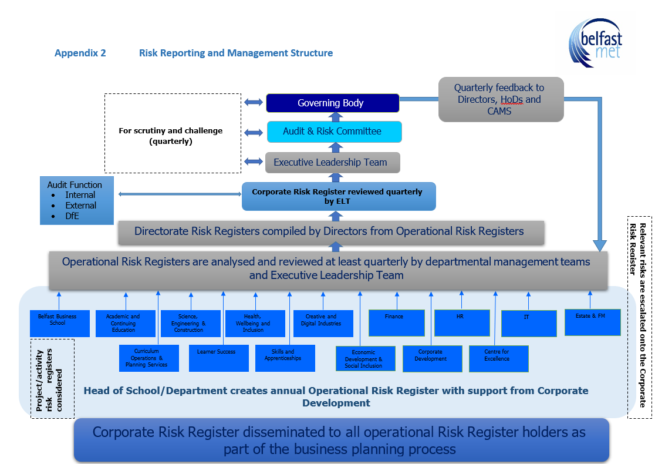

# Appendix 3 Scoring Mechanism

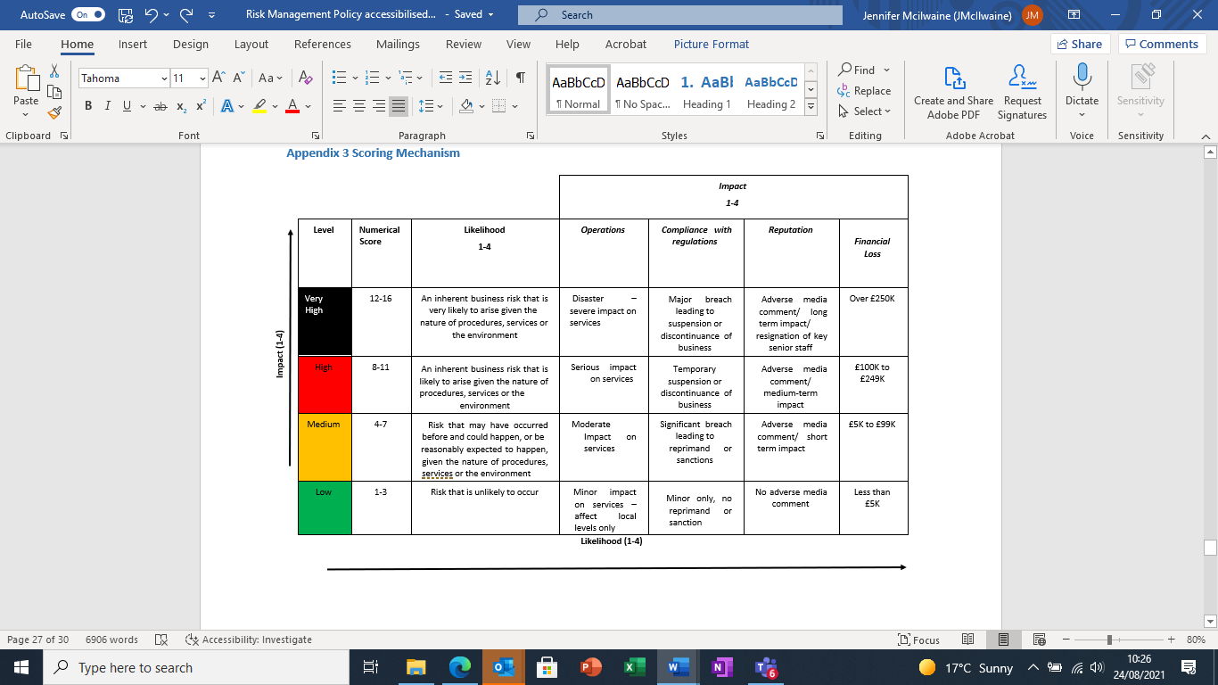

# Appendix 4 Risk Register Template

Diagram shows a risk register template, which allows for recording of risk reference, category, description, appetite, owner, its key cases, inherent rating, what controls are in place, its residual rating, current action and planned actions. 


# Appendix 5 Corporate Risk Appetite

**As a NDPB** **, the College operates within a tightly controlled and audited regime. The following risk appetite is reflective of those operating conditions and is based upon the Orange Book risk categories.**

|  |  |  |  |
| --- | --- | --- | --- |
| **Risk Categories** | **Risk appetite** | **Types of risk** | **Risk Appetite Description** |
| 1. Financial Sustainability | Cautious | Risks relating to expenditure and income generation | The College has a cautious approach towards financial risks that would impact materially on College financial targets or the financial sustainability of the College.   In accordance with the DfE’s position, the College has adopted a zero tolerance approach to fraud. |
| 1. Property | Open | Risks relating to the College estate | The College is open to property projects that will improve the quality of service delivery providing that risks are considered, managed and mitigated against. |
| 1. Operations | Hungry | Risks relating to enrolment numbers which underpin core grant and MaSN allocation | Enrolments The College is hungry for opportunities to maximise enrolments. |
| Open | Risks related to securing and delivering on non-core grant business development and funded programmes | The College is open to pursuing business development opportunities providing that risks are considered, managed and mitigated against. |
| Open | Risks relating to the quality of learning, teaching and student experience and impact of that on student retention and success | Teaching and Learning The College has an open approach to educational innovation that improves the student experience and outcomes for students providing that there is no detrimental impact to academic standards. |
| Open | Risks of not realising the benefits of the implementation of new EBS system | The College is open to opportunities to realise the full benefits of the EBS system improving data, business intelligence and reporting |
| 1. Technology | Open | Risks relating to the College IT infrastructure | The College has an open appetite for technological innovation that will improve the quality of service delivery providing that risks are considered, managed and mitigated against. |
| 1. Information/Security | Averse | Risks relating to the College role as a data controller/processor | The College is averse to activity that has the potential to impact negatively on information security. |
| 1. Governance | Averse | Risks relating to the College’s corporate governance structure | In accordance with the DfE’s position, the College has adopted an averse appetite to matters of corporate governance, but in the context of working to develop the partnership model with DfE is open to enhancing earned autonomy. |
| 1. People | Open | Risks relating to staff, students and visitors | The College takes an open approach to activity that is likely to impact upon the goal of being an excellent organisation and a great place to work for all its people.  The College has an open approach to activity that will impact upon the College values of collaboration, ambition, respect and excellence. |
| 1. Strategy | Open | Risks relating to external and internal influences that may impact on the College’s ability to implement the Strategic Plan | The College is open to developing new and innovative approaches which will support the delivery of the Strategic Plan. |
| 1. Legal | Averse | Risks relating to the College’s compliance with legislative obligations | The College has no appetite for activity that could result in legislation/regulation or policy breaches. |
| 1. Project/Programme | Cautious | Risks relating to College projects | The College has a low appetite for incidents that could interrupt everyday operations. |
| 1. Reputational | Cautious | Risks relating to the perception of the College | The College has a vision of being a College, Employer and Partner of Choice and therefore it takes a cautious approach to activity that has the potential to impact on reputation. |

Corporate Risk Appetite table